King Saud University

College of Computer and Information Sciences

Department of Information Technology

Graduation Project

2nd 1438/1439 – 2017/2018

تكتيك



**Prepared by**

|  |  |
| --- | --- |
| Hala Meera | 435204395 |
| Batoul Akkam | 435204410 |
| Ola Hejazi | 435204442 |
| Marwa Salahi | 435204545 |
| Hala Al-refai | 435204433 |

**Supervised by**

Dr. Bedour Alrayes

Student Declaration

Student acknowledges that he has read the above policy pertaining to plagiarism and understands that the penalty for such an act could result in disciplinary action.

**Project Title:** تكتيك

**Term of the Project:** 2nd Semester

**Academic Year:** 1439-1440(Hijri)

2018-2019 (Gregorian)

|  |  |  |  |  |
| --- | --- | --- | --- | --- |
|  | Student Name | Student University  ID Number | Student’s  Signature | Date |
| 1 |  |  |  |  |
| 2 |  |  |  |  |
| 3 |  |  |  |  |
| 4 |  |  |  |  |

1. ACKNOWLEDGEMENTS

First, we would like to express our gratitude and thanks to Allah Almighty for the blessing of completing this project and achieving it at its appointed time in health and wellness. Secondly, we would like to thank whom had illuminated the darkness of our ideas and guided us to do the best results, to whom helped and supported us, to whom devoted her time, despite her great responsibilities to motivate and guide us to Dr. Bedour Alrayes.

We would also like to thank Dr. Balsam Al-Suqeir and Dr. Sahar Al-Bayoumi for helping us analyze and understand the project and guide us to do the right steps.

We are also grateful to the IT department for their support, comments and assistance in addition, we should not forget our gratitude to our parents for their support and encouragement to us and bear our pressure.

Finally, a lot of thanks to everyone who worked with us and helped us to facilitate the consequences that we faced to accomplish our project.

We hope from Allah that our project will be part of the benefit of society and a good point in our CV to begin our first job with it.

1. ABSTRACT (IN ENGLISH):

Nowadays, the world is witnessing the role of technology in facilitating and organizing our tasks. Many people are turning to sites or applications that meet their demands, facilitate them to achieve it and store their data.

"Tactic": is a website and its application that cares about events and activities to organize and facilitate the functions of the organizer and achieve His requirements. A "Tactic" for event organizers provides a range of integrated electronic services that help to manage and ensure the success of the event with excellence and merit. It enables the organizer to manage its activities and manage all that is related to it.

"Tactic" allows the attendee to register for the event and keep track of his movements within the event. Also allows him to evaluate the event to ensure the high quality of the event. In addition, with the few applications available in Arabic, tactic appears in Arabic to meet this need, moreover it provides to print the attendee badge in Arabic.

1. ABSTRACT (IN ARABIC):

في الوقت الحاضر ، يشهد العالم دور التكنولوجيا في تسهيل وتنظيم مهامنا. يتوجه الكثير من الناس إلى المواقع أو التطبيقات التي تلبي مطالبهم، ويسهل عليهم تحقيقها ويساعدهم على تخزين بياناتهم. "تكتيك": هو موقع ويب مع يهتم بالفعاليات واألنشطة لتنظيم وتسهيل مهام المنظم وتحقيق متطلباته. يوفر "تكتيك" لمنظمي الحدث مجموعة من الخدمات اإللكترونية المتكاملة التي تساعد على إدارة وضمان نجاح الحدث بتميز وجدارة. إنها تمكن المنظم من إدارة الحدث .وإدارة كل ما يتعلق به تكتيك" يسمح للحضور بالتسجيل في الحدث وتتبع تحركاته في هذا الحدث. كما يسمح له بتقييم الحدث لضمان الجودة " العالية للحدث. باإلضافة إلى ذلك، مع وجود القليل من التطبيقات المتاحة باللغة العربية، يظهر تكتيك باللغة العربية لتلبية هذه الحاجة، باإلضافة إلى أنه يوفر طباعة شارة الحضور باللغة العربية.

**TABLE OF CONTENTS**

ACKNOWLEDGEMENTS ..............................................................................................................III

ABSTRACT (IN ENGLISH): ............................................................................................................ IV

ABSTRACT (IN ARABIC): ............................................................................................................... V

TABLE OF CONTENTS........................................................................................................................ VI

CHAPTER 1: INTRODUCTION ..............................................................................................................1

1.1 INTRODUCTION: .....................................................................................................................2

1.2 THE PROBLEM: .......................................................................................................................3

1.2.1 GOALS: .................................................................................................................................4

1.2.2 OBJECTIVES: .........................................................................................................................4

1.3 THE SOLUTION: ........................................................................................................................5

1.4 PROJECT SCOPE: .......................................................................................................................6

1.4.1 The scope of the system: .....................................................................................................6

CHAPTER 2: BACKGROUND. ............................................................................................................7

2.1 INTROUDUCTION .................................................................................................................8

2.2 TYPES OF EVENTS: ................................................................................................................8

2.3 WHY EVENT MANAGEMENT IS IMPORTANT? .....................................................................11

2.4 2.4 COMPONENTS OF THE SYSTEM: ................................................................................13

2.4.1 WEBSITE: ....................................................................................................................13

2.4.2 SMART PHONE: ...........................................................................................................13

2.4.3 ANDROID: ....................................................................................................................13

2.4.4 BARCODE: ....................................................................................................................14

2.4.4.1 Introduction to Barcode: ..............................................................................................14

2.4.4.2 Why we choose barcode?............................................................................................14

2.4.4.3 compression: ................................................................................................................14

2.4.4.3.1 CODE 39: ...................................................................................................................14

2.4.4.3.2 Two-Dimensional (2D) Barcode Types .......................................................................15

2.4.4.3.3 The QR code ..............................................................................................................15

2.4.4.4 The components of QR: .................................................................................................16

2.4.4.5 How do you scan a QR Code? .........................................................................................16

2.5 Summary: ................................................................................................................................17

CHAPTER 3: LITERATURE REVIEW ......................................................................................................18

3.1 INTRODUCTION: .....................................................................................................................19

3.2 THE SYSTEMS THAT SUPPORT ARABIC LANGUAGE: ................................................................19

Lamma: ...........................................................................................................................................19

Sty Tickets: ......................................................................................................................................20

Halayalla: .........................................................................................................................................21

3.3 THE SYSTEMS THAT SUPPORT ENGLISH: ..............................................................................22

Eventbrite: ....................................................................................................................................22

EventLeaf: ......................................................................................................................................23

3.4 ANALYSIS: ...............................................................................................................................24

3.5 ON SITE LITERATURE: ..............................................................................................................26

3.6 "تكتيك " SYSTEM: ...........................................................................................................27

3.7 SUMMARY: ..............................................................................................................................27

CHAPTER 4: SYSTEM ANALYSIS.............................................................................................................28

4.1 INTRODUCTION: .....................................................................................................................29

4.2 ORGANIZER CHARACTERISTIC: ................................................................................................29

4.3 INTERVIEW: .............................................................................................................................29

4.4 INTERVIEW SUMMARY: ..........................................................................................................31

4.5 SPECIFIC REQUIREMENT: ........................................................................................................32

4.5.1 FUNCTIONAL REQUIREMENTS: ........................................................................................32

4.5.2 NONFUNCTIONAL REQUIREMENTS: .................................................................................35

4.6 USE CASE DIAGRAM: ............................................................................................................36

Use case: ..........................................................................................................................................37

Sign up Use Case: .........................................................................................................................37

login Use Case: .............................................................................................................................38

Reset the password Use Case: .....................................................................................................39

Edit profile Use Case: ....................................................................................................................40

Manage Event Use Case: ..............................................................................................................41

Manage prizes Use Case: .............................................................................................................44

Manage badges Use Case: ..........................................................................................................47

Manage certificates Use Case: ....................................................................................................48

Manage registration Use Case: ..................................................................................................50

Attendee Registration Use Case: ..............................................................................................52

Send email Use Case: ................................................................................................................53

Check in the attendee by scanning their barcode Use Case: ......................................................54

Manage track Use Case: ............................................................................................................55

Rate Use Case: ...........................................................................................................................57

Analyze the data Use Case: ......................................................................................................58

Log out Use Case: ....................................................................................................................59

4.7 SEQUENCE DIAGRAMS: .....................................................................................................60

SIGN UP: ....................................................................................................................................60

LOGIN: .......................................................................................................................................61

RESET PASSWORD: ....................................................................................................................62

EDIT PROFILE: ............................................................................................................................63

ADD EVENT: ............................................................................................................................64

EDIT EVENT: ............................................................................................................................65

DELETE EVENT: .......................................................................................................................66

ADD SUB EVENT: ....................................................................................................................67

EDIT SUB EVENT: ....................................................................................................................68

DELETE SUB EVENT: ...............................................................................................................69

ADD PRIZE: .............................................................................................................................70

EDIT PRIZE: ..............................................................................................................................71

DELETE PRIZE: .........................................................................................................................72

ADD BADGES: .........................................................................................................................73

EDIT BADGES: .........................................................................................................................74

DELETE BADGES: ....................................................................................................................75

ADD CERTIFICATE: ..................................................................................................................76

EDIT CERTIFICATE: .......................................................................................................................77

DELETE CERTIFICATE: .................................................................................................................78

CREATE REGISTER FORM: ...........................................................................................................79

EDIT REGISTER FORM: ..................................................................................................................79

DELETE REGISTER FORM: ............................................................................................................80

DEACTIVATE LINK: .......................................................................................................................81

ATTENDEE REGISTRATION: ........................................................................................................82

SEND EMAIL: ...................................................................................................................................83

SCAN BARCODE: ............................................................................................................................84

PRINT CERTIFICATE: .....................................................................................................................85

PRINT BADGE: .................................................................................................................................86

ONSITE REGISTRATION: ..............................................................................................................87

TRACK AND PRINT: .......................................................................................................................88

TRAK SUB EVENT: .........................................................................................................................89

ANALYSIS DATA: ...........................................................................................................................90

log out: ................................................................................................................................................91

4.8 CONCEPTUAL DIAGRAM: .....................................................................................................92

4.9 CLASS DIAGRAM: ...................................................................................................................93

4.10 SUMMARY: ..............................................................................................................................95

CHAPTER5: SYSTEM DESIGN...........................................................................................................96

5.1 INTRODUCTION: .....................................................................................................................97

5.2 ARCHITECTURE DESIGN: .....................................................................................................98

5.3 DATA DESIGN: ........................................................................................................................99

5.3.1 DATABASE SCHEMA: ......................................................................................................100

5.3.2 ATTRIBUTE DICTIONARY: .............................................................................................102

5.3.3 RELATIONSHIP DATA DICTIONARY ............................................................................108

5.3.4 ENTITY DATA DICTIONARY: .........................................................................................109

5.4 COMPONENT DESIGN: .........................................................................................................110

5.5 INTERFACE DESIGN: ............................................................................................................128

5.5.1 WEBSITE SITEMAP ...........................................................................................................128

5.5.2 APPLICATION SITEMAP: .................................................................................................129

5.6 SUMMARY: ............................................................................................................................177

CHAPTER 6: CONCLUSION .............................................................................................................178

6.1 CONCLUSION: .......................................................................................................................179

6.2 LOCAL AND GLOBAL IMPACT: .........................................................................................179

6.2.1 LOCAL IMPACT: ................................................................................................................179

6.2.2 Global Impact: ......................................................................................................................179

6.3 PROBLEMS ENCOUNTERED: ..............................................................................................180

6.4 FUTURE WORK: ....................................................................................................................180

6.5 APPENDICES: .........................................................................................................................181

6.5.1 TIMELINE............................................................................................................................181

6.5.2 ROLES AND RESPONSIBILITIES: ...................................................................................182

6.5.3 Hardware and Software Tools: .............................................................................................182

HARDWARE: ..................................................................................................................................182

SOFTWARE: ...................................................................................................................................182

6.5.4 COST (IF APPLICABLE) ....................................................................................................183

6.6 REFERENCES: ........................................................................................................................184

LIST OF TABLES:

Table 1: Analysis Literature review..........................................................................................................25

Table 2: Sign up use case ........................................................................................................................37

Table 3: Login use case ...........................................................................................................................38

Table 4: Reset password use case...........................................................................................................39

Table 5: Edit profile use case ..................................................................................................................40

Table 6: Manage Event use case .............................................................................................................43

Table 7: Manage prize use case ..............................................................................................................46

Table 8: Manage badges use case ..........................................................................................................48

Table 9: Manage certificates use case ....................................................................................................49

Table 10: Manage registration use case .................................................................................................51

Table 11: Attendee Registration Use Cas ...............................................................................................52

Table 12: send email use case ................................................................................................................53

Table 13: Check in the attendee use case ..............................................................................................54

Table 14: Manage track use case.............................................................................................................57

Table 15: Rate use case...........................................................................................................................57

Table 16: Analyze the data use case .......................................................................................................58

Table 17: Log out use case ......................................................................................................................59

Table 18: Attribute dictionary...............................................................................................................107

Table 19: Relationship data dictionary .................................................................................................108

Table 20: entity data dictionary.............................................................................................................109

Table 21: login interface .......................................................................................................................130

Table 22: password interface................................................................................................................132

Table 23: reset password interface ......................................................................................................133

Table 24: manage event interface .........................................................................................................135

Table 25: add event interface ...............................................................................................................137

Table 26: delete event interface...........................................................................................................137

Table 27: edit event interface...............................................................................................................139

Table 28: manage sub -event interface ................................................................................................140

Table 29: add sub -event interface ........................................................................................................141

Table 30: edit sub -event interface .......................................................................................................142

Table 31: delete sub -event interface ...................................................................................................143

Table 32: manage prize interface .........................................................................................................144

Table 33: add prize interface ................................................................................................................145

Table 34: edit prize interface ................................................................................................................147

Table 35: delete prize interface ...........................................................................................................148

Table 36: Choose Winer interface ........................................................................................................149

Table 37: manage badges interface......................................................................................................149

Table 38: add badges interface.............................................................................................................150

Table 39: delete badges interface ........................................................................................................151

Table 40: edit badges interface ............................................................................................................152

Table 41: Manage Certificate interface ................................................................................................153

Table 42: Add Certificate interface .......................................................................................................154

Table 43: Edit Certificate interface .......................................................................................................155

Table 44: Delete Certificate interface ...................................................................................................156

Table 45: Manage registration form interface .....................................................................................157

Table 46: Add form interface ................................................................................................................158

Table 47: Edit form interface ..............................................................................................................159

Table 48: Registration form interface ..................................................................................................160

Table 49: Choose statistical report interface........................................................................................161

Table 50: Statistical report interface .....................................................................................................162

Table 51: Manage rating interface........................................................................................................163

Table 52: Rating interface......................................................................................................................164

Table 53: Send Email interface .............................................................................................................165

Table 54: Manage track interface .........................................................................................................166

Table 55: Print badge and certificate interface ....................................................................................168

Table 56: Choose to track interface ......................................................................................................168

Table 57: Track Sub event interface .....................................................................................................169

Table 58: Track event interface ............................................................................................................170

Table 59: Onsite Registration interface ................................................................................................171

Table 60: Log in (APP) interface ..........................................................................................................172

Table 61: Home page (App) interface ...................................................................................................173

Table 62: Manage rate (App) interface.................................................................................................174

Table 63: Event/subevent Rate (App) interface ...................................................................................175

Table 64: Track Attendee by scan bar code (App) interface.................................................................176

Table 65: Print badge (App) interface...................................................................................................177

Table 66: Timeline.................................................................................................................................181

Table 67: Timeline..................................................................................................................................181

Table 68: Role and responsibilities ........................................................................................................182

Table 69: Hardware...............................................................................................................................182

Table 70: Software: ...............................................................................................................................183

LIST OF FIGURES:

Figure 1: CODE 39 ..................................................................................................................................14

Figure 2: Two-Dimensional (2D) Barcode ..............................................................................................15

Figure 3: The QR code .............................................................................................................................15

Figure 4: The components of QR .............................................................................................................16

Figure 5: Lamma logo..............................................................................................................................19

Figure 6: Lamma website ........................................................................................................................20

Figure 7: Sty Tickets logo ........................................................................................................................20

Figure 8: Sky Ticket website....................................................................................................................21

Figure 9: Halayalla Logo ..........................................................................................................................21

Figure 10: Halayalla website ...................................................................................................................22

Figure 11: Eventbrite Logo ......................................................................................................................22

Figure 12: Eventbrite website .................................................................................................................23

Figure 13: EventLeaf Logo.......................................................................................................................23

Figure 14: EventLeaf website..................................................................................................................24

Figure

15: Use Case diagram ..................................................................................................................36

Figure 16: Sign Up sequence...................................................................................................................60

Figure 17: Login sequence ......................................................................................................................61

Figure 18: Reset password sequence ......................................................................................................62

Figure 19: Edit profile sequence .............................................................................................................63

Figure 20: Add event sequence ..............................................................................................................64

Figure 21: Edit event sequence...............................................................................................................65

Figure 22: Delete event sequence ..........................................................................................................66

Figure 23: Add sub event sequence........................................................................................................67

Figure 24: Edit sub event sequence .........................................................................................................68

Figure 25: Delete sub event sequence....................................................................................................69

Figure 26: add prize sequence ................................................................................................................70

Figure 27: Edit prize sequence ................................................................................................................71

Figure 28: Delete prize sequence ...........................................................................................................72

Figure 29: Add badges sequence .............................................................................................................73

Figure 30: Edit badges sequence ............................................................................................................74

Figure 31: Delete badges sequence .........................................................................................................75

Figure 32: Add certificate sequence .......................................................................................................76

Figure 33: Edit certificate sequence .......................................................................................................77

Figure 34: Delete certificate sequence ...................................................................................................78

Figure 35: Create register form sequence ..............................................................................................79

Figure 36: Edit register form sequence...................................................................................................79

Figure 37: Delete register form sequence ..............................................................................................80

Figure 38: Deactivate link sequence .......................................................................................................81

Figure 39: Attendee registration sequence ............................................................................................82

Figure 40: Send email sequence .............................................................................................................83

Figure 41: Scan barcode sequence .........................................................................................................84

Figure 42: Print certificate sequence ......................................................................................................85

Figure 43: Print badge sequence ............................................................................................................86

Figure 44: Onsite registration sequence.................................................................................................87

Figure 45: Track and print sequence ......................................................................................................88

Figure 46: Trak sub event sequence .......................................................................................................89

Figure 47: Analysis data sequence .........................................................................................................90

Figure 48: log out: sequence...................................................................................................................91

Figure 49: Conceptual diagram ...............................................................................................................92

Figure 50: Class diagram .....................................................................................................................93

Figure 51: Class diagram2 ...................................................................................................................94

Figure 52: Architecture design.................................................................................................................98

Figure 53: ER diagram .............................................................................................................................99

Figure 54: Website Site-Map..................................................................................................................128

Figure 55: Application Site Map............................................................................................................129

CHAPTER 1

INTRODUCTION

1. INTRODUCTION:

An event is a planned and organized occasion, for example (Conference, Exhibition, Festival, Initiative, etc.) [7]. "Today's events can impact the economy by increasing tourism in the region where the economists estimated that the economic returns from the events in Saudi Arabia is more than 11 billion SR yearly" [4]. As a result, the number of events started to increase noticeably.

if we look to other country in middle east we see Dubai that is familiar city with national and international events today.

according to statistic there are 75 events hosted at various venues within the Culture and

Fine Arts category in 2015 [5].

The growing demand for this type of events has led to develop a new specialized venue infrastructure like the Dubai Opera which opened in 2016.

Also, if we go back to Saudi Arabia we see the entertainment authority released up to 45 events for mid-year holiday 2018 [1]. However, organizing these events are a complex task and require a high amount of administration work and time management.

There are many event management systems in the market that help the event organizer to manage his event. but it still not providing the most needed functionalities. There are three most important problems which the event organizers are facing especially in the Middle East.

First, most of the event management systems are supporting English language only when registering the attendee information [2] while most of the event organizers and attendees in Middle East need system in Arabic. Second, identifying the attendees in the event by printing badges in Arabic language [3]. Finally, the organizer may need to keep track on the attendee locations during the events and no one system provide this service.

Our system (تكتيك) will solve the previous problems by provide many services to the organizer that facilitate the management processes and enable the organizer to use a smart events management system that enables him to automate management registration, print the badges for the attendees, keep track on delights attendees in the event, and give the right analytics tools to prove the value of the organizer event.

**1.2 THE PROBLEM:**

Saudi Arabia is entering a new generation of entertainment events. Most of these events require registration in advance, printing badges in Arabic, and registering the participants in different activities in the event with the same barcode (QR).

However, there are no smart interactive system that can be used by the event organizer to manage the registration system and to analyze the data collected from the attendees during mobility in the event.

After we looked into existing systems we found that it requires the attendee information to be in English [6] while many of the current events require the attendee information to be in Arabic. Moreover, the existing systems don't involve printing attendees’

badges in Arabic which is required by most of the event organizers.

At present, the systems provide an attendance tracking service for the event, but since there are many sub-events within the event, we need to track them too, which means that we need a barcode. Moreover, events now need to analyze data for Some of reasons like assess the success rate of the event, see the interaction of people with this event and knowing the number of attendees, etc.

All these problems have will be solved in our interactive system that meet the needs of organizers.

1.3 PROJECT GOALS AND OBJECTIVES:

1.3.1 GOALS:

This project aims to develop a mobile application & website that help event organizers to organize their events from A to Z by managing it remotely.

Our system (تكتيك) will save the effort, time and money to the organizers of the events since it will smarty automated the events registration and management tasks.

Also, our system will offer highly valuable information to the event organizer by utilizing the QR use in the registration. In addition, our system will encourage small companies to establish activities that improve their profits and the national economy, and this leads to increase the tourism in the region. Also, the system will encourage volunteers to participate in organizing the events.

1.3.2 OBJECTIVES:

• Create a system in Arabic language.

• Register the organizers and give them authority to manage their events.

• Provide the service of advertising events through social networks of the system.

• Send Reminder to attendee \ volunteers to attend the events that they enrolled.

• Allow the online registered participants to verify and print their badges by using QR

of event.

• Allow attendees to join subevents via same QR.

**1.4 THE SOLUTION:**

• Give the organizers full control of their event from the registration page to analyze the attendee \ volunteer’s data.

• Send customized and automatic questionnaires to attendee at the end of the event.

• Offer reports and instantaneous statistics (like: number of attendees at each event).

• Print certificates of attendee \ volunteers.

• develop an application to read and print the QR badge.

According to some previously mentioned problems, we decided to produce an intelligent systematic website and mobile application (تكتيك) designed completely in Arabic to make it more comprehensible and allow each organizer company for any event to register and modify their accounts. Furthermore, to use our system as an advance approach to organize events in a clear way and make them effective for attendee and volunteers to be as an active member at the events. Also, the system will provide a link about the event offered with valuable and sufficient information provided for all people who wants to be as a part at any event organizes by the organizer companies.

After the registration being done for the organizer companies, all of them have the validity to see the information about the register attendee in details. However, the application has the capability to scan barcodes and print the entrance badges which they were given to each member after the system asks the attendee for some personal information at the beginning to utilize the answers later at numerous processes. For instance, each member of the attendee will be given one and only one barcode without being updating latterly, and the attendee can use it at any sub-events.

The system offers admin panel for the organizer companies to do statistics for the number of registrants by scanning the barcode and analyze the attendance data to know which of the sub-events have attended. Based on the attendee and volunteers who want to attendance the particular event , an alert before many days will occur to each participant member.

At the end of any event the organizer company will send customized and automatic questionnaires for each member. in addition, the company will grant many certificates for attendee and volunteers printed by the system.

Based on the above, our application allows the responsible about the events to scan the barcodes owned by the attendee and print out ID cards containing information about each attendee. Moreover, the website includes plentiful services we have mentioned above in details like allow the organizer companies to register into the system and print the badges for the attendee and volunteers in Arabic, send automatic questionnaires to attendee at the end of the event, offer reports and do instantaneous statistics to describe the event after it’s over and advertise the events in the social network. These features which make the participation for any event easier and available with more and more service.

1.5 PROJECT SCOPE:

Our system is an online event registration system that helps event organizers to register an event, add sub events related to the recorded event, in addition, customize automatic questionnaires, prints badges and certificate for attendee and volunteers and provide the link of that event with the ability to share it on the social network that gives attendee authority to reserve and ticket management.

The main features of (تكتيك) are support Arabic language, use the barcode to make process of printing badges easier and giving the event organizer accessibility to keep tracking attendees of the sub-events.

**1.3.1 THE SCOPE OF THE SYSTEM:**

• The main language will be Arabic

• The system consists of an Android mobile application and website.

• The system serves the event organizer.

• The system registers the organizers and give them authority to manage their events.

• The system provides service of advertising events through social networks of the system.

• The system allows the attendees to reserve and manage tickets in Arabic.

• The system uses the QR to register attendees and print badge.

• The system allows attendees to join subevents via same QR.

• The system sends messages and alerts to attendees for the events.

• The system offers reports and instantaneous statistics (like: number of attendees at each event).

• The system offers customized and automatic questionnaires.

• The system allows the event organizer to print certificates for attendee \ volunteers.

CHAPTER 2

BACKGROUND

**2.1 INTROUDUCTION**:

"An event is a gathering of any number of people that takes place at a certain time, over one or multiple days in an indoor or outdoor location and for a certain purpose whether free or chargeable.

The characteristics of an event that it’s includes a group of persons willing to attend participate, has a predetermined start and end time, takes place at a certain location and has a specific purpose like (conferences, entertainment, marketing, family events, etc.). the event may require entrance tickets or otherwise and may be free of charge for attendance". [1]

Event management is one of the most important strengths of any event, which contributes significantly to profits to become more effective and efficient. [2]

An Event Organizer is the person who schedules an event, and usually the person that runs it and reports it.

Organizers make sure their events run in a good way, and if there are any problems, they will find solution for them. They are responsible for the event from start point to end finish.

**2.2 TYPES OF EVENTS:**

**Conferences:**

it is the most important events that professional event managers organize it.

The term “conferences” can apply to a variety of gatherings from a group of researchers who meet to discuss scientific results or to solve specific problem [3].

* **Academic conferences:**

Many of these conferences are held on the campus of a large university to announce research results and publish the research or paper.

* **Medical conferences:**

“A medical conference is a meeting for physicians and other medical professionals. These professionals may include students, researchers, nurses, technologists, and scientists. Medical conferences are essentially a series of meetings about medical diagnostics, treatments, and cases, as they pertain to the medical specialty in which a physician practices, from primary care to surgery. Presenters and participants in the conference discuss new trends in the medical field and brush up on pertinent clinical information. Physicians learn about new technology that will help them to better serve their patients. Other topics may include new hazards in the medical community and new ways to detect diseases” [4].

* **Business conferences:**

companies usually hold this type of meeting for shareholders to announce the company’s achievements of the past year and explain the plan for next year. In addition, business conferences may be for the company departments, to manage teams and talk about the business’ direction and to share best practices.

* **Press Conferences:**

Organized by newsmakers to make an announcement or to field questions by press who happen to be invited to the conference [5].

**Education events:**

* **Seminar:**

Educational events that include one or more experts who proffer information by lecture and discussion.

* **Workshop:**

Usually workshops are smaller than seminars. it is involving students practicing their new skills under the supervision of the coach [6]

* **Colloquium:**

A colloquium can be considered an “academic networking event.”

Participants are often experts in a given field and they meet to exchange new ideas. [7].

**Trade Events:**

* **Trade Show:**

A type of business event (B2B) in which companies present their new business products and services to show them to the labor market. The event is attended by business representatives, industry officials and, of course, the press. They are usually organized and sponsored by trade unions for specific industries.

* **Trade Fair:**

A type of event that serves trade. Companies gather not only to display their products but also to market, sell and put in the labor market. Trade fairs are open to anyone interested in and can cover more than one industry at the same time. Tend to occur more than 3 to 5 days, sometimes longer.

* **Exhibition:**

The primary objective is to showcase products and services. Usually, exhibitions cover one industry at a time and it set up to building a general image of a company/brand” [8].

**Social events**

* **Commemorative events:**

This kind of events usually is to special people like when we mark anniversaries or important historical or cultural movements. [9].

* **Fundraisers:**

Gathering donations are events or sales designed to collect funding for a school, community, or other group to help them. donations are often either product sales or provide services. [10]

* **Award Ceremonies event:**

An award ceremony is an event where one or multiple awards are given out to special people in recognition of their efforts in a particular matter. [11]

* **Music event:**

A music event is a community event oriented towards live performances of singing of all kinds like blues, folk, jazz, classical music.

* **Business Events , Team building events:**

This type of event to motivate teams in companies and used to enhance social

relations, often involving collaborative tasks.

Essentially the purpose of this kind of events getting team members to know each other better and thus be more efficient as a team.

* **Sports event:**

A sports event is one which involves professional or amateur participants of all kinds of sports like Football, Boxing matches and boat races.

usually takes place at locations designated for sports activities (playgrounds, halls, etc.) or locations which may be used for such activities (beaches, desert and mountain areas, etc.)

**2.3 WHY EVENT MANAGEMENT IS IMPORTANT?**

Event management is like any other project management that needs to create a registration form, select max number of attendees, identifying its target audience. that will be giving the organizer an initial picture of the event before actually launching the event [12].

The process of planning and coordinating the event is usually referred to as event planning and which include all about events from start point to end point like budgeting, time scheduling, selecting site, coordinating parking, arranging of speakers, acquiring necessary permits, arranging decor, event security, and emergency plans.

As we know that events are different in its nature so planning and execution of each event will be different on basis of type of event.

“تكتيك” will offer services in order to improve event management process.

we need process by which an event planner organizes attendance to an experience for one or more attendees. This process can be as simple as a paper list that the event planner uses to record details about attendees, or a more advanced event registration system that gives attendees multiple ticket options, collects detailed information about the attendee, processes payments, scans and validates registrations or tickets at the door, communicates with attendees automatically and tracks attendance so we need the event registration.

The organizer needs to track attendees in order to know the extent of people's interest in its effectiveness, the extent of its success and how much the number of the attendee that attended this event. This track will benefit him later if he wants to repeat this type of event. This lead us to the need of sub-events' tracking.

In today's world people are cautious about strangers. we need an instant introduction and available information to tell who you are and where you work. This what lead us to use the badges as a way to identify the attendee and make their participation in the event reassuring for other by using printing badgesfor each member.

after an event, one of the most important things to do is knowing feedback to learn what the needs and expectations of your target market, this process will be useful to create future business and marketing strategies. after the events, it is good to send surveys via email which asking attendees to complete an online feedback survey by sending a link of survey.

After-event surveys often provide the most meaningful feedback. it gives attendees the chance to evaluate the effectiveness of different aspects of your events such as individual speakers, seminar topics, their opinion of product, sponsors, in addition to their overall opinion of the event.

The goal of a post-event survey is to know whether the efforts that put into event planning met expectations of attendees and sponsors. To ensure the highest participation rate, send your survey to attendees as soon as the event has finished, while their experience is fresh in their minds. The most important information collected from post-event surveys is whether attendees found value in the event, Is they have suggestions for developing similar events? is it was worth their investment of time, and whether they would participate in the event again. We can summarize all these needs in questioner survey.

We need to motivate people to be active, which requires encouraging them by attaching their presence with a certificate of attendance. In addition, some people do not attend the event unless they receive a certificate at the end of the event. Hence the idea of printing attendance certificates.

**2.4 COMPONENTS OF THE SYSTEM:**

**2.4.1 WEBSITE:**

Due to the development of information technology, many business owners are looking to create websites for their company whether the company is small or large, technology or not websites are the fastest, easiest and cheapest way to reach the target group that the manager wants. For example: If a customer has questions that can be better answered on a website than over the phone, this is a valuable asset to your marketing mix. [13]

**2.4.2 SMART PHONE:**

Smart phone is a mobile phone that has advanced technologies with functionality. Some of functionality are similar to functionality in personal computer and other are different

So, we can say that smartphones are now like a mini- computer, with most of the features in it.

As technology advances, smartphones have become a very important part of our daily lives and consume much of our time and are constantly evolving, both in terms of new features and system updates. This increased the customer's requirements as he asked for new features in line with his needs. We can say that the world has become smaller by the use of smart phones and features in which. [14]

**2.4.3 ANDROID:**

Android is a mobile operating system developed by Google, based on a modified version of the Linux kernel and other open source software.

Most developers are currently designing the Android application because of its ease of handling and over-demand by users.

And Android is not only applications for the phone! So, in addition to that, Google has further developed Android TV for televisions, Android Auto for cars, and Android Wear for wrist watches, digital cameras, PCs and other electronics. [15]

**2.4.4 BARCODE:**

**2.4.4.1 Introduction to Barcode:**

Barcode is an optical readable machine, it’s represent a valuable information about the object that carries the barcode. Systemically, traditional barcodes represent data by changing the widths and spacings of parallel lines.

A laser line can be used to scan (read) the barcode which is also called barcode readers. Newer barcode such as QR (abbreviated from Quick Response Code) is consists of black squares arranged in a square grid on a white background, which can be read by an imaging device such as a camera, smart phones ... etc.

**2.4.4.2 Why we choose barcode?**

1. Barcodes eliminate the possibility of human error.

2. Barcodes are inexpensive to design and print.

3. Barcodes provide better data.

4. Data obtained through barcodes is available rapidly.

**2.4.4.3 compression:**

Barcodes representing data in the lines and the spacings of parallel lines.

Here are many of barcodes and its characteristics are exist in this comparison. [16]

One dimensional barcodes(1D) or linear barcode that will representing data by vary the width and spacings of parallel lines.

These include some of the traditional or most well recognized barcode types such as the UPC and EAN, code 39. [17]

**2.4.4.3.1 CODE 39:**

Code39 barcodes (or Code 3 of 9) are used to label goods across many industries. It allows the use of both digits and characters, as a figure 1 bellow.

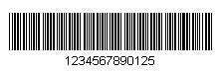

**Figure 1: CODE 3**

Two-dimensional (2D) barcode, systematically represent data using two-dimensional symbols and shapes. They are similar to a 1D linear barcode, but it can represent more data per unit area. These include some modern barcode types like the QR Code and PDF417 code types [18], as the figure below.

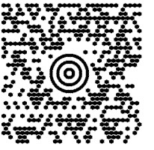

**Figure 2: Two-Dimensional (2D) Barcode**

**2.4.4.3.3 The QR code:**

Similar to the above barcodes, is an example of an information matrix. However, a big difference is that while that the above barcode only holds information goodly in the horizontal direction, a QR can do so vertically as well.

This is why QR codes are referred to as two dimensional, because they hold information both vertically and horizontally.

QR has strong consumer focus, often used in tracking and marketing such as advertisements, magazines, and business cards. IT's commonly used with mobile and smart-phone devices to direct users to additional information about a particular topic or product [19], the following figure illustrate it.



**Figure 3: The QR code**

The right tools for scanning the barcodes are commonly similar for all.

To use QR codes feasibly you need a smartphone equipped with a camera and a QR code reader or scanner application feature. The modern smartphones models available today often have an application which pre-installed on them.

The figure bellow will illustrate mean of each component of QR barcode.

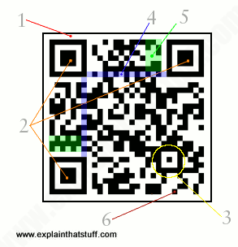

**Figure 4: The components** **of QR**

**1- Quiet zone:** Quiet area: Is a white place that limits the barcode to isolate it from other printed information and make it clear to look at

**2- Finder patterns:** Large white and black squares exist in three corners that show that this is a quick response code and not a symbol. Each square refers to a specific object unless it

is damaged or blocked by something.

**3- Alignment pattern:** This ensures decoding the bar code even if it is distorted or corrupted.

**4- Timing pattern:** It works vertically and horizontally and exists between the three finder patterns. It helps to facilitate the identification of individual cells inside the barcode. It is useful especially if the barcode is damaged or distorted.

**5- Version information:** Specifies the type of version used in particular bar code and provide its information.

**6- Data cells:** It not part of one of the standard features contains specific data in the code such as timing, alignment, and other patterns.

**2.4.4.5 How do you scan a QR Code?**

If you have an Android, iPhone or Blackberry smartphone then you can use various different barcode scanner applications that have the ability to read and translate data from a QR code.

The applications include: Red Laser, Barcode Scanner and QR Scanner. Most of these applications are completely FREE, and you only need to install one and use your smartphone’s camera to scan the barcode. The application will then load for you the encoded data automatically.

**2.5 Summary:**

This Chapter was a simple description of all kinds of events that one could think of as organized. It explains to technical and non-technical people how the world today is interested in events of various kinds (known and unknown) events, which emphasizes the great need and the importance of a system that supports and organizes these events and that's why tactic was created.

CHAPTER 3

LITERATURE REVIEW

**3.1 INTRODUCTION:**

In this chapter, we will go through brief description of selected systems similar to "تكتيك" and compare these systems with it. Most of these systems are web-based systems and support mobile application.

The aim of this chapter is to illustrate what is the functionalities that " تكتيك" should provide. The various functions that would make it stand out amongst other similar systems would surface, which would be helpful in eliciting the requirements and the potential functions

and features to consider.

**3.2 THE SYSTEMS THAT SUPPORT ARABIC LANGUAGE:**

**Lamma:**



**Figure 5: Lamma logo**

Lama is a Saudi e-platform that provide to you all the activities and events in Saudi Arabia and enables you to book your ticket. it also offers to the event organizers a lot of services that help to manage events in easy and simple way. [20]

**Features include:**

• Special control panel.

• Organizer page.

• Reservation and ticket management.

• Integrated payment services.

• Reports and statistics.

• Certificate Delivery Service.

• Auto reminders.

• Send messages and alerts.

• Publish to social networks.

• Application for Attendance Registration.

• Customized and automatic questionnaires.

• Include tickets in the organizer's website.

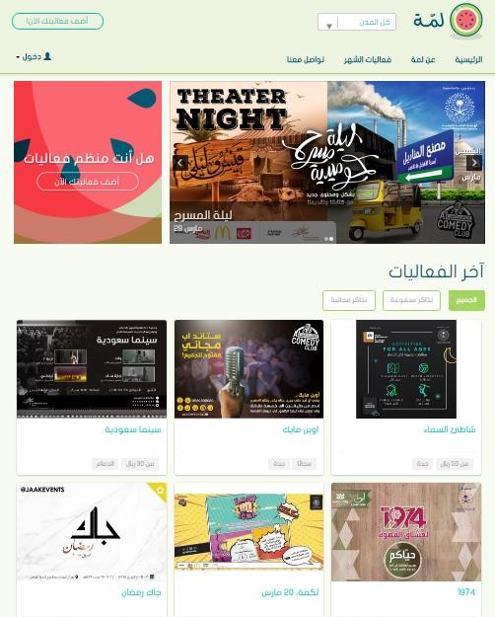

**Figure 6: Lamma website**

**Sty Tickets:**



**Figure 7: Sty Tickets logo**

It is a system that provide services to event organizers. it enables you to create events, organize it in easy way and allow customers to book tickets online [21].

**Features include:**

• Selling and booking tickets electronically.

• Provide adequate means of payment.

• Collection and financial report 24-hour customer service.

• View the event on the website.

• Provide a system to manage and regulate the entry of visitors to the event.

• Reports and statistics.

• Electronic attendance certificates.

• Questionnaire for attendance.

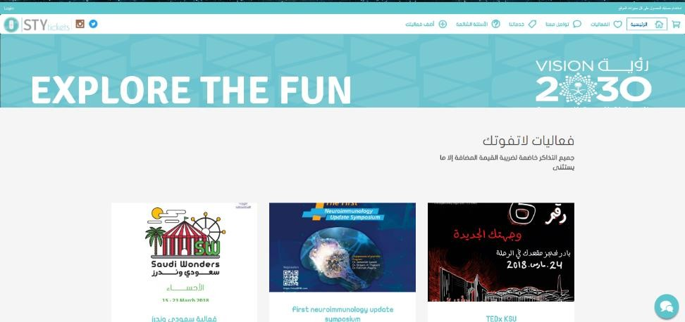

**Figure 8: Sky Ticket website**

**Hala yalla:**



**Figure 9: Hala yalla Logo**

Hala Yalla is a free event and activity booking application\website that give you an ability to easily book, attend or organize entertainment\sports activities in Saudi Arabia.

Hala Yalla uses your phone’s internet connection and location services to allow you engage in an array of sports hobbies and events taking place around you [22].

**Features include:**

• Create your own activities or choose from tons of existing ones.

• Organize sports and entertainment events.

• Easily invite friends through WhatsApp, Facebook or Twitter.

• Live chat functionality.

• it sends alerts to attendee based on his interests, schedule and location.

• Book venues, classes & trainers.

• Support website and application.

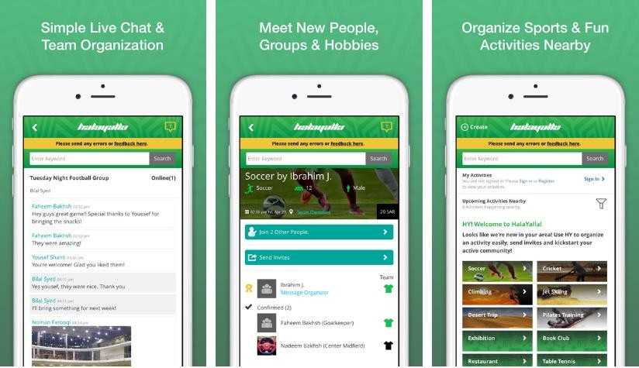

**Figure 10: Halayalla website**

**3.3 THE SYSTEMS THAT SUPPORT ENGLISH:**

**Eventbrite:**

**Figure 11: Eventbrite Logo**



Eventbrite is the largest event technology platform in the world. it enables anyone to create, share, find and attend.

Conferences, music festivals, marathons, hackathons, contests, fundraisers, gaming competitions. it gathers the world together through live experiences [23].

**Features include:**

• Manage and analyze your event from anywhere.

• Reach target consumers.

• Build a loyal attendant base.

• Support many languages.

• Display Event.

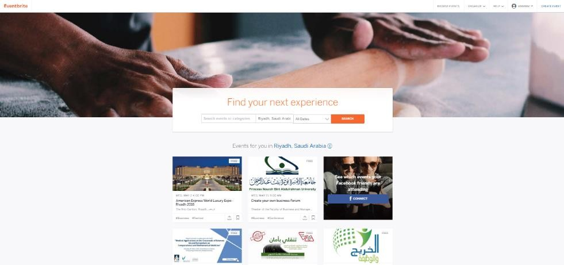

**Figure 12: Eventbrite website**

**EventLeaf:**



**Figure 13: EventLeaf Logo**

EventLeaf offer online web-based event management platform as well as mobile event apps. it serves all sort of event registration, ticket sale, check in and survey needs [24].

**Features include:**

• Registration attendees.

• Send personalized invitation emails.

• Sell admission tickets and event packages.

• Choose a language for guests to register in their native language (English, Arabic, Chinese and etc.)

• Track invitation status.

• Track registrations and ticket sales.

• Invite on social media on Facebook, LinkedIn and Twitter.

• Check attendee by mobile app or EventLeaf desktop.

• Print event badges for registered guests from the EventLeaf website.

• Print 1d barcodes on the event badges for fast scanning.

• Personalized web address.

• Publish event online.

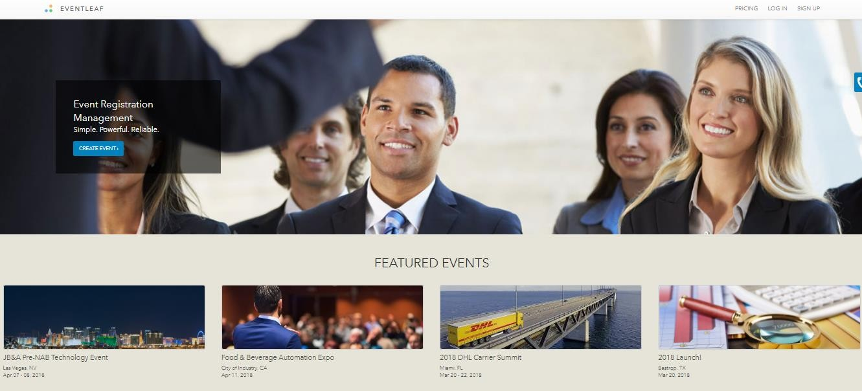

**Figure 14: EventLeaf website**

**3.4 ANALYSIS:**

We will compare our application with other related applications that are mentioned in this chapter and will try to apply the best functions in our application.

|  |  |  |  |  |  |  |
| --- | --- | --- | --- | --- | --- | --- |
|  | "تكتيك" | Lamma | Sty Ticket  titticket s | Eventbrite | EventLeaf | Halayalla |
|  |  |  |  |  |  |
| Mobil  Application | √ | √ | √ | √ | √ | √ |
| Registration | √ | √ | √ | √ | √ | √ |
| Printing badges in Arabic | √ |  |  |  |  |  |
| Reminders | √ | √ | √ | √ | √ |  |
| Track on attendee | √ | √ |  | √ | √ |  |
| Track on attendee of sub-event | √ |  |  |  |  |  |
| Arabic  Languages | √ | √ | √ |  |  | √ |
| English  Languages |  |  |  | √ | √ | √ |
| Provide link of  event | √ | √ | √ | √ | √ |  |

|  |  |  |  |  |  |  |
| --- | --- | --- | --- | --- | --- | --- |
| Provide add prize service | √ |  |  |  |  |  |
| Publish events on website |  | √ | √ | √ | √ | √ |
| Questionnaire | √ | √ | √ | √ | √ |  |
| Printing  Certificates | √ | √ | √ | √ | √ |  |

**Table 1: Analysis Literature review**

**3.5 ON SITE LITERATURE:**

We have attended two events "Second Entrepreneurship Forum" and "make your own job" to get a good idea of how the attendee registered into events and how the responsible volunteers dealing with the proposed system. So, after that we will be able to understand our system clearly and mastered the method of registration to avoid the mistakes that occurred in the last two events in the registration method,

It was an enjoyable experience for us to see the importance of our project and the benefits it brings to society. It was a motivating point for us to face the consequences by ourselves and try to solve it by creating our website.

At the end, here are the features and problems that had been face in each event:

**"MAKE YOUR OWN JOB":**

**The date of this event was 26/2/2018.**

**The features were:**

1. Badges are printed in Arabic.
2. The registration process was quick and easy.
3. Provides number of registrars.
4. Provides number of attendees.
5. The required equipment was provided.

**The problems were:**

1. Barcode had not been used even though hardware is available to scan.
2. Lack of awareness of them volunteers, "What is needed to do"!
3. Registration process for non-registrants was slow and time-consuming.
4. There is no trace of sub events.
5. The system was expensive.

**"SECOND ENTREPRENEURSHIP FORUM"**

**The date of this event was 20/3/2018.**

**The features were:**

1. Badges are printed in Arabic.
2. Provides number of registrars.
3. Provides number of attendees.
4. The required equipment was provided.

**The problems were:**

1. Barcode had not been used even though hardware is available to scan.
2. Lack of awareness of them volunteers, "What is needed to do"!
3. Registration process for non-registrants was slow and time-consuming.
4. There is no trace of sub events.
5. The system was expensive.
6. The registration for non-registrants had made in excel sheet, which is a bad point of their system.

**3.6 "تكتيك" SYSTEM:**

We have found many applications in the same domain and we divided them into two categories: applications in the Arabic language and applications in the English language. Then we summarized the features of those applications and compared them with "تكتيك" features.

**Now we will summarize"تكتيك" features.**

**Features include:**

• Mobile application support Arabic language.

• Allowing people to register the event.

• Supply special registration code for the very important people (VIP).

• Support printing badges and provide it in Arabic.

• Tracking the sub-events.

• Provide awards winning prizes for event & sub-event.

• Printing certificate to the attendee.

• Sending reminders to the registered people to attend the event.

• Sending questioner survey to collect their opinions about the event.

**3.7 SUMMARY:**

In this chapter, we have discussed and described many systems that have been exist

around the fields of the event management. From the above analysis, we can see that not all systems support printing badges in Arabic. Also, many of them don't support track on attendee of sub-event. Furthermore, many of features are going to be present in our system which makes it comprehensive and completed solution for a lot of problems been included in other systems like printing badges in Arabic, customized and automatic questionnaires and certificates.

.

**CHAPTER 4: SYSTEM ANALYSIS**

**4.1 INTRODUCTION:**

In this chapter, we will include detailed description of the analysis and design process. first section of this chapter will describe analysis processes which describe of requirement specification, use case diagram, conceptual diagram, sequence diagrams, class diagram of our system. The second section of this chapter describe component design and interface design.

In system analysis and development there are two approaches (object-oriented approach and structured approach)

In our system we will follow the object-oriented approach.

4.2 **ORGANIZER CHARACTERISTIC:**

The system is documented and designed essentially for institutions' organizers to help them in event management. The organizers should have a high degree technical skill especially an experience in dealing with the mobile Application and the website.

* 1. **INTERVIEW:**

At the first, to be sure for what we want to do and how we really want our system to be appropriate in the marketing place, we decided to make an interview with Targeted people

who will help us to know what is rolling and what is required in these days and to gather many requirements for our system and to understand the basic things that are important to users of the system.

|  |  |
| --- | --- |
| **Interview outline** | |
| **Interviewee:**   * Dr. Budour Alrayes * Msr. Deema | **Interviewers:**   * Hala Meera * Batoul Akkam * Marwa Salahi * Ola Hejazi * Hala Alrefai |
| **Location / Medium**  King Salman Institute for Entrepreneurship,  Dr. Bedor’s office. | **Appointment Date:**  **Day:** Thursday, February,15  **Start time:** 12 PM  **End time:** 1 Pm |
| **Objectives:**  Gathering requirement for our system. | **Reminders:**  Observe the thinking and the key analytical of the ideas |
| **Agenda:**  **Introduction Background on project Overview for interview Topic 1 Questions Topic 2 Questions Topic 3 Questions** | **Approximate Time:**  1 minute  2 minutes  2 minutes  4 minutes  3 minutes  3minutes |
| **Topic 4 Questions Topic 5 Questions** | 4 minutes  4 minutes |
| **Questions:** | **Answer:** |
| 1.What extra things should our system contains in order to be effective in your opinion? | Maybe it will be good if you integrate the system with other features in the close coming years. |
| 2.Do you think that the marketing needs this system to be added in the space of work? | Yes, sure we are in the world of evolution and in the speed age, it seems that the system will be very effective. |
| 3.What problems do you want us to avoid from your experience? | You have to be careful when you know your targeted users because they are the  goal, and the most important thing that you have to make the registration way as simple as possible. |
| 4.What is the most functionality takes the importance side in your opinion? | The way the organizer company will know how to deal with the system, try to make it easy and fast as possible, additional thing your system going to be in Arabic and this is perfect and good point. |
| 5.What is the most functionality takes the importance side in your opinion? | Yes, be sure that your system could provide efficiency and the good interface cause one of the best thing to have a good system with an easy to use way. |

4.4 **INTERVIEW SUMMARY:**

The interview's main objective was to gather as much information as possible to be able to specify the requirements and the understanding the things that the labor market and the users of the system focus on to organize their events. Marwa was the interviewer and the rest of the team members were writing the answers. The questions were about the functions that our system should offer for the user. Dr. Budor and Mrs. Deema were so cooperative, and she answered all of the asked questions, and this helped us to understand what we are going to work on and what should the system do.

4.5 **SPECIFIC REQUIREMENT:**

**4.5.1 FUNCTIONAL REQUIREMENTS:**

**1. The organizer shall be able to sign up**

1.1. The system shall allow the organizer to signup via email from the welcoming page

1.2. The system shall display the registration page containing fields required to create an organizer name, Email, password, confirm password, sex, DOB).

1.3. The system shall check that the organizer name and email are not already used.

1.4. The system shall check that the password is more than 6 characters.

1.5. The system shall check that the two passwords entered are identical

1.6. The system shall display a "signup" button at the end of the signup page.

1.7. The system shall transfer the organizer to his home page.

1.8. The system shall show a confirmation message to the organizer that his account has been created.

**2. The organizer shall be able to login into the system.**

2.1 The system shall allow the organizer to login into the system by entering the organizer name and password.

2.2 The system shall check the entered organizer name and password.

2.3 The system shall notify the organizer if the entered organizer name or land password was wrong.

2.4 The system shall take the organizer to the main interface of application if the entered organizer name and password was correct.

**3. The organizer shall be able to reset his/her password.**

3.1 The system shall allow the organizer to enter his/her email.

3.2 The system shall send the link to the organizer email.

3.3 The organizer shall open link and enter the new password

**4. The organizer shall be able to edit his profile**

4.1 The system shall allow the organizer to edit his name, password, sex and DOB.

**5. The organizer shall be able to manage events.**

5.1 The organizer shall be able to add event.

5.1.1 The system shall display button to add new event.

5.1.2 The organizer shall be able to insert information about the event (name of event,

description of the event, date of event, place, organizer’s company name, and potential

number of attendee, phone).

5.2 The organizer shall be able to add sub-events.

5.2.1 The organizer shall be able to insert information about the sub-event (name of sub-

event, description of the sub-event).

5.3 The organizer shall be able to modify the information about events.

5.3.1 The system shall display edit button to edit the information about event.

5.3.2 The system shall allow the organizer to edit the name, description, date, place, organizer’s company name, potential number of attendee and phone.

5.3.3 The system shall edit the event in the database if it has edited.

5.4 The organizer shall be able to modify the information about sub-event.

5.4.1 The system shall allow the organizer to edit the name, description of the sub-event.

5.4.2 The system shall allow the organizer to delete events or sub event.

5.5 The system shall display delete button at the end of each event/sub event.

5.5.1 The system shall prompt a message to ask organizer if he wants to delete the event.

5.5.2 The system shall delete the event from the database if it has deleted.

**6. The organizer shall be able to manage prizes**

.1 The organizer shall be able to add prizes for his event or sub-events.

.1.1 The organizer shall be able to enter the name and number of the prizes.

.2 The organizer shall be able to edit prize for his event or sub-events.

.2.1 The organizer shall be able to edit the number and name of the prizes.

.3 The organizer shall be able to delete the prize.

.4 the organizer shall be able to chooses the winner randomly.

**7. The system shall allow the organizer to manage badges.**

7.1 The system shall allow the organizer to choose specific event.

7.2 The system shall allow the organizer to upload templates of badges for this event.

7.3 The system shall allow the organizer to choose the type of templates (VIP, normal).

7.4 The system shall allow the organizer to edit templates.

7.5 The system shall allow the organizer to delete templates (VIP, Normal).

**8. The system shall be able to manage the certificate for the attendee.**

8.1 The system shall allow the organizer to choose specific event.

8.2 The system shall allow the organizer to upload templates of certificate for this event.

8.3 The system shall allow the organizer to edit templates.

8.4 The system shall allow the organizer to delete templates.

**9. The organizer shall be able to manage registration**

9.1 The organizer shall be able to create registration form.

9.2The system shall provide checkboxes contain the fields to register in this event

(name, email, phone, age, gender, educational level, career, nationality ID, nationality, VIP

code).

9.3The system shall allow the organizer to detect the required fields

9.4The system shall allow the organizer to detect the length of fields.

9.5The organizer shall be able to edit the registration form.

9.6The system shall provide the ability to edit the selected fields.

9.7The system shall allow the organizer to edit required fields.

9.8The system shall allow the organizer to edit length of fields.

9.9The system shall generate link for the event.

9.10The system shall generate VIP code if there exist.

9.11The organizer shall be able to deactivate the generated link.

**10. The system shall allow the attendee to register in the event.**

10.1 The attendee shall open link of the event.

10.2 The system shall display the registration form.

10.3 The system shall allow the user to fill the fields.

10.4 The system shall allow the user to submit the filled form.

10.5 The system shall send to registered people their badges with barcode.

**11. The system shall be able to send email to the registered people.**

11.1 8.1 The system shall allow the organizer to choose the type of receiver (all, VIP, Normal).

11.2 8.2 The system shall allow the organizer to choose the time to send the email

(immediately, before [1,2,3, etc].

11.3 8.3The system shall allow the organizer to choose the type of message (alert message, shift time of event, delete event, send certificate, resend badges and other).

11.4 The organizer shall be able to write (title, body) of the email.

**12. The organizer shall be able to scan the barcode of the badges.**

12.1 The application shall be able to scan the barcode of the attendee.

12.2 The system shall be able to retrieve the information about the attendee from it is barcode.

12.3 The system shall be able to print the badges in Arabic.

**13. The system shall manage track**

13.1 The system shall allow the organizer to choose specific event

13.1.1 The system shall allow the organizer to arrangement the event

13.1.1.1 The system shall be able to print the badges in Arabic (all, VIP, normal)

13.1.1.2 The organizer shall be able to print the certificate for the registered (all, VIP, normal).

13.2 The system shall allow the organizer to track an event

13.2.1 The system shall allow the organizer to choose event to track

13.2.1.1 The system shall allow the organizer to register the person as "on-Site" registration.

13.2.1.1.1 The system shall allow the organizer to enter name, email and phone to register and track the person

13.2.1.1.2 The system shall allow the organizer to print the badge for this person

13.2.1.2 The system shall allow the organizer print badge in case he forgot or lose his badge.

13.3 The system shall allow the organizer to choose sub-event to track

13.3.1 The system shall allow the organizer to enter the phone of the registered person to track it in sub-event.

**14. The system shall allow the attendee shall be able to rate the event.**

14.1 The system shall allow the attendee to choose specific event/ sub-event to rate it.

**15. The system shall be able to analyze the data.**

15.1 The system shall allow the organizer to choose specific event.

15.2 The system shall be able to track the attendee based on selected attribute (number of

attendee, sex, type of attendee, etc...).

15.3 The system shall allow the organizer to view the statistic.

**16. The event organizer shall be able to log out from the system.**

**4.5.2 NONFUNCTIONAL REQUIREMENTS:**

Non-functional requirement is a requirement that specifies criteria that can be used to judge the operation of a system.

**Include:**

1. The system shall work on an android platform.

2. The language of the interface is Arabic.

3. The system interface shall be organizer friendly by applying HCI (Human

Computer Interaction) principles.

**4. Usability:**

4.1 The system shall be easy to use the organizer shall be able to use all the system functions after one-hour training.

4.2 The system should use very simple language so that it is easy to understand.

4.3 The system shall have a clear interface.

**5. Performance:**

5.1 The system response shall be fast, it takes only 0.2 second to perform the user commands.

**6. Reliability:**

6.1 The system should display accurate data.

6.2 The system shall show the right profile to the right person.

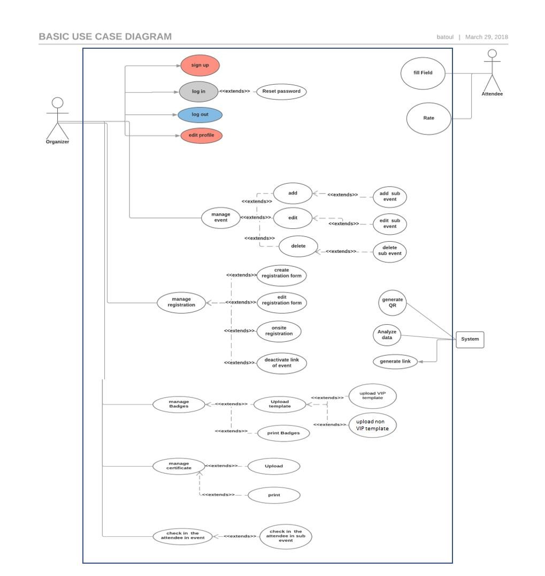**4.6** **USE CASE DIAGRAM:**

*Use Case diagram* :15*Figure*

**Use case:**

**Sign up Use Case: Use Case:**

Sign up.

**Actors:**

Event organizer.

**Purpose:**

To allow the organizer to sign up in the system.

**Type:**

Primary, Essential.

**Overview**

(Success Scenario):

The event organizer opens the system to create an account. The system asks

the organizer to enter specific information. The system validates the inputs and confirm the operation.

**Cross-reference:**

R1.

**Pre-condition:** none

|  |  |
| --- | --- |
| **Actor Action** | **System Response** |
| 1. This use case begins when the organizer wants to the sing up in the system. | 2. The system prompts user to enter registration information. |
| 3. The organizer enter the information (name, email, password, gender, DOB). | 4. The system validates inputs. |
|  | 5. The system verifies the user's email. |
|  | 6. The system creates an account and  confirms the registration. |
| **Alternative Course: Line 3.**  If the organizer chooses to cancel the request, then the account will not be generated in the system.  **Line 4.**  If an invalid input is entered, the system will display a message to prompt the organizer.  **Line 5.**  If the organizer enters an exist email the system shall prompt the organizer. | |

*Table 2: Sign up use case*

**login Use Case: Use Case:**

Login.

**Actors:**

Event Organizer.

**Purpose:**

To allow the organizer to login to the system and access its functions.

**Type:**

Primary, Essential.

**Overview**

(Success Scenario):

The organizer enters the login information to access the system. The system will verify the login information. If it is correct, then the system displays the organizer's home page. **Cross -reference:** R2.

**Pre-condition:** R1

|  |  |
| --- | --- |
| **Actor Action** | **System Response** |
| 1. This use case begins when the organizer wants to the log in in the system. | 2. The system prompts user to enter  Log in information. |
| 3. The organizer enter the information  (email, password). | 4. The system validates inputs. |
|  | 5. The system displays the organizer's home page. |
| **Alternative Course: Line 4.**  If an invalid input is entered, the system will display a message to prompt the organizer. | |

*Table 3: Login use case*

**Reset the password Use Case: Use Case:**

Reset the password.

**Actors**

Event Organizer.

**Purpose:**

To allow the organizer to reset the password in case he forgot it.

**Type:** Secondary. **Overview** (Success Scenario):

The organizer enters the email then the system will send email containing link to enter the new password.

**Cross -reference:** R3.

**Pre-condition:** R2

|  |  |
| --- | --- |
| **Actor Action** | **System Response** |
| 1. This use case begins when the organizer wants to reset his password. | 2. The system will prompt the organizer to enter the email. |
|  | 3. The system validates inputs. |
|  | 4. The system will send email to the user containing link to enter the new password. |
| 5. the organizer enter the new password. | 6.The system will validate the new password |
| **Alternative Course: Line 3.**  If an invalid email is entered, the system will display a message to prompt the organizer.  **Line 5.**  If an invalid password is entered, the system will display a message to prompt the organizer. | |

*Table 4: Reset password use case*

**Edit profile Use Case:**

**Use Case:**

Edit profile.

**Actors:**

Event Organizer.

**Purpose:**

To allow the organizer to edit his profile.

**Type:** Primary. **Overview** (Success Scenario):

The organizer clicks on edit field then enter new information to edit his profile.

**Cross -reference:** R4.

**Pre-condition:** R2

|  |  |
| --- | --- |
| **Actor Action** | **System Response** |
| 1. This use case begins when the organizer wants to the edit his profile. | 2. The system prompts user to enter  new information (name, password, phone number) in fields. |
| 3. The organizer enter the information. | 4. The system validates inputs. |
| 5.the organizer choose save option. | 6. The system update the organizer's profile. |
|  | 7. The system confirms organizer that update process done successfully. |
| **Alternative Course: Line 4.**  If an invalid input is entered, the system will display a message to prompt the organizer. | |

*Table 5: Edit profile use case*

**Manage Event Use Case:**

**Use Case:**

Manage Event.

**Actors:**

Event Organizer.

**Purpose:**

To allow the organizer to manage event/sub event.

**Type:**

Primary, essential.

**Overview**

(Success Scenario):

The organizer chooses one of process (add, delete, edit) event/sub event.

**Cross -reference:** R5.

**Pre-condition:** R2.

|  |  |
| --- | --- |
| **Actor Action** | **System Response** |
| 1. This use case begins when the organizer wants to the mange event/sub event. |  |
| 2. The organizer choose process:  a. Add event b. Edit event  c. Delete event  d. Add sub event e. Edit sub event  f. Delete sub event |  |

**Section: Add event**

|  |  |  |
| --- | --- | --- |
| 1. The organizer choose to add event. | 2. The system prompts user to enter  Information of event. | |
| 3. The organizer enter the information (event name, email, description, Date, Location,  organization company Name, Max Number of  Attendee). | 4. The system validates inputs. | |
| 5. the organizer choose to add option. | 6. The system add event. | |
|  | 7. The system confirms organizer that add event/sub event process done successfully. | |
| **Alternative Course: Line 4.**  If an invalid input is entered, the system will display a message to prompt the organizer. | |  |

**Section: Edit event**

|  |  |
| --- | --- |
| 1. the organizer choose to edit event option. | [2. display e](https://www.dropbox.com/referrer_cleansing_redirect?hmac=SSewUnRF00T%2BiNdJUS%2FnHplAK0wfVTCum3U4lySFlVs%3D&url=http%3A%2F%2F2.display)dit event page that contain list of events. |
| 3.The organizer select an event | 4. The system prompts user to enter  Information of event to be edit. |
| 5. The organizer enter new information (event name, email, description, Date, Location, organization company Name, Max Number of Attendee). | 6. The system validates inputs. |
| 7. the organizer choose to edit option. | 8. The system edit event. |
|  | 9. The system confirms organizer that edit  Event process done successfully. |
| **Alternative Course: Line 6.**  If an invalid input is entered, the system will display a message to prompt the organizer. | |

**Section Delete event**

|  |  |
| --- | --- |
| 1. The organizer choose delete event. | 2. Display delete event page that  contain list of events. |
| 3. The organizer select an event. |  |
| 4. The organizer choose delete option. | 5.The system ask organizer if he wants to  delete the event. |
|  | 6. The system delete event. |
|  | 7. The system confirms organizer that  delete event process done successfully. |

**Section: Add sub event**

|  |  |
| --- | --- |
| 1. The organizer choose to add sub event. | 2. The system prompts user to enter  Information of event. |
| 3. The organizer enter the information (sub event name and description). | 4. The system validates inputs. |
|  | 5. The system add sub event. |
| 6. the organizer choose to add option. | 7. The system confirms organizer that add sub event process done successfully. |

**Alternative Course: Line 4.**

If an invalid input is entered, the system will display a message to prompt the organizer

**Section: edit sub event**

|  |  |
| --- | --- |
| 1. the organizer choose to edit sub event option. | [2. display e](https://www.dropbox.com/referrer_cleansing_redirect?hmac=SSewUnRF00T%2BiNdJUS%2FnHplAK0wfVTCum3U4lySFlVs%3D&url=http%3A%2F%2F2.display)dit sub event page that contain list of sub events. |
| 3.The organizer select sub event | 4. The system prompts user to enter  Information of sub event to be edit. |
| 5. The organizer enter new information (sub event name and description). | 6. The system validates inputs. |
| 7. the organizer choose to edit option. | 8. The system edit sub event. |
|  | 9. The system confirms organizer that edit  Sub event process done successfully. |
| **Alternative Course: Line 6.**  If an invalid input is entered, the system will display a message to prompt the organizer. | |

**Section Delete sub event**

|  |  |
| --- | --- |
| 1. The organizer choose delete sub event. | 2. Display delete sub event page that  contain list of events. |
| 3. The organizer select sub event. |  |
| 4. The organizer choose delete option. | 5.The system ask organizer if he wants to  delete the sub event. |
|  | 6. The system delete sub event. |
|  | 7. The system confirms organizer that  delete sub event process done successfully. |

*Table 6: Manage Event use case*

**Manage prizes Use Case: Use Case:**

Manage prizes.

**Actors:**

Event Organizer.

**Purpose:**

To allow the organizer to manage prizes.

**Type:** Secondary. **Overview** (Success Scenario):

The organizer will manage the prize (add, edit and delete choose a winner) from the attendee.

**Cross -reference:** R6.

**Pre-condition:** R2, R5.

|  |  |
| --- | --- |
| **Actor Action** | **System Response** |
| 1. This use case begins when the organizer wants to manage prize to event or sub event. |  |
| 2. The organizer choose process:  a. Add prize b. Edit prize  c. Delete prize  d. Choose winner |  |

**Section Add prize**

|  |  |
| --- | --- |
| 1. The organizer choose to add a prize. | 2.Display add prize page that contain list of event/sub event |
| 3.The organizer select event/sub event. | 4. The system will prompt the organizer to  enter number and name of prize. |
| 5.The organizer enter the information (name, number). | 6.The system will check if all fields are filled |
| 7. the organizer choose add option. | 8. The system will indicate that the prize  added successfully. |
| **Alternative Course: Line 6.** | |

**Section Edit prize.**

|  |  |
| --- | --- |
| 1. The organizer choose to edit prize of event or sub event. | 2. Display edit prize page that contain list of  event/sub event |
| 3.The organizer select event/sub event | 4.The system will prompt the organizer to  enter new name and number of prize to be edit. |
| 5.The organizer enter the information (name, number) | 6.The system will check if all fields are filled |
| 7. The organizer choose edit option. | 8. The system will indicate that the prize  edited successfully |
| **Alternative Course: Line 6.**  If all fields are not filled, the system will display a message to prompt the organizer. | |

**Section: Delete prize.**

|  |  |
| --- | --- |
| 1. The organizer choose to delete prize of event or sub event. | 2. Display delete prize page that contain list  of event/sub event |
| 3.The organizer select event/sub event | 4.Display prize belong to selected event/sub event. |
| 5.The organizer select prize to delete. | 6.Display information about selected prize (name, number). |
| 7. The organizer choose delete option. | 8.The system ask organizer if he sure to  delete the event/ sub event. |
| 9.Organizer choose OK. | 10.The system will delete the prize. |

**Section: choose winner.**

|  |  |
| --- | --- |
| 1.The organizer choose winners of event  and sub event. | 2. Display Choose winners page that contain list of event/sub event |
| 3.The organizer select event. | 4.Display prize belong to selected event/sub event. |
| 5.The organizer choose "choose winners" option. | 6.the system randomly select the winners. |
|  | 7.the system display list of winners. |
| 8.The organizer choose send mail to winners  Option. | 9.the system send emails for winners. |
|  | 10.display confirm message that email sent successfully. |

*Table 7: Manage prize use case*

**Manage badges Use Case: Use Case:**

Manage badges.

**Actors:**

Event Organizer, attendee, mobile Application.

**Purpose:**

To allow the organizer to manage badges.

**Type:**

Primary, essential.

**Overview**

(Success Scenario):

the organizer shall be able to (upload, send and print) the badge, also he will be able to scan the barcode on the badges to collect information about the attendee.

**Cross -reference:** R7.

**Pre-condition:** R2, R5

|  |  |
| --- | --- |
| **Actor Action** | **System Response** |
| 1. This use case begins when the organizer wants to manage badges. |  |
| 2. The organizer choose process:  a. add badges. b. Edit badges.  c. Delete badges. |  |

**Section: add badges**

|  |  |
| --- | --- |
| 1. This use case begins when the organizer wants to upload the badge template. | 2.display add page that contain list of events. |
| 3. The organizer select an event. |  |
| 4. The organizer upload the templates for VIP  and normal people. | 5.display badge template. |
| 6.The organizer choose save option. | 7.The system confirms organizer that badge has been uploaded successfully. |

**Section: edit badges.**

|  |  |
| --- | --- |
| 1. This use case begins when the organizer wants to edit the badge template. | 2.display edit page that contain list of events. |
| 3. The organizer select an event. |  |

|  |  |
| --- | --- |
| 4.The organizer edit templates for VIP and normal people. | 5.display badge template. |
| 6.The organizer choose save option. | 7.The system confirms organizer that badge has been uploaded successfully. |

**Section: delete badges.**

|  |  |
| --- | --- |
| 1. This use case begins when the organizer wants to delete the badges. | 2.display delete page that contain list of events. |
| 3. The organizer select an event. |  |
| 4.The organizer select the templates for VIP  and normal people. | 5.display badge template. |
| 6. The organizer choose delete option. | 7. The system ask organizer if he sure to delete badge. |
| 8. The organizer choose save option. | 9.The system confirms organizer that delete process done successfully. |
| **Alternative Course: Line 8.**  If organizer choose "Cancel" and the system will do nothing. | |

*Table 8: Manage badges use case*

**Manage certificates Use Case: Use Case:**

Manage certificates

**Actors:**

Event Organizer.

**Purpose:**

To allow the organizer to manage certificates.

**Type:** Secondary. **Overview** (Success Scenario):

the organizer shall be able to manage the certificates.

**Cross -reference:** R8.

**Pre-condition:** R2, R5.

|  |  |
| --- | --- |
| **Actor Action** | **System Response** |
| 1. This use case begins when the organizer wants to manage certificates. |  |
| 2. The organizer choose process:  a. Add certificates. b. Edit certificates.  c. Delete certificates. |  |

**Section: add certificates**

|  |  |
| --- | --- |
| 1. This use case begins when the organizer wants to upload the certificates. | 2.display add page that contain list of events. |
| 2. The organizer select an event. |  |
| 3. The organizer upload the certificates. | 4.display certificate template. |
| 5. The organizer choose to save. | 6. The system confirms organizer that certificate has been uploaded successfully. |

**Section: edit certificates.**

|  |  |
| --- | --- |
| 1. This use case begins when the organizer wants to edit the certificates. | 2.The system display edit page that contain list of events. |
| 3. The organizer select an event. |  |
| 4.The organizer edit certificates. | 5.The system display certificate template. |
| 6.The organizer choose to save. | 7.The system confirms organizer that certificate has been uploaded successfully. |

**Section: delete certificate.**

|  |  |
| --- | --- |
| 1. This use case begins when the organizer wants to delete the certificate. | 2.The system display delete page that contain list of events. |
| 3. The organizer select an event. |  |
|  | 4.The system display certificate template. |
| 5. The organizer choose delete option. | 6. The system ask organizer if he sure to delete certificate. |
| 7.The organizer choose on OK. | 8.The system confirms organizer that delete process done successfully. |
| **Alternative Course: Line 8.**  If organizer choose "Cancel" and the system will do nothing. | |

Table 9: Manage certificates use case

**Manage registration Use Case: Use Case:**

Manage registration.

**Actors:**

Event Organizer.

**Purpose:**

To allow the organizer to Manage registration form.

**Type:**

Primary, essential.

**Overview**

(Success Scenario):

The organizer will manage the registration form

**Cross -reference:** R9.

**Pre-condition:** R2, R5.

|  |  |
| --- | --- |
| **Actor Action** | **System Response** |
| 1. This use case begins when the organizer wants to manage registration process. |  |
| 2. The organizer choose process:  a. Create register form. b. Edit the register form  c. Deactivate the generated link d. Delete register form. |  |

**Section: create register form.**

|  |  |
| --- | --- |
| 1. This use case begins when the organizer wants to create register form. |  |
| 2. The organizer choose create option. | 3.The system display create register form  page. |
| 4. The organizer select attribute of the from  (name, email, phone, Age, sex, education level, career, nationality, ID, VIP code ). |  |
| 5. The organizer select which required field |  |
| 6. The organizer enter length of the field |  |
| 7. The organizer choose create register form  option. | 8.The system generate link for the event  and VIP code if was selected |

**Section: edit register form.**

|  |  |
| --- | --- |
| 1. This use case begins when the organizer wants to edit the register form. |  |
| 2. The organizer choose edit register form option. | 3.The system display edit register form page. |
| 4. The organizer select attribute of the from (name, email, phone, Age, sex, education level, career, nationality, ID, VIP code ). |  |
| 5. The organizer edit which required field |  |
| 6. The organizer enter length of the field |  |
| 7.The organizer choose edit register form option. | 8. The system confirms organizer that edit register successfully |
| **Alternative Course: Line 6.**  If Organizer choose VIP field, the system should generate VIP code. | |

**Section: deactivate the generated link.**

|  |  |
| --- | --- |
| 1. This use case begins when the organizer wants to deactivate the generated link. |  |
| 2. The organizer choose deactivate link option. | 3.The system ask organizer if he sure to  deactivate the link. |
| 4.The organizer choose OK. | 5.The system confirms organizer that  deactivate link process done successfully. |
| **Alternative Course: Line 4.**  If organizer choose "Cancel" option and the system will do nothing. | |

**Section: Delete register form.**

|  |  |
| --- | --- |
| 1. This use case begins when the organizer  wants to delete register form. | 2.The system ask organizer if he sure to  delete register form. |
| 3.The organizer choose OK. | 4.The system confirms organizer that delete process done successfully. |
| **Alternative Course: Line3.**  If organizer choose "Cancel" and the system will do nothing. | |

*Table 10: Manage registration use case*

**Attendee Registration Use Case: Use Case:**

Attendee registration.

**Actors:** attendee. **Purpose:**

To allow the attendee to register in event.

**Type:** Primary. **Overview** (Success Scenario):

The attendee clicks on registration link of event to register.

**Cross -reference:** R10.

**Pre-condition:** R5, R9.

|  |  |
| --- | --- |
| **Actor Action** | **System Response** |
| 1. This use case begins when the attendee wants to register in event. |  |
| 2.The attendee opens the link of event. | 3.the system will display attendee registration page. |
| 4.The attendee enter his information (name, email, phone, Age, sex, education level, career, nationality, ID, VIP code ). |  |
| 5. The organizer choose register option. | 6.The system confirms attendee that register has been successfully. |
|  | 7.the system send email to attendee contain badge. |

*Table 11: Attendee Registration Use Cas*

**Send email Use Case: Use Case:**

Send email.

**Actors:**

Event Organizer.

**Purpose:**

To allow the organizer to send email to the registered people.

**Type:** Primary. **Overview** (Success Scenario):

The organizer clicks on send email to contact and notify the registered people.

**Cross -reference:** R11.

**Pre-condition:** R2, R5, R9, R10.

|  |  |
| --- | --- |
| **Actor Action** | **System Response** |
| 1. This use case begins when the organizer wants to send email. |  |
| 2. The organizer choose send email option to send email. | 3.the system will display send email’s  page. |
| 4.The organizer enter information about email (receiver, the time of sending, type of message, name of event, title, body of message). |  |
| 5. The organizer choose send email option. | 6.The system confirms organizer that email has been sent successfully. |

*Table 12: send email use case*

**Check in the attendee by scanning their barcode Use Case: Use Case:**

Check in the attendee by scanning their barcode.

**Actors:**

Event Organizer.

**Purpose:**

To allow the organizer to scan barcode.

**Type:**

Primary, essential.

**Overview**

(Success Scenario):

the organizer shall be able to scan the barcode on the badges to collect information about the attendee.

**Cross -reference:** R12

**Pre-condition:** R2, R5, R7, R9.

|  |  |
| --- | --- |
| **Actor Action** | **System Response** |
| 1. This use case begins when the organizer  wants to scan attendee’s barcode. |  |
| 2. the organizer choose to scan barcode. | 3. the system retrieves the information of attendee from the barcode. |
|  | 4.The system confirms organizer that can barcode successfully. |
|  | 5.The system display to organizer 3 choices "print, cancel, new scan". |
| 6. the organizer select option "print" option. |  |
|  | 8.The system confirms organizer that scan barcode successfully. |
| **Alternative Course: Line 6.**  If organizer choose "Cancel" and the system will do nothing. | |

*Table 13: Check in the attendee use case*

**Manage track Use Case:**

**Use Case:** Manage track **Actors:**

Event Organizer.

**Purpose:**

To allow the organizer to manage tracking attendee.

**Type:** Secondary. **Overview**

(Success Scenario):

the organizer shall be able to manage the track.

**Cross -reference:** R13.

**Pre-condition:** R2, R5, R9

|  |  |
| --- | --- |
| **Actor Action** | **System Response** |
| 1. This use case begins when the organizer wants to manage the track. |  |
| 2. The organizer choose process:  a. event arrangements. a.1 print certificate. a.2 print badges.  b. track event.  b.1 onsite registration. b.2 print badges.  c. track sub event. |  |

**Section: event arrangements (print certificate)**

|  |  |
| --- | --- |
| 1. This use case begins when the organizer clicks event arrangements option. | 2.the system display event arrangements pages. |
| 3.the organizer choose print certificate. |  |
| 4. the organizer select type of registered. | 5. the system display list of registered people based on their selected type. |
| 6.the organizer choose who he wants to print their certificate. |  |
| 7. the organizer choose print event option. |  |

**Section: event arrangements (print badges)**

|  |  |
| --- | --- |
| 1. This use case begins when the organizer chooses event arrangements option. | 2.the system display event arrangements  pages. |
| 3.the organizer choose print badges. |  |
| 4. the organizer select type of registered. | 5. the system display list of registered people  based on their selected type. |
| 6.the organizer choose who he wants to print their badges. |  |
| 7. the organizer choose print event option. |  |

**Section: track event (onsite registration)**

|  |  |
| --- | --- |
| 1. This use case begins when the organizer chooses track event option. | 2.The system display track event page. |
| 3.the organizer choose onsite registration | 4.The system request attendee (email or phone). |
| 5. the organizer enters attendee (email or phone) |  |
| 6.the organizer choose register. | 7.The system register and track attendant. |
|  | 8.The system display pop message that registration was successfully |
| 9. the organizer chooses print option to print badges. |  |

**Section: track event (print badges)**

|  |  |
| --- | --- |
| 1. This use case begins when the organizer chooses track event option. | 2.The system display track event page. |
| 3. The organizer select event |  |
| 4.The organizer choose print badges | 5.The system request attendee (name, email, phone). |
| 6. The organizer enters attendee (name, email, phone) |  |
| 7.The organizer choose track | 8.The system track attendant. |
|  | 9.The system display message that track was successfully |
| 10. The organizer chooses print option to print badges. |  |

**Section: track sub event**

|  |  |
| --- | --- |
| 1. This use case begins when the organizer chooses track sub event option. | 2.The system display track sub event page. |
| 3.The organizer select subevent. |  |
|  | 4.The system request attendee phone. |
| 5. The organizer enters attendee phone. |  |
| 6.The organizer choose track. | 7.The system track attendant. |
|  | 8.The system display pop message that registration was successfully. |

*Table 14:Manage track use case*

**Rate Use Case: Use Case:**

Rate.

**Actors:** Attendee. **Purpose:**

Allow the attendee to rate event and sub event.

**Type:** Secondary. **Overview:** (Success Scenario):

the attendee will be able to rate the event or sub event by facing rate.

**Cross -reference:** R14.

**Pre-condition:** R13.

|  |  |
| --- | --- |
| **Actor Action** | **System Response** |
| 1. This use case begins when the attendee wants to rate event / sub event**.** | 2.The system will display rate’s page. |
| 2. The attendee choose one of face rate  (happy, normal, sad) option. |  |
| 3.The attendee choose rate option. | 4. The system will confirm the rate was successfully. |

Table 15: Rate use case

**Analyze the data Use Case: Use Case:**

Analyze the data.

**Actors:**

Event Organizer.

**Purpose:**

Allow the event organizer to analyze the data.

**Type:**

Primary, Essential.

**Overview:**

(Success Scenario):

The system will track the number of the registered and attendee people to analyze the data by the smiley rating faces.

**Cross -reference:** R15.

**Pre-condition:** R2, R5

|  |  |
| --- | --- |
| **Actor Action** | **System Response** |
| 1. This use case begins when the organizer wants to analysis data. | 2. The system track the number of the registered and attendee people in the event/sub event. |
| 3. If the organizer chooses statistical report. | 4. The system will display list of statistical attributes. |
| 5. the organizer select attribute (number of attendee for the event, number of attendee for sub  event, number of VIP, Age, sex, education level,  career, nationality). |  |
| 6. the organizer choose to view statistic. | 7.System display statistics on required. |

*Table 16: Analyze the data use case*

**Log out Use Case: Use Case:**

Log out.

**Actors:**

Event Organizer**.**

**Purpose:**

Allow the event organizer to Log out.

**Type:** Primary. **Overview:** (Success Scenario):

the organizer will be able to log out from system.

**Cross -reference:** R16.

**Pre-condition:** R2.

|  |  |
| --- | --- |
| **Actor Action** | **System Response** |
| 1. This use case begins when the organizer wants to log out from the system**.** |  |
| 2. The organizer choose on log out option. | 3. The system logging out the organizer. |

*Table 17: Log out use case*

4.7 **SEQUENCE DIAGRAMS:**

**SIGN UP:**

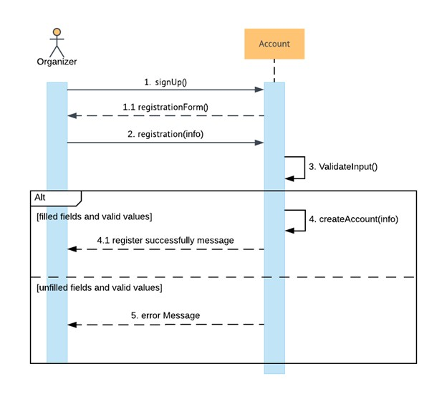

*Figure 16: Sign Up sequence*

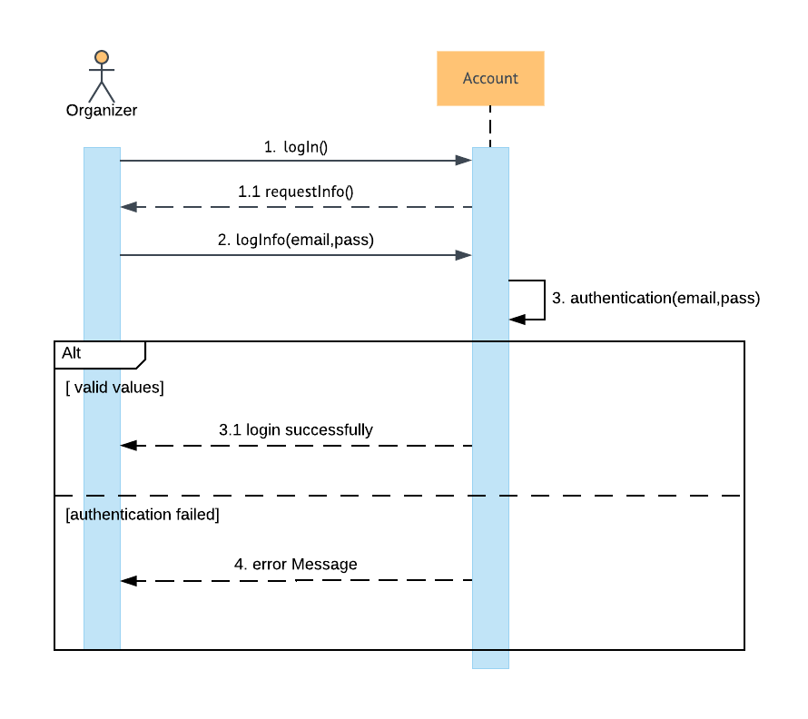

*Figure 17: Login sequence*

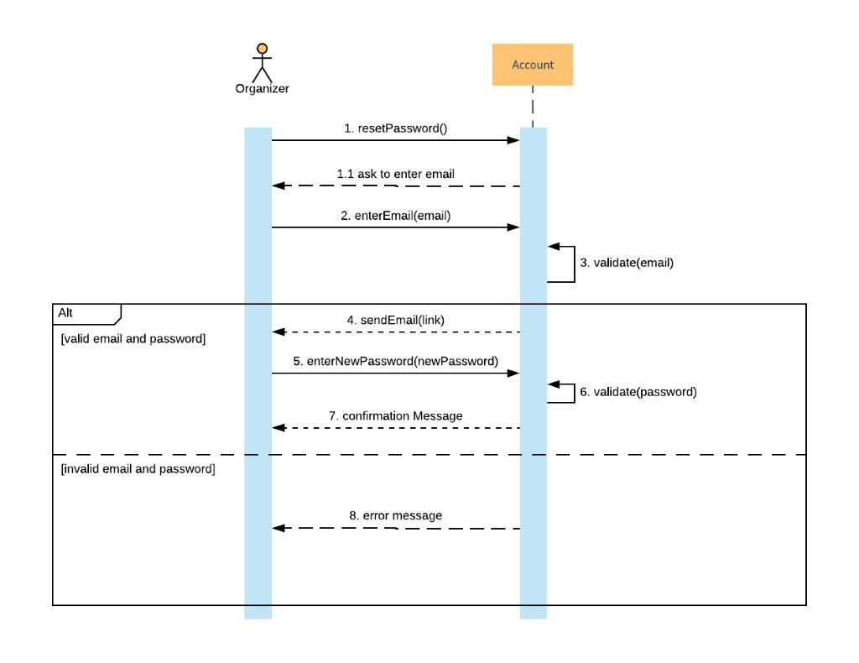

*Figure 18:Reset password sequence*

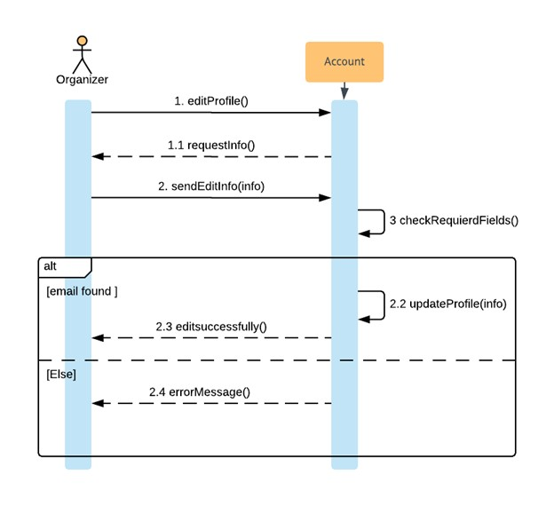

*Figure 19: Edit profile sequence*

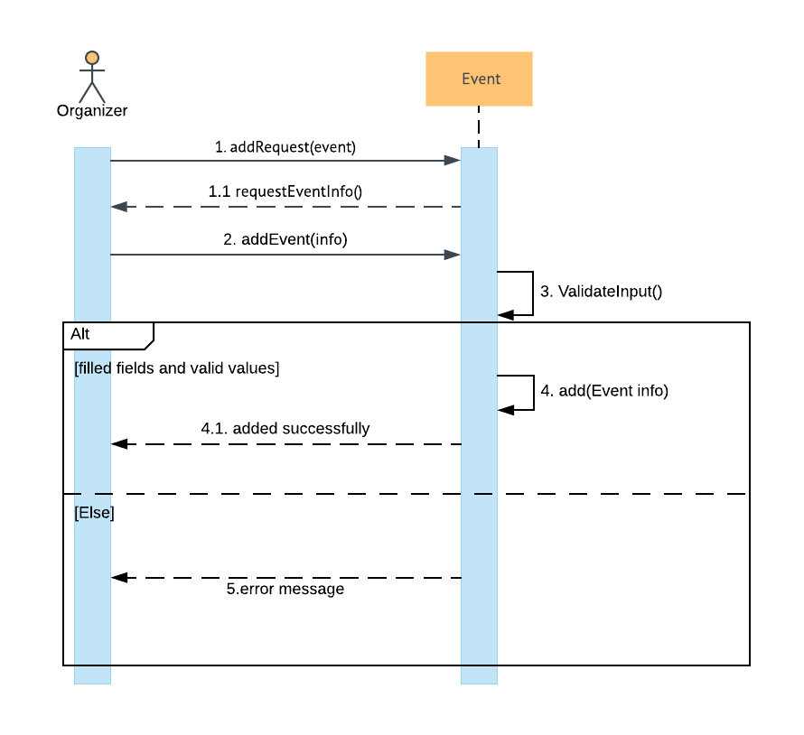

*Figure 20: Add event sequence*

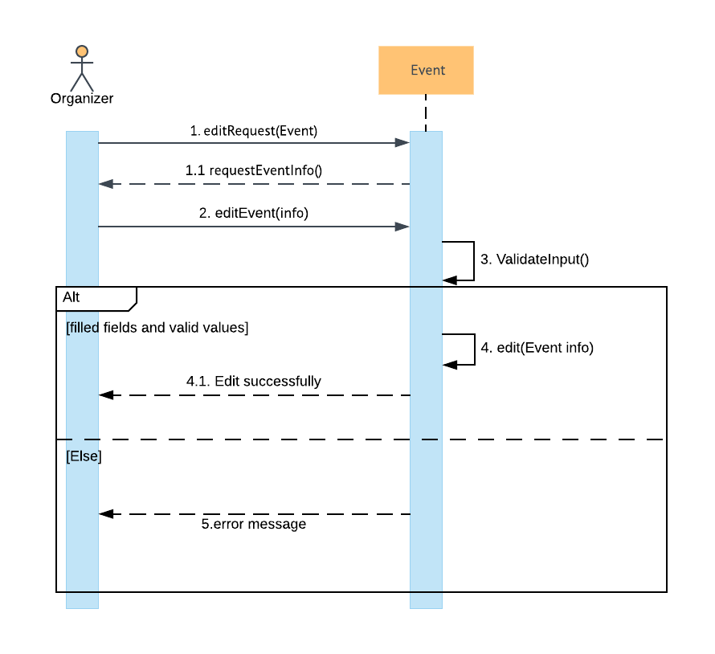

*Figure 21: Edit event sequence*

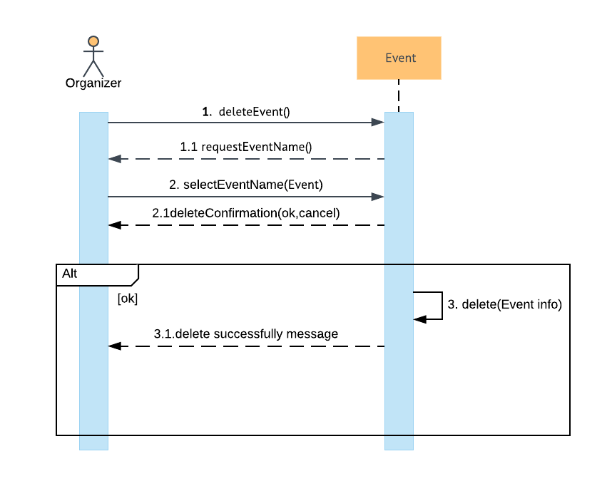

*Figure 22: Delete event sequence*

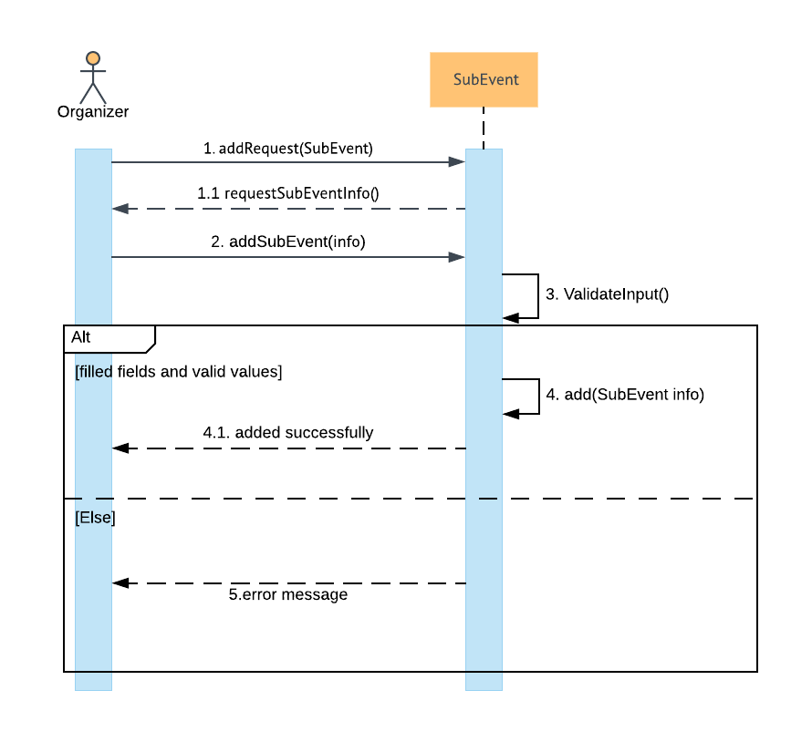

*Figure 23: Add sub event sequence*

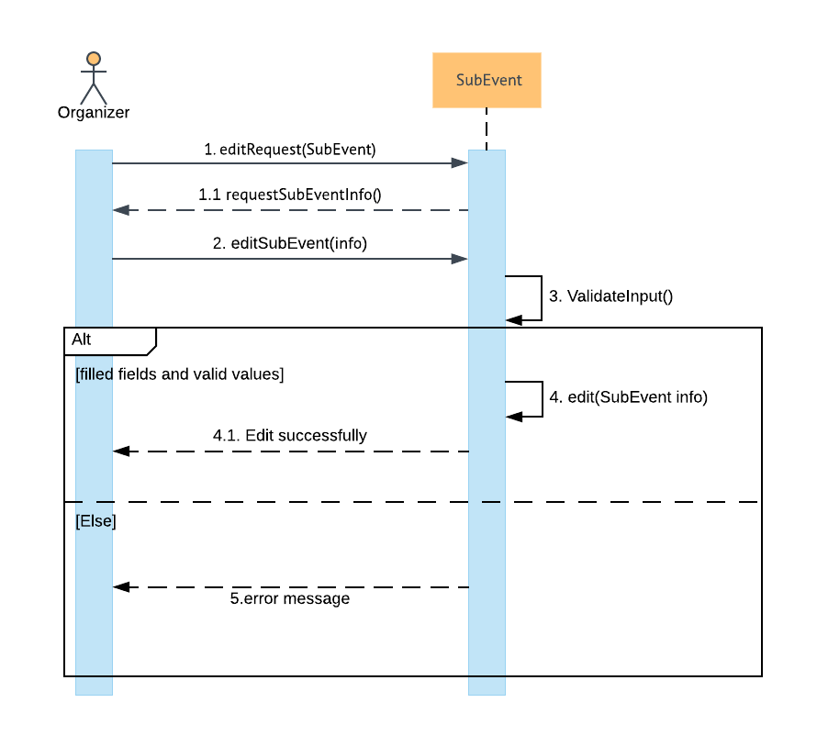

*Figure 24:Edit sub event sequence*

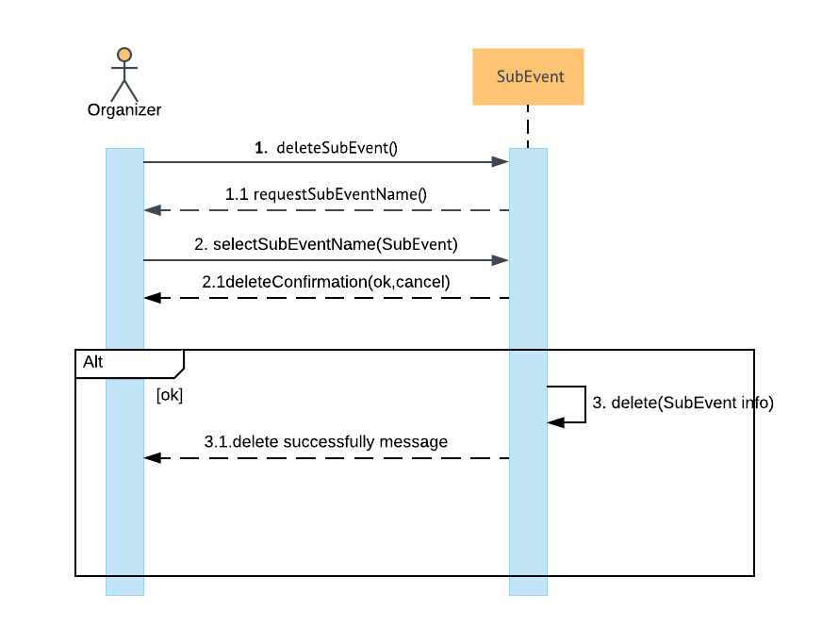

*Figure 25: Delete sub event sequence*

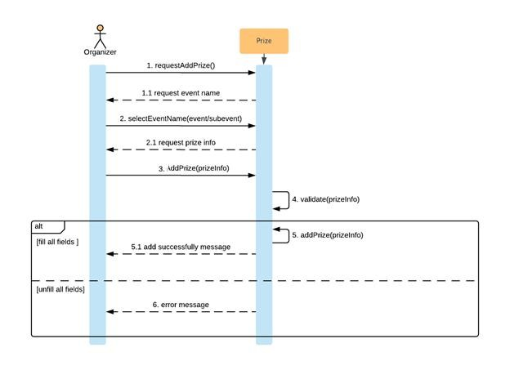

*Figure 26: add prize sequence*

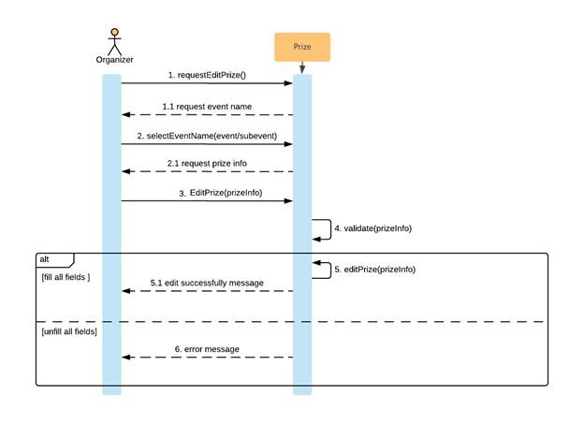

*Figure 27: Edit prize sequence*

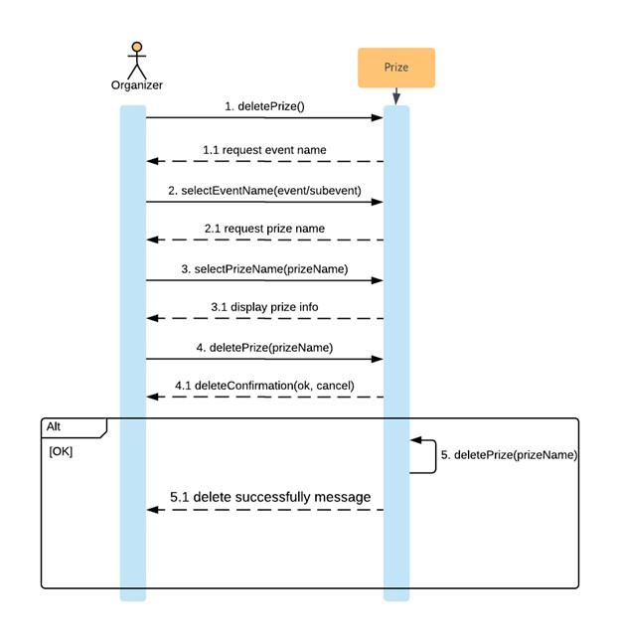

*Figure 28: Delete prize sequence*

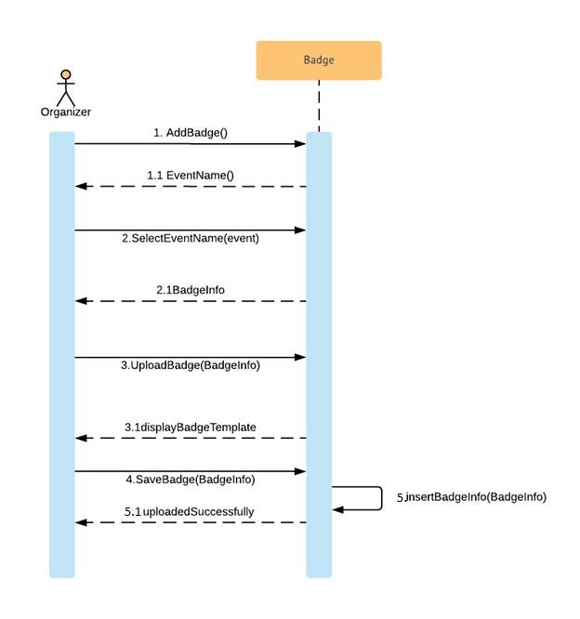

*Figure 29:Add badges sequence*

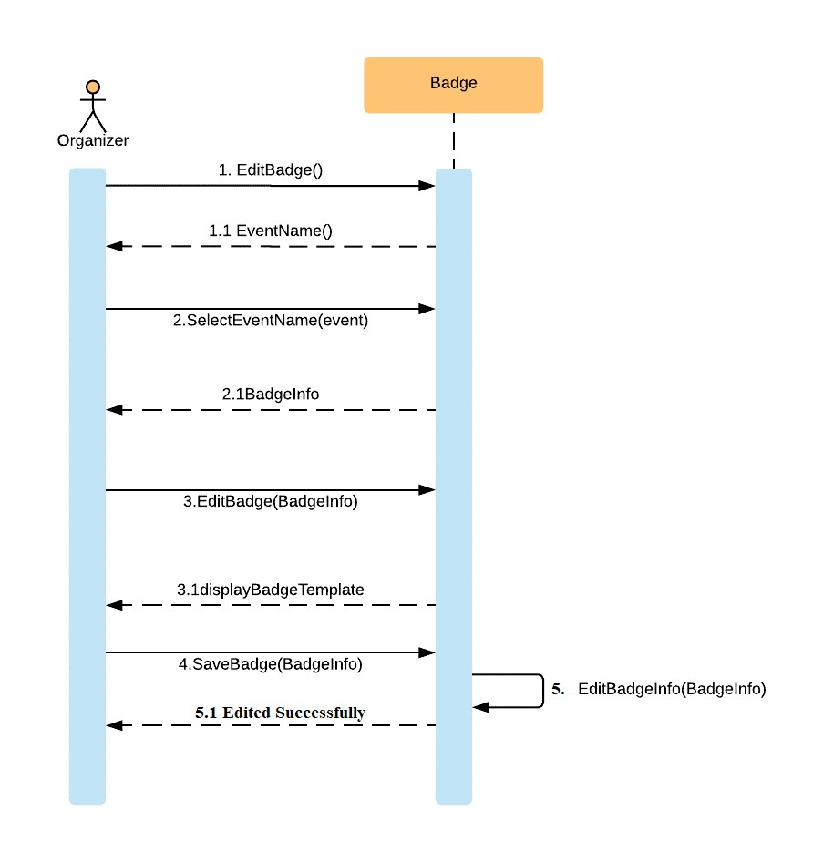

*Figure 30: Edit badges sequence*

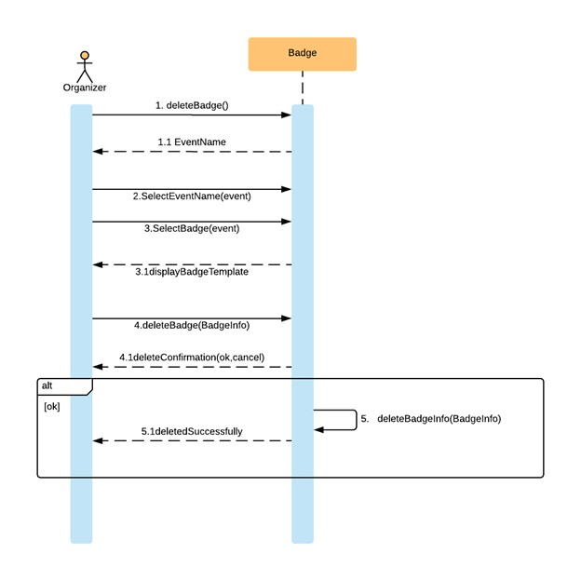

*Figure 31:Delete badges sequence*

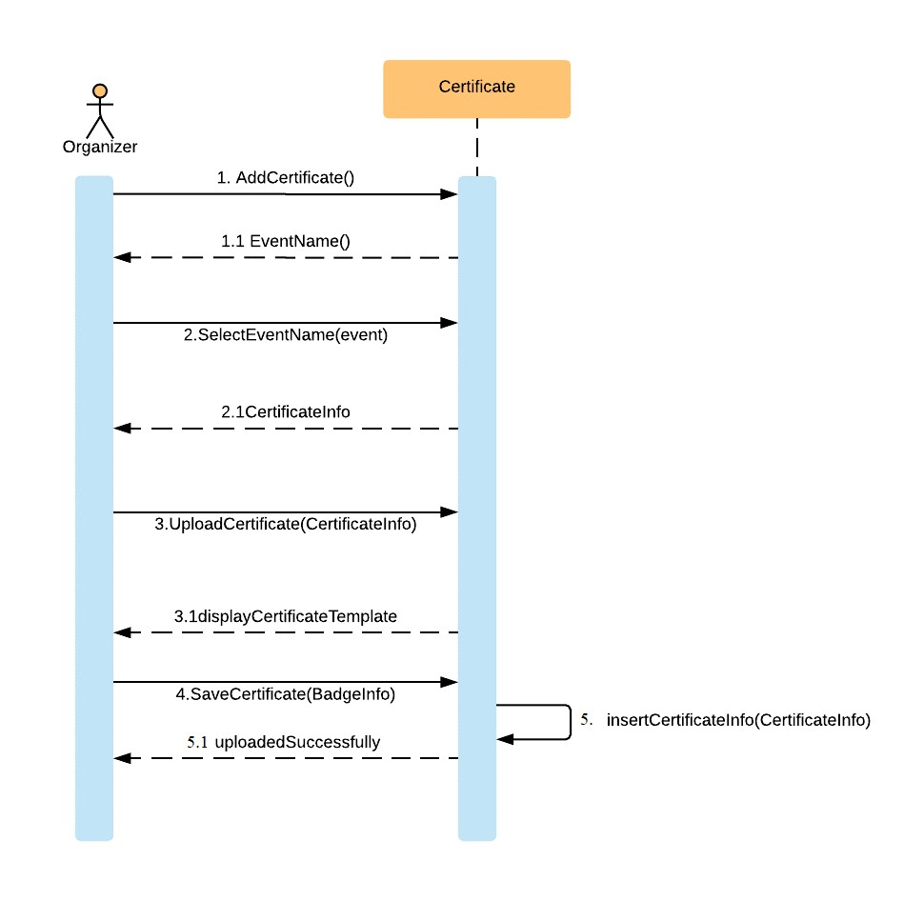

*Figure 32: Add certificate sequence*

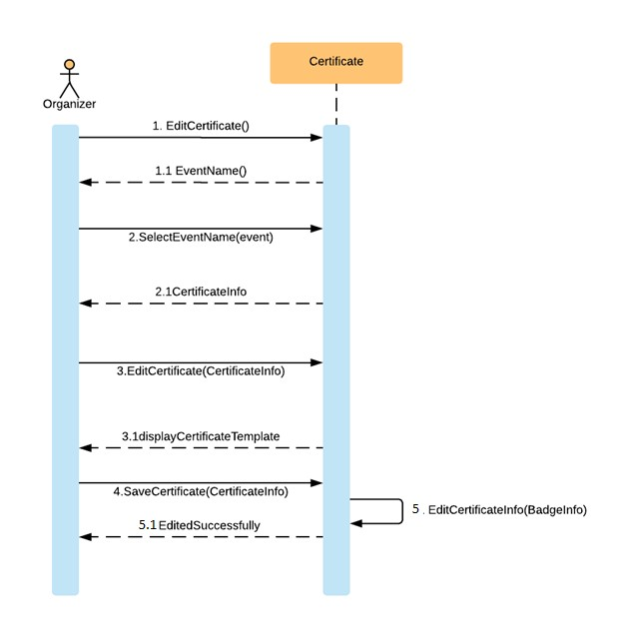

*Figure 33: Edit certificate sequence*

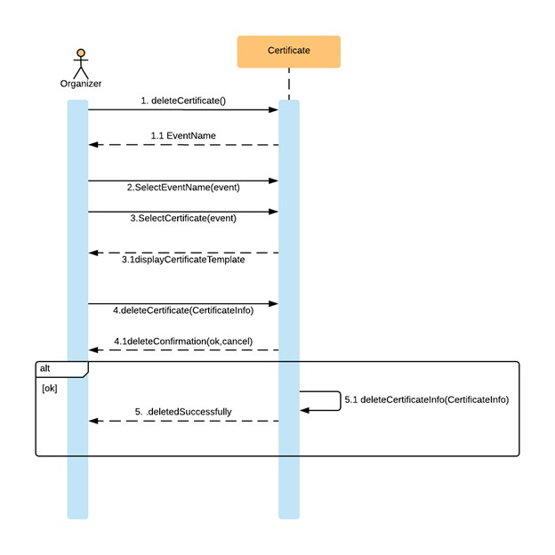

*Figure 34: Delete certificate sequence*

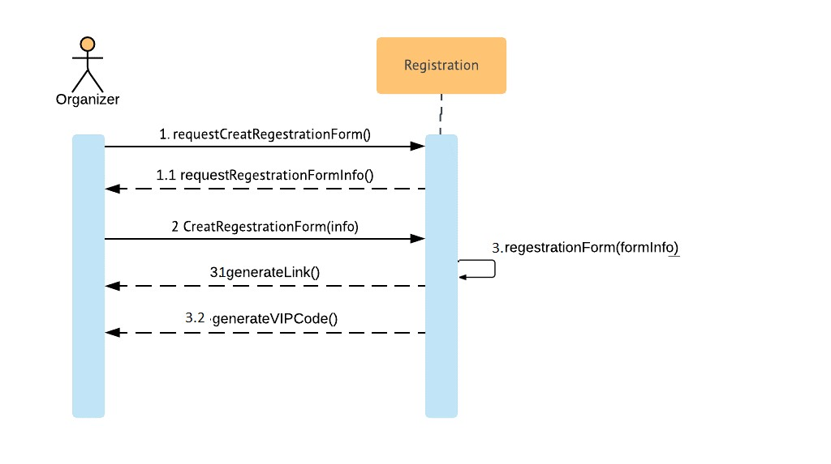

*Figure 35: Create register form sequence*

**EDIT REGISTER FORM:**

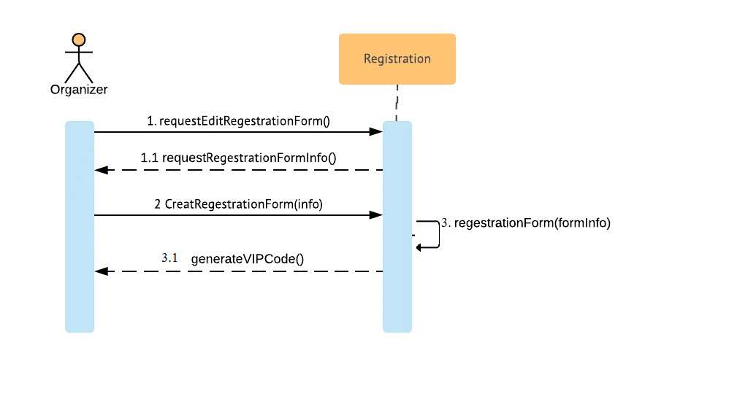

*Figure 36: Edit register form sequence*

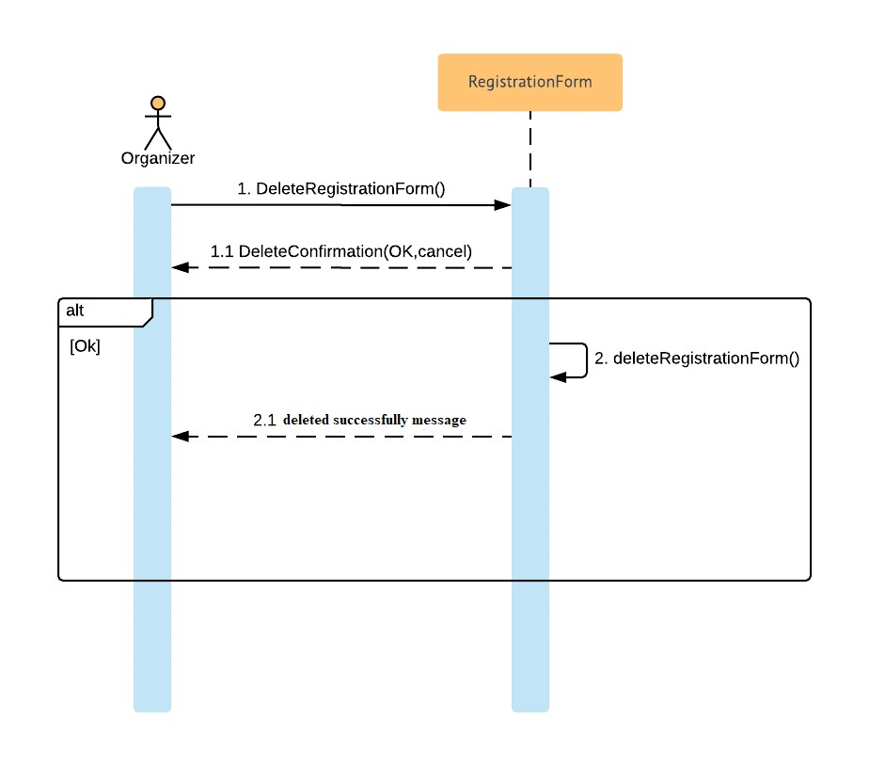

*Figure 37: Delete register form sequence*

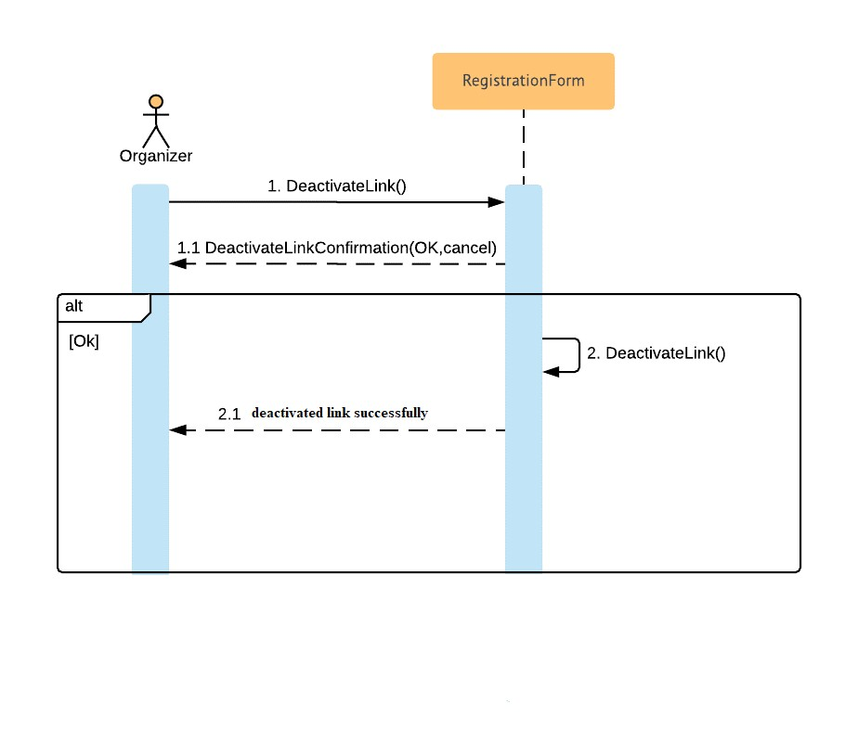

*Figure 38: Deactivate link sequence*

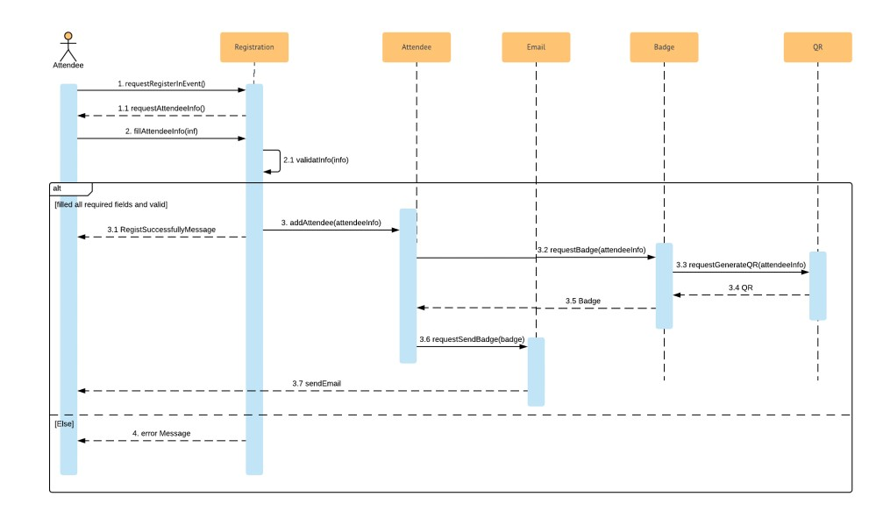

*Figure 39: Attendee registration sequence*

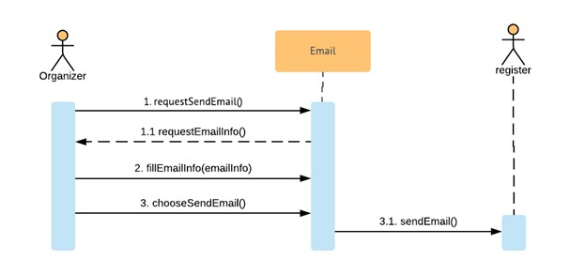

*Figure 40: Send email sequence*

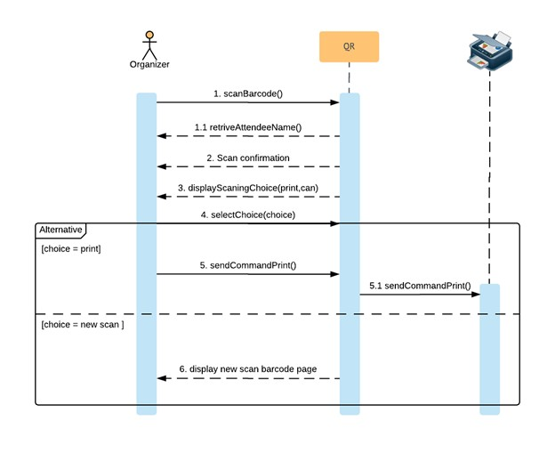

*Figure 41: Scan barcode sequence*

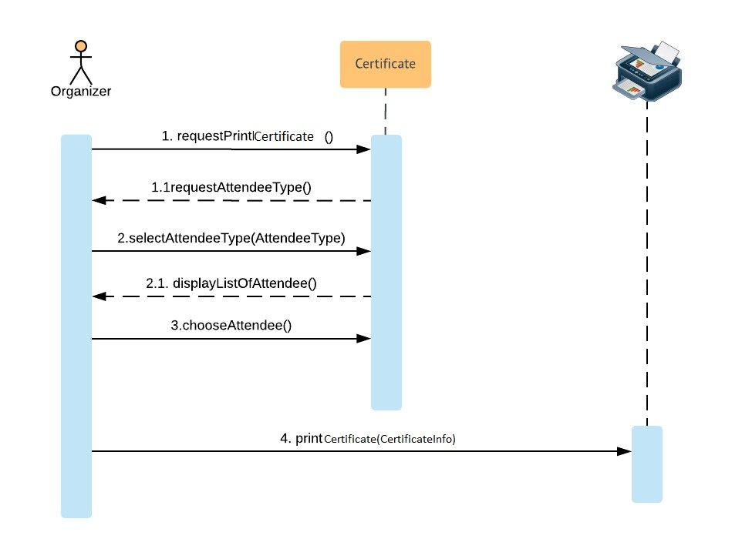

*Figure 42: Print certificate sequence*

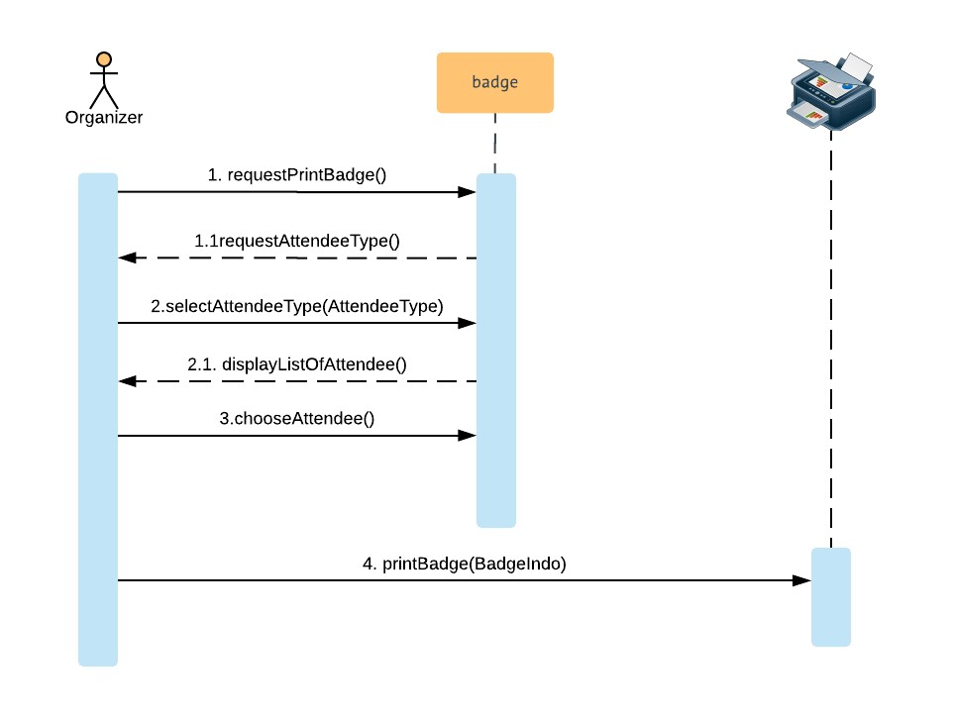

*Figure 43: Print badge sequence*

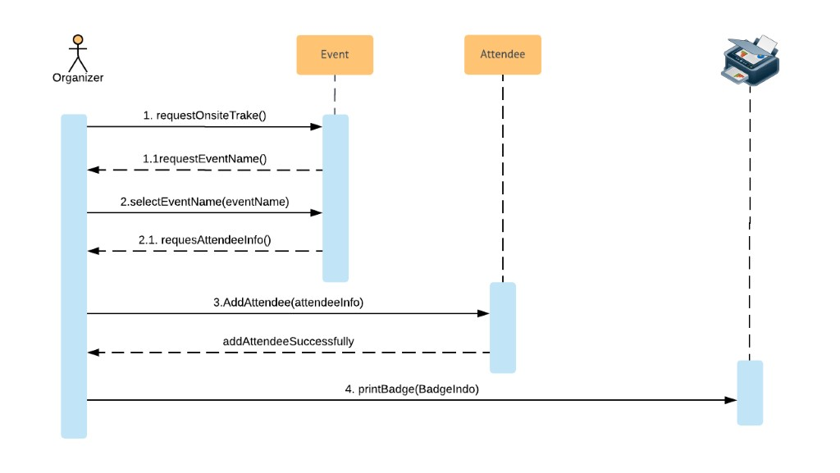

*Figure 44: Onsite registration sequence*

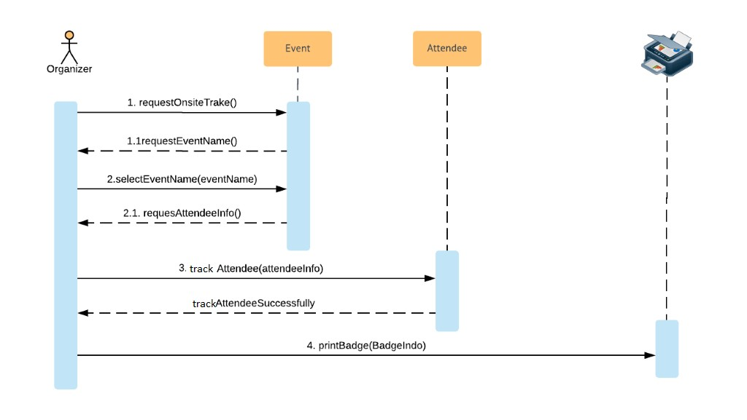

*Figure 45: Track and print sequence*

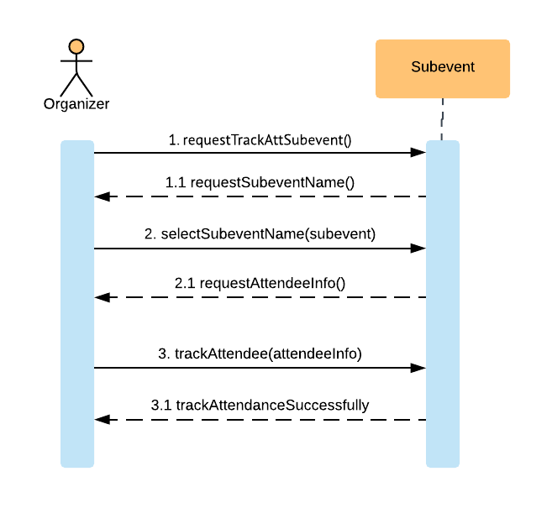

*Figure 46: Trak sub event sequence*

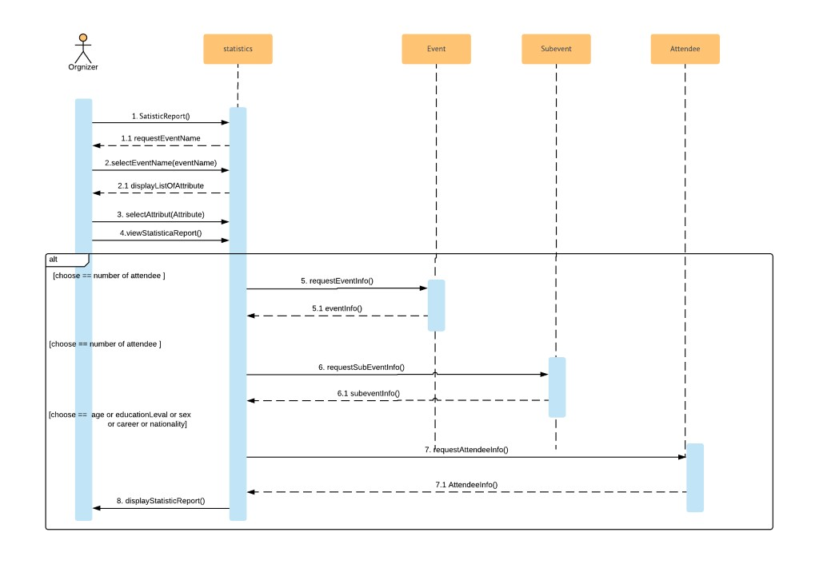

*Figure 47: Analysis data sequence*

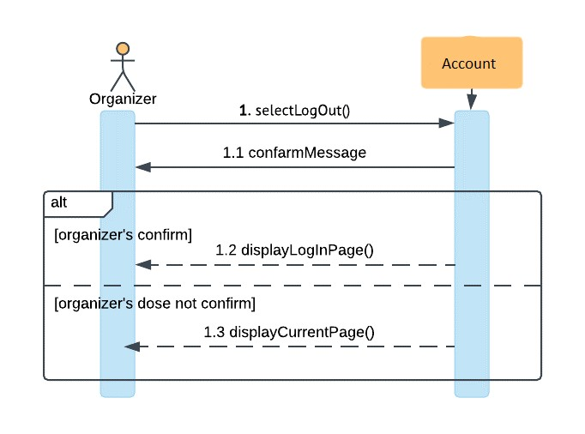

*Figure 48: log out: sequence*

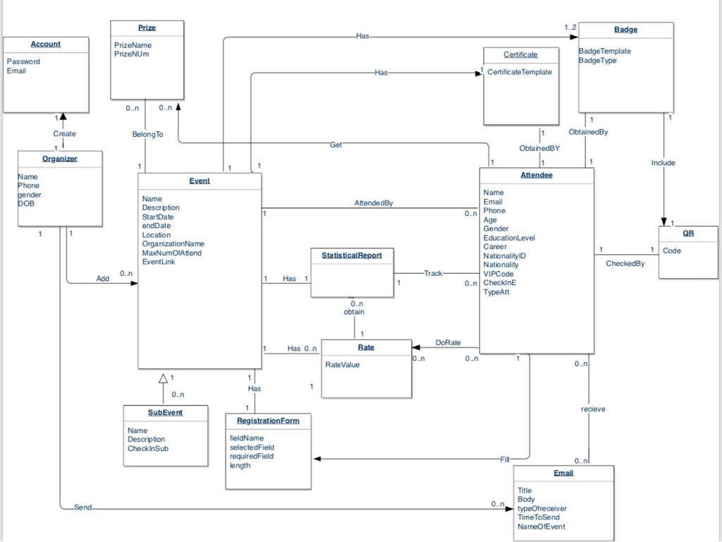

*Figure 49: Conceptual diagram*

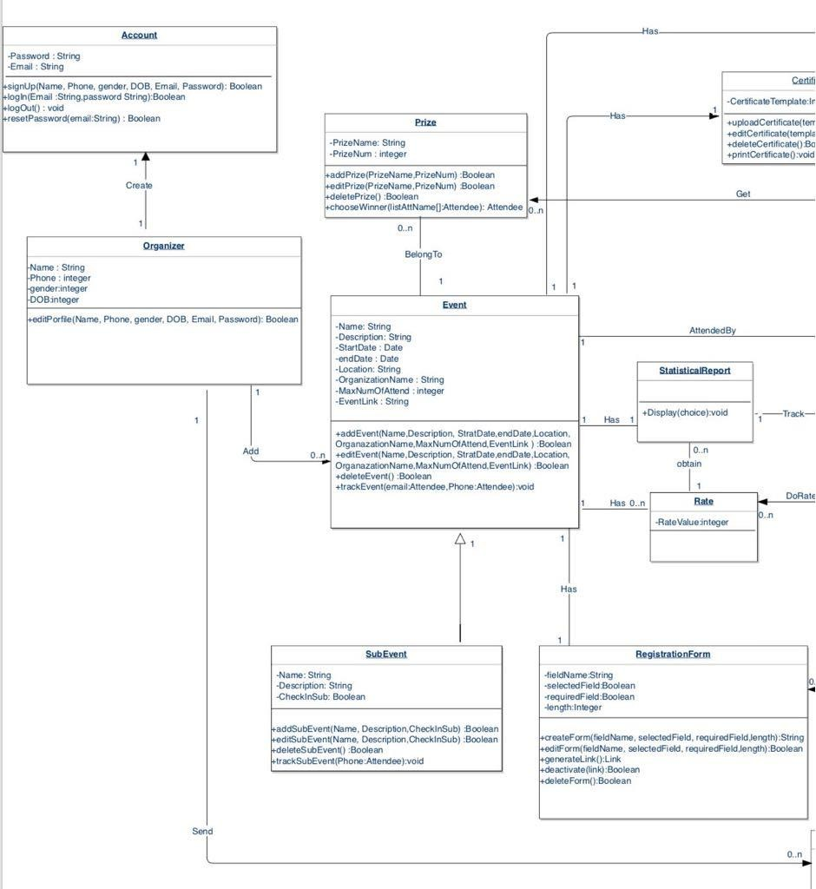

*Class diagram* :50*Figure*

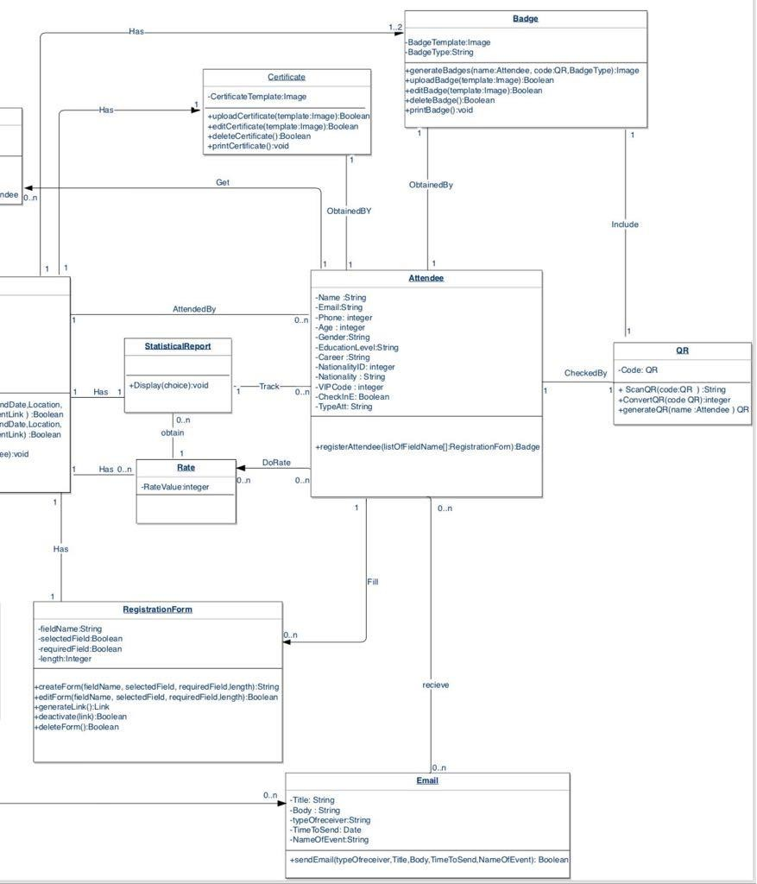

*Figure 51: Class diagram2*

94

4.10 **SUMMARY:**

This chapter is one of the most important parts of software development process.

It describes what the requirements and how the function will be work in system, detailed scenario of each action may organizer/attendee do in the system, it explain to the organizer/attendee each element and what its role in the system.

in addition to that this chapter illustrate non-functional requirements which mean constraints in system.

95

**CHAPTER5: SYSTEM DESIGN**

96

In this chapter, we will mention four sections to describe system design structure: System architectural section describe system organization style. Detailed system design section describes details and implantation of each Hierarchy diagram section describes the hierarchy of the system. Data design that show the entity relationship diagram, data schema, attribute dictionary, entity data dictionary and relationship data dictionary. Component design that will be presented using pseudo code. Finally, Interface Design

section describes user interfaces and illustrate in detail to show how the system will behave.

Many types of the architecture design are existing. each one of them specialized on many services. Our project includes many users and each user need to access the system from different location and simultaneously using the internet to achieve their requirements and needs.

"تكتيك" will follow the client-server architecture to achieve high efficient and simplifying updates data and software for future maintenance

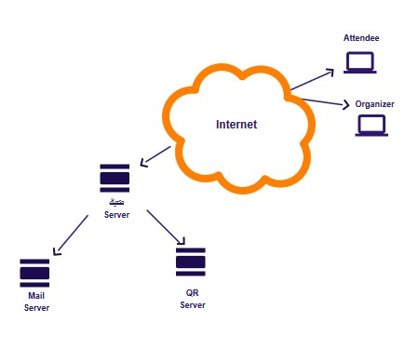

*Figure 52: Architecture design*

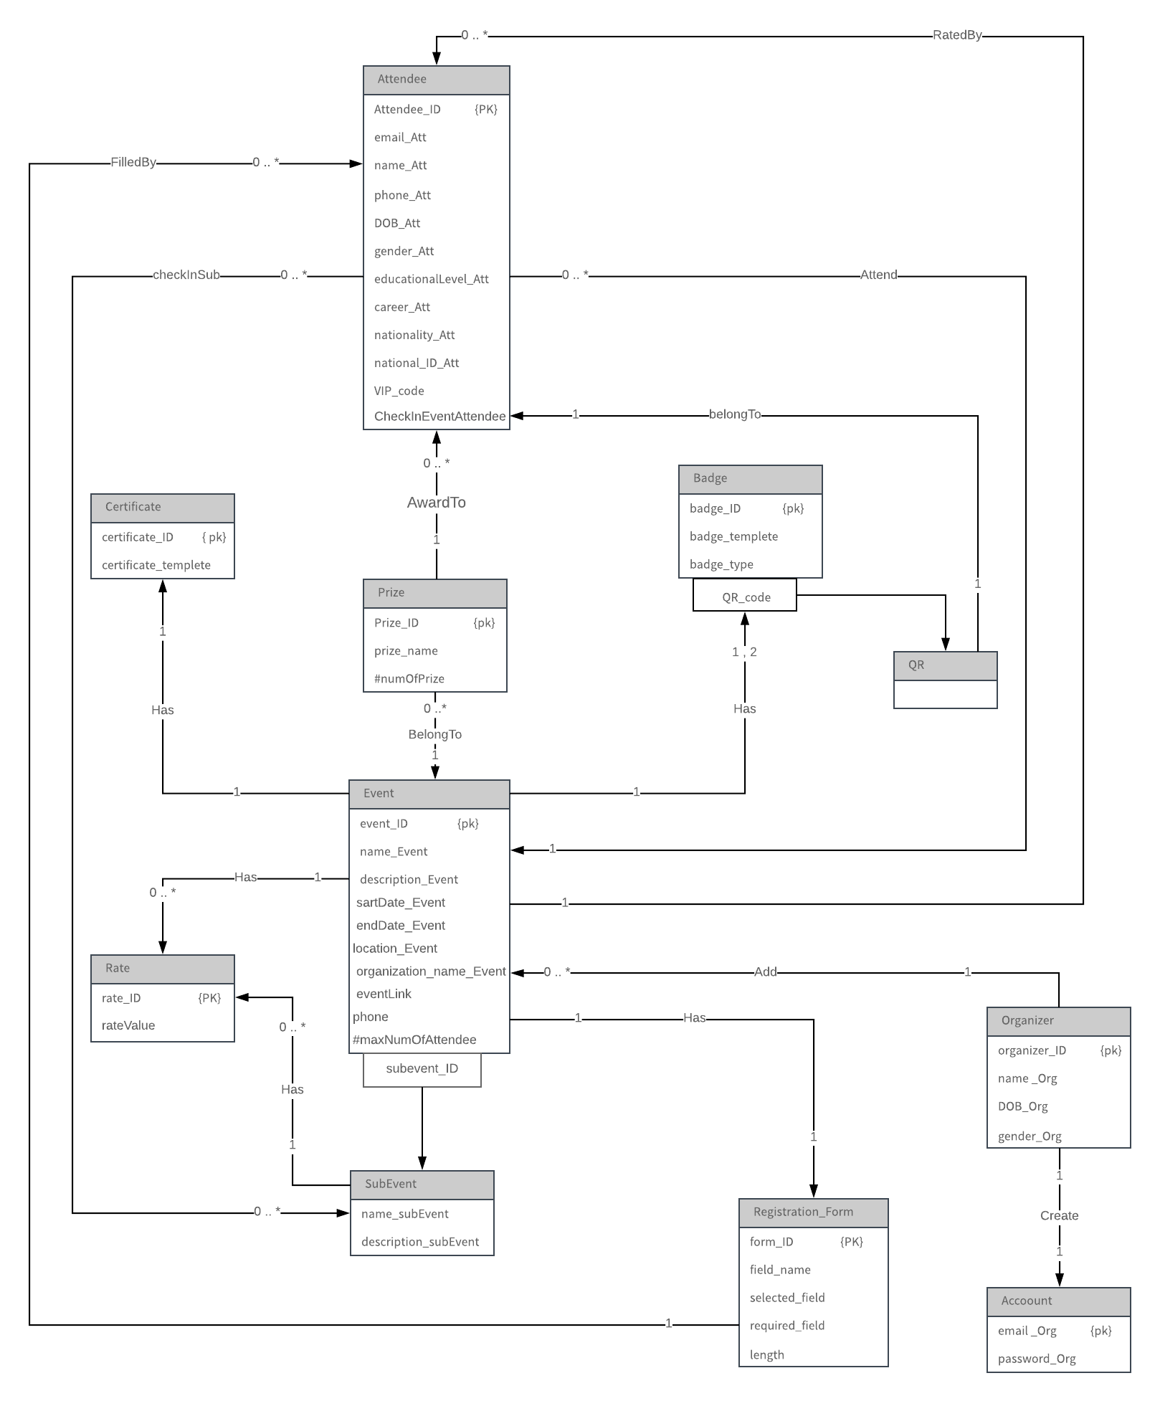

*Figure 53: ER diagram*

**5.3.1 DATABASE SCHEMA:**

**Organizer** (organizer_ID, name_Org, gender_Org, DOB_Org) Primary Key: organizer_ID

**Account** (email_Org, password_Org, organizer_ID) Primary Key: email_Org

Foreign Key: organizer_ID

**Attendee** (Attendee_ID, email_Att, name_Att, phone_Att, DOB_Att, gender_Att, educationalLevel_Att, career_Att, nationality_Att, national_ID_Att, VIP_code, CheckInEventAttendee, form_ID, event_ID, prize_ID)

Primary Key: Attendee_ID

Foreign Key: form_ID, event_ID, prize_ID

**Event (**event_ID, name_Event, description_Event, sartDate_Event, endDate_Event, location_Event, organization_name_Event, eventLink, maxNumOfAttendee, organizer_ID) Primary Key: event_ID

Foreign Key: organizer_ID

**Subevent** (subevent_ID, event_ID, name_subEvent, description_subEvent) Primary Key: event_ID, subevent_ID

**checkInSub (**Attendee_ID, subevent_ID, event_ID) Primary Key: Attendee_ID, subevent_ID, event_ID.

**Prize** (Prize_ID, prize_name, numOfPrize, event_ID) Primary Key: Prize_ID.

Foreign Key: event_ID

**Badge** (badge_ID, badge_templete, badge_type, event_ID) Primary Key: badge_ID

Foreign Key: event_ID

**QR** (badge_ID, QR_code, Attendee_ID) Primary Key: badge_ID, QR_code Foreign Key: Attendee _ID

**Certificate** (certificate_ID, certificate_templete, event_ID) Primary Key: certificate_ID

Foreign Key: event_ID

**Registration_Form** (form_ID, name_of_field, selected_field, required_field, length, event_ID)

Primary Key: form_ID Foreign Key: event_ID

**Rate** (rate_ID, rateValue, event_ID, subevent_ID) Primary Key: rate_ID

Foreign Key: event_ID, subevent_ID

**5.3.2 ATTRIBUTE DICTIONARY:**

|  |  |  |  |  |  |  |  |  |  |  |
| --- | --- | --- | --- | --- | --- | --- | --- | --- | --- | --- |
| **Entity** | **Attribute** | **Description** | **Data**  **Type** | **Length** | **Null** | **Multi value** | **Default value** | **Range** | **PK** | **FK** |
| **Organizer** | organizer  _ID | Uniquely identify organizer(incremental) | Integer |  | N  o | N  o | N  o | N  o | Y  e s |  |
| name_Org | Organizer’s  name | Varchar | 3  0 | N  o | N  o | N  o | N  o |  |  |
| gender_ Org | Gender of organizer (male, female) | Varchar | 6 | N  o | N  o | N  o | N  o |  |  |
| DOB_Org | Organizer’s  date of birth | date |  | N  o | N  o | N  o | N  o |  |  |
| **Account** | organizer  _ID | Uniquely identify account of organizer(incremental) | Integer |  | N  o | N  o | N  o | N  o | Y  e s | Y  e s |
| email_Org | Organizer’s  email | Varchar | 3  0 | N  o | N  o | N  o | N  o | Y  e s |  |
| password  _Org | Organizer’s  password | Varchar | 3  0 | N  o | N  o | N  o | N  o |  |  |

102

|  |  |  |  |  |  |  |  |  |  |  |
| --- | --- | --- | --- | --- | --- | --- | --- | --- | --- | --- |
| **Attendee** | Attendee_ID | Uniquely identify attendee (incremental) | Integer |  | N  o | N  o | N  o | N  o | Y  e s |  |
| email_Att | Attendee’s  email | Varchar | 3  0 | N  o | N  o | N  o | N  o |  |  |
| name_Att | Attendee’s  name | Varchar | 3  0 | N  o | N  o | N  o | N  o |  |  |
| phone_Att | Attendee’s  Phone number | Integer | 1  0 | N  o | N  o | N  o | N  o |  |  |
| DOB_Att | Date of birth of attendee | Date |  | Y  e s | N  o | N  o | N  o |  |  |
| gender_Att | Gender of attendee | Varchar | 6 | Y  e s | N  o | N  o | N  o |  |  |
| eductional Level_Att | Educational  Level of attendee | Varchar | 4  0 | Y  e s | N  o | N  o | N  o |  |  |
| career_Att | Career of attendee | Varchar | 3  0 | Y  e s | N  o | N  o | N  o |  |  |
| natio nality_Att | Nationality of attendee | Varchar | 2  0 | Y  e s | N  o | N  o | N  o |  |  |
| national_I D_At t | National ID of attendee | Integer |  | Y  e s | N  o | N  o | N  o |  |  |
| VIP_  code | Special code for important attendee | Integer |  | Y  e s | N  o | N  o | N  o |  |  |
| form_ ID | Uniquely identify form (incremental) | Integer |  | N  o | N  o | N  o | N  o |  | Y  es |

103

|  |  |  |  |  |  |  |  |  |  |  |
| --- | --- | --- | --- | --- | --- | --- | --- | --- | --- | --- |
|  | event  _ID | Uniquely identify event  (incremental) | Integer |  | N  o | N  o | N  o | N  o |  | Y  es |
| Chec kInEv entAt tende e | To check if this attendee was attend or not | Boolean |  | N  o | N  o | Y  es | N  o |  |  |
| Prize  _ID | Uniquely identify prize (incremental) | Integer |  | N  o | N  o | N  o | N  o |  | Y  es |
| **Event** | event  _ID | Uniquely identify event (increment al) | Integer |  | N  o | N  o | N  o | N  o | Y  e s |  |
| name  _Event | Event’s name | Varchar | 3  0 | N  o | N  o | N  o | N  o |  |  |
| descrption  _Event | Description of event | Varchar | 2  0  0 | N  o | N  o | N  o | N  o |  |  |
| sartD ate_E vent | Started date of event | date |  | N  o | N  o | N  o | N  o |  |  |
| endD ate_E vent | end date of event | date |  | N  o | N  o | N  o | N  o |  |  |
| locati on_E  vent | Event’s address | Varchar | 3  0 | N  o | N  o | N  o | N  o |  |  |
| organ izatio n_na me_E vent | Name of organization responsible on this event | Varchar | 3  0 | N  o | N  o | N  o | N  o |  |  |
| event  Link | Link generated for event | Varchar | 1  4  0 | N  o | N  o | N  o | N  o |  |  |

104

|  |  |  |  |  |  |  |  |  |  |  |
| --- | --- | --- | --- | --- | --- | --- | --- | --- | --- | --- |
|  | maxNumOf Atten dee | Allowed max number of  attendee | Integer |  | N  o | N  o | N  o | N  o |  |  |
| organ izer_I D | Uniquely identify organizer (incremental) | Integer |  | N  o | N  o | N  o | N  o |  | Y  es |
| **Sub event** | subev ent_I D | Uniquely identify sub- event (increment  al) | Integer |  | N  o | N  o | N  o | N  o | Y  e s |  |
| event  _ID | Uniquely identify event (increment al) | Integer |  | N  o | N  o | N  o | N  o | Y  e s |  |
| name  _sub  Event | Sub-event  vent’s name | Varchar | 3  0 | N  o | N  o | N  o | N  o |  |  |
| descri ption  _sub  Event | Description of sub-event | Varchar | 1  5  0 | N  o | N  o | N  o | N  o |  |  |
| **Registration_Form** | form_ ID | Uniquely identify form (incremental) | Integer |  | N  o | N  o | N  o | N  o | Y  e s |  |
| name  _of_field | Name of selected attribute | Varchar | 2  5 | N  o | N  o | N  o | N  o |  |  |
| select ed_fi eld | Organizer  check the fields he need them at form | Boolean |  | N  o | N  o | Y  es | N  o |  |  |
| requir ed_fi eld | Organizer choose the fields that the attendee has to filled them | Boolean |  | N  o | N  o | Y  es | N  o |  |  |

105

|  |  |  |  |  |  |  |  |  |  |  |
| --- | --- | --- | --- | --- | --- | --- | --- | --- | --- | --- |
|  | length | Length of shape | Integer |  | Y  e s | N  o | N  o | N  o |  |  |
| event  _ID | Uniquely identify event (incremental) | Integer |  | N  o | N  o | N  o | N  o |  | Y  es |
| **Badge** | badge  _ID | Uniquely identify badge (incremental) | Integer |  | N  o | N  o | N  o | N  o | Y  e s |  |
| badge  _templete | Templet of badge | Picture |  | N  o | N  o | N  o | N  o |  |  |
| badge  _type | Type of badge for VIP or normal attendee) | Varchar | 6 | N  o | N  o | N  o | N  o |  |  |
| event  _ID | Uniquely identify event (incremental) | Integer |  | N  o | N  o | N  o | N  o |  | Y  es |
| **QR** | badge  _ID | Uniquely identify badge (incremental) | Integer |  | N  o | N  o | N  o | N  o | Y  e s |  |
| QR_c ode | Unique code that generate to attendee | Integer |  | N  o | N  o | N  o | N  o | Y  e s |  |
| Atten dee_I  D | Uniquely identify  attendee  (incremental) | Integer |  | N  o | N  o | N  o | N  o |  | Y  es |
| **Certificate** | Certif icate_ ID | Uniquely identify certificate (incremental) | Integer |  | N  o | N  o | N  o | N  o | Y  e s |  |
| Certif icate_ templ  ete | Templet of  certificate | Picure |  | N  o | N  o | N  o | N  o |  |  |

106

|  |  |  |  |  |  |  |  |  |  |  |
| --- | --- | --- | --- | --- | --- | --- | --- | --- | --- | --- |
|  | event  _ID | Uniquely identify event  (incremental) | Integer |  | N  o | N  o | N  o | N  o |  | Y  es |
| **Prize** | Prize  _ID | Uniquely identify prize (incremental) | Integer |  | N  o | N  o | N  o | N  o | Y  e s |  |
| num OfPri ze | Number of each prize | Integer |  | N  o | N  o | N  o | N  o |  |  |
| event  _ID | Uniquely identify event  (incremental) | Integer |  | N  o | N  o | N  o | N  o |  | Y  es |
| **Rate** | rate_I D | Uniquely identify rate (incremental) | Integer |  | N  o | N  o | N  o | N  o | Y  e s |  |
| rateValue | Rate of event | Boolean |  | N  o | N  o | N  o | N  o |  |  |
| event  _ID | Uniquely identify event  (incremental) | Integer |  | N  o | N  o | N  o | N  o |  | Y  es |
| subev ent_I D | Uniquely identify sub- event (incremental) | Integer |  | N  o | N  o | N  o | N  o |  | Y  es |
| **checkInSub** | Atten dee_I D | Uniquely identify attendee (incremental) | Integer |  | N  o | N  o | N  o | N  o | Y  e s |  |
| subev ent_I D | Uniquely identify sub event (incremental) | Integer |  | N  o | N  o | N  o | N  o | Y  e s |  |
| event  _ID | Uniquely identify event (incremental) | Integer |  | N  o | N  o | N  o | N  o | Y  e s |  |

*Table 18: Attribute dictionary*

107

|  |  |  |  |  |
| --- | --- | --- | --- | --- |
| Entity Name | Multiplicity | Relationship | Entity Name | Multiplicity |
| Attendee | 0..* | checkInSub | Subevent | 0..* |
| Attendee | 0..* | Attend | Event | 1 |
| Organizer | 1 | Add | Event | 0..* |
| Organizer | 1 | Create | Account | 1 |
| Event | 1 | RatedBy | Attendee | 0..* |
| Event | 1 | Has | Rate | 0..* |
| Event | 1 | Has | Certificate | 1 |
| Event | 1 | Has | Badge | 1,2 |
| Event | 1 | Has | Registration_Form | 1 |
| Subevent | 1 | Has | Rate | 0..* |
| Registration_Form | 1 | FilledBy | Attendee | 0..* |
| Prize | 0..* | BelongTo | Event | 1 |
| Prize | 1 | AwardTo | Attendee | 0..* |

*Table 19: Relationship data dictionary*

*Table 20: entity data dictionary*

|  |  |  |
| --- | --- | --- |
| **Entity Name** | **Description** | **Occurrence** |
| Attendee | General information about an attendee who fill form to attend event | Each attendee can attend many events |
|  |  | Many attendees may  check in many sub event |
| Organizer | General information about organizer who register in system to add event | Each organizer creates one account |
|  |  | One organizer can add many events |
| Event | General information about event  to be added | Each event has one  registration form |
|  |  | one event can rate by many attendees |
|  |  | One event has many rate |
|  |  | Each event has one or two badges |
|  |  | Each event has one certificate |
| Registration_Form | General information about registration form of event | One registration form filled by many attendee |
| Prize | General information about prize  that will win it attendee | Many prizes belong  to one event |
|  |  | One prize can award to many attendee |

**5.4 COMPONENT DESIGN:**

**1. SIGN UP Classification**: function

**Definition:** function of **WEBSITE** allows the organizer to register into the system

**Responsibility Reference:** R1

**Constrain**: None

**Pseudocode**:

**BEGIN**

**IF** "Register" option was clicked **THEN DISPLAY** registration form

**READ** name, password, confirm password, email, sex, DOB

**IF** all fields are filled **THEN**

**IF** password characters < 8

**DISPLAY** password not valid

**IF** confirm password does not match the password **THEN**

**DISPLAY** password not match

**IF** email address is unique **THEN**

**ACCEPT** user registration and save user information

**DISPLAY** Control panel page

**ELSE DISPLAY** an error message "This email is already existed"

**ELSE DISPLAY** an error message "Please fill all required information"

**END IF END**

**Classification:** function

**Definition**: function of **WEBSITE** allows the organizer to log in the system

**Responsibility Reference:** R2

**Constrain:**

• pre-condition: sign up.

**Pseudocode: BEGIN**

**IF** "Log In" option was clicked **THEN DISPLAY** login form

**READ** email, password

**IF** the email matches a registered account email **THEN IF** password is correct for the email **THEN**

**ACCEPT** log in

**ELSE DISPLAY** an error message" The password or email is incorrect"

**ELSE DISPLAY** an error message "This email is not associated with any account"

**END IF END**

**Classification**: Function

**Definition**: function of **WEBSITE** allows the user to recover their password.

**Responsibilities reference**: R3.

**Constraints:**

• Pre-condition: log in

**Pseudocode: BEGIN**

**IF** "Reset Password" option was clicked **THEN DISPLAY** an empty field for user email

**IF** “submit” option was clicked **THEN IF** the email field is filled **THEN**

**IF** the email is a valid email **THEN SEND** email with link to reset password **IF** click "link" **THEN**

**DISPLAY** page will open to enter new password and confirm password

**IF** confirm password does not match the new password **THEN**

**DISPLAY** passwords not match

**ELSE DISPLAY** an error message "Please fill required information"

**END IF END**

**Classification**: Function

**Definition:** function of **WEBSITE** allows the user to edit her/his profile.

**Responsibilities reference**: R4.

**Constraints:**

• Pre-condition: Log in.

**Pseudocode**:

**BEGIN**

**IF** "Edit profile" option was clicked **THEN DISPLAY** edit profile form

**READ** name, password, confirm password, sex, DOB

**IF** all fields are filled **THEN IF** password characters < 8

**DISPLAY** password not valid

**IF** confirm password does not match the password **THEN**

**DISPLAY** an error message password not match

**DISPLAY** confirm message that organizer profile has been edited successfully

**ELSE DISPLAY** an error message "Please fill all required information"

**END IF END**

**Classification**: function

**Definition:** function of **WEBSITE** allows the organizer to manage events.

**Responsibility Reference:** R5

**Constrain:** pre-condition: login

**Pseudocode:**

**BEGIN**

**IF** "home page" option was clicked **THEN DISPLAY** Manage Event Page

**IF** "Add Event" button was clicked **THEN DISPLAY** "Add Event" page

**IF** Organizer fill all fields **THEN**

**IF** all fields are filled correct **THEN**

**DISPLAY** confirm message that added was successfully

**ELSE DISPLAY** an error message "please fill the fields correctly"

**ELSE DISPLAY** an error message "Please fill all required information"

**END IF**

**ELSE IF** "Edit Event" button was clicked **THEN DISPLAY** "Edit Event" page that contain events **IF** Organizer select an event to edit **THEN Retrieve** information of selected event **THEN**

**IF** Organizer fill new information **THEN IF** click "save" **THEN**

**UPDATE** event information

**DISPLAY** confirm message that edit was successfully

**ELSE DISPLAY** an error message "please fill the fields correctly"

**END IF**

**ELSE IF** "Delete Event" button was clicked **THEN DISPLAY** "Delete Event" page that contain list of events **IF** Organizer select an event to delete **THEN**

**DISPLAY** confirm message that illustrate if he sure to delete

**IF** "OK" clicked **THEN**

**DISPLAY** confirm message that delete was successfully

**END**

**END IF**

**6. MANAGE PRIZES**

**Classification**: function

**Definition:** function of **WEBSITE** allows the organizer to manage prizes.

**Responsibility Reference:** R6

**Constrain:** pre-condition: login

**Pseudocode:**

**BEGIN**

**IF** "Manage Prizes" option was clicked **THEN DISPLAY** Manage Prizes Page

**IF** "Add Prize" button was clicked **THEN**

**DISPLAY** "Add Prize" page that contain list of events/subevent

**IF** Organizer fill all fields **THEN**

**DISPLAY** confirm message that added was successfully **ELSE DISPLAY** an error message "please fill all fields" **END IF**

**ELSE IF** "Edit Prize" button was clicked **THEN**

**DISPLAY** "Edit Prize" page that contain list of events/subevent

**I**F Organizer select event to edit its prize **THEN DISPLAY** list of prizes for selected event **THEN I**F Organizer select prize to edit **THEN**

**IF** Organizer fill new information **THEN IF** click "edit " **THEN**

**DISPLAY** confirm message that edit was successfully

**ELSE DISPLAY** an error message "please fill all fields"

**END IF**

**ELSE IF** "Delete Prize" button was clicked **THEN**

**DISPLAY** "Delete Prize" page that contain list of events/subevent

**IF** Organizer select event to delete its prize **THEN DISPLAY** list of prizes for selected event

**IF** Organizer select prize to delete **THEN DISPLAY** the information of the prize **THEN IF** "Delete" button was clicked **THEN**

**DISPLAY** confirm message that illustrate if he sure to delete

**IF** "OK" clicked **THEN**

**DISPLAY** confirm message that delete was successfully

**END IF**

**ELSE IF** "Choose Winners" button was clicked **THEN**

**DISPLAY** "Choose Winners" page that contain list of events /subevent

**IF** Organizer select an event **THEN DISPLAY** table of events with its prizes

**IF** Organizer select "choose winner" **THEN**

**SELECT** randomly one name of attendee to each prize **THEN DISPLAY** table of winners with its prizes

**END**

**7. MANAGE REGISTRATION Classification**: function

**Definition:** function of **WEBSITE** allows the organizer to manage registration.

**Responsibility Reference:** R7

**Constrain:** pre-condition: login

**Pseudocode:**

**BEGIN**

**IF** "Manage Registration" option was clicked **THEN DISPLAY** Manage Registration Page

**SELECT** event from list of events

**IF** "Create Form" button was clicked **THEN DISPLAY** the registration form fields **SELECT** fields

**IF** the field is text **THEN READ** length of fields **SELECT** required fields

**IF** select VIP code

**GENERATE** code for VIP

**IF** Organizer click on "Create" button **THEN DISPLAY** form was created

**GENERATE** link of event

**END IF**

**ELSE IF** "Edit Form" button was clicked **THEN**

**DISPLAY** the registration form fields that was selected to an event

**IF** Organizer edit fields **THEN**

**IF organizer** select VIP code

**GENERATE** code for VIP

**IF** Organizer click on "save edit" button **THEN**

**DISPLAY** confirm message that the form was edited successfully

**END IF**

**ELSE IF** "Deactivate Link" button was clicked **THEN**

**DISPLAY** message that confirm that he sure to deactivate link

**IF** "OK" clicked **THEN**

**END IF**

**DISPLAY** confirm message that deactivate was successfully

**ELSE IF** "Delete" button was clicked **THEN**

**DISPLAY** confirm message that confirm that he sure to delete form

**IF** "OK" clicked **THEN**

**DISPLAY** confirm message that delete was successfully

**END**

**END IF**

**ATTENDEE REGISTRATION Classification**: function

**Definition:** function of **WEBITE** allows the attendee to register.

**Responsibility Reference:** R12.

**Constrain:**

pre-condition: add event

pre-condition: manage registration pre-condition: manage badges.

**Pseudocode: BEGIN**

IF user click on link **THEN DISPLAY** User Registration form **IF** User fill all fields **THEN**

**IF** fields filled correctly **THEN IF** User submit form **THEN**

**DISPLAY** confirm message that Registration was successfully

**ELSE Do nothing**

**ELSE DISPLAY** an error message "pleas fill the fields correctly"

**ELSE DISPLAY** an error message "please fill all fields"

**END IF**

**8. SEND EMAIL TO THE REGISTERED PEOPLE.**

**Classification:** Function

**Definition**: function of **WEBSITE** allows the organizer to manage send email.

**Responsibilities reference:** R8**. Constraints:**

• Pre-condition: Log in.

• Pre-condition: have event

**Pseudocode: BEGIN**

**IF** "Send Email" option was clicked **THEN DISPLAY** Send Email Page

**SELECT** the name of event

**SELECT** the type of receiver (all, normal, VIP)

**SELECT** the time of sending (Immediate, before (1,2,3,4) day of event

**SELECT** type of message (alert message, shift time of event, delete event, send certificate, resend badges and other. )

**READ** the title of message

**READ** the body of message

**IF** the organizer clicks on "send" button

**DISPLAY** confirm message that send email was successfully

**END IF END**

**9. MANAGE BADGES Classification:** Function

**Definition**: function of **WEBSITE** allows the organizer to manage badged.

**Responsibilities reference:** R9**. Constraints:**

• Pre-condition: Log in.

• Pre-condition: have event

**Pseudocode: BEGIN**

**IF** "manage badges " option was clicked

**IF "**add badges" option was clicked'

**DISPLAY** add page that contain list of events **THEN SELECT** event from the list

**UPLOAD** badges templets (VIP , normal) **THEN DISPLAY** uploaded templates

**IF** organizer click "save" **THEN**

**DISPLAY** that templates uploaded successfully

**END IF**

**ELSE IF "**Edit badges" option was clicked'

**DISPLAY** add page that contain list of events **THEN SELECT** event from the list

**UPLOAD** new badges templets **THEN DISPLAY** new uploaded templates **IF** organizer click "edit " **THEN**

**DISPLAY** the new templates uploaded successfully

**END IF**

**ELSE IF** "Delete Badge" button was clicked **THEN**

**DISPLAY** "Delete Badge" page that contain list of events **THEN SELECT** event from the list

**SELECT** type of badges (VIP, Normal)

**DISPLAY** badge for selected event

**IF** Organizer click "delete" button **THEN**

**DISPLAY** confirm message that illustrate if he sure to delete

**IF** "OK" clicked **THEN**

**DISPLAY** confirm message that delete was successfully

**END IF**

**10. ATTENDEE REGISTRATION Classification:** function

**Definition:** function of **WEBITE** allows the attendee to register**. Responsibility Reference: R12.**

**Constrain:**

• pre-condition: add event

• pre-condition: manage registration

• pre-condition: manage badges.

**Pseudocode: BEGIN**

**IF** user click on link **THEN DISPLAY** User Registration form **IF** User fill all fields **THEN**

**IF** fields filled correctly **THEN IF** User submit form **THEN**

**DISPLAY** confirm message that Registration was successfully

**ELSE** Do nothing

**ELSE DISPLAY** an error message "pleas fill the fields correctly"

**ELSE DISPLAY** an error message "please fill all fields"

**END IF**

**11. MANAGE THE CERTIFICATE:**

**Classification:** Function

**Definition**: function of **WEBSITE** allows the organizer to manage the certificate.

**Responsibilities reference: R10. Constraints:**

• Pre- condition: Log in.

• Pre- condition: add event.

• Pre- condition: attended event.

**Pseudocode: BEGIN**

**IF** "manage certificate " option was clicked

**IF "**add certificates" option was clicked'

**DISPLAY** add page that contain list of events **THEN SELECT** event from the list

**UPLOAD** certificate templets **THEN DISPLAY** uploaded templates

**IF** organizer click "save" **THEN**

**DISPLAY** that templates uploaded successfully

**END IF**

**ELSE IF "**Edit certificate " option was clicked'

**DISPLAY** edit page that contain list of events **THEN SELECT** event from the list

**UPLOAD** new certificates templets **THEN DISPLAY** new uploaded templates

**IF** organizer click "edit " **THEN**

**DISPLAY** the new templates uploaded successfully

**END IF**

**ELSE IF** "Delete certificate" button was clicked **THEN**

**DISPLAY** "Delete certificate" page that contain list of events **THEN SELECT** event from the list

**DISPLAY** certificate for selected event

**IF** Organizer click "delete" button **THEN**

**DISPLAY** confirm message that illustrate if he sure to delete

**IF** "OK" clicked **THEN**

**DISPLAY** confirm message that delete was successfully

**END IF**

**12. ANALYZE THE DATA Classification:** Function

**Definition**: function of **WEBSITE** allows the organizer to analyze the data.

**Responsibilities reference:** R11.

**Constraints:**

• Pre- condition: Log in.

• Pre- condition: add event.

• Pre- condition: create registration form.

• Pre- condition: rate event.

• Pre- condition: track attendee.

**Pseudocode: BEGIN**

**IF** "Statistics" option was clicked **THEN**

**DISPLAY** "View Statistics " page that contain list of events **THEN IF** Organizer select an event to show its statistic **THEN**

**DISPLAY** list of checkboxes that contain attributes to analyze based on it **THEN**

**IF** Organizer select an event to show its statistic **THEN**

**DISPLAY** statistic of selected event based on selected attributes

**END**

**13. RATE EVENT**

**Classification:** Function

**Definition**: function of **WEBSITE/APP** allows the attendee to rate the event and sub- event.

**Responsibilities reference:** R12.

**Constraints:**

• Pre-condition: Log in.

• Pre-condition: add event.

• Pre-condition: filled registration form.

**Pseudocode: BEGIN**

**IF** "Rate" option was clicked **THEN**

**DISPLAY** EVENT Rate page that contain list of events **THEN**

**IF** Attendee select an event to rate it **THEN**

**IF** attendee click on "Start event Rate" **THEN**

**DISPLAY** Rate Event page that contain three types of faces (happy, neutral, sad)

**END IF END**

**IF** click on one of rating face **THEN IF** click "Rate" button **THEN**

**DISPLAY** POP message "Thank you for your rating"

**ELSE IF** click on " do another rate" for event

**14. LOG OUT**

**Classification:** Function

**Definition**: function of **WEBSITE** allows the user to log out from the system.

**Responsibilities reference:** R13.

**Constraints:**

• Pre- condition: Log in.

**Pseudocode: BEGIN**

**IF** "Log out" option was clicked **THEN**

**DISPLAY** a confirmation message that confirm if he sure to log out

**IF** “OK” option was clicked **LOGOUT** Organizer **RETURN** home page

**END IF END**

**15. SCAN THE BARCODE OF THE BADGES**

**Classification:** Function

**Definition**: function of **WEBSITE/APP** allows the organizer to scan the barcode of the badges.

**Responsibilities reference:** R14

**Constraints:**

• Pre- condition: Log in.

• Pre- condition: add event.

• Pre- condition: create registration form.

**Pseudocode: BEGIN**

**SELECT** "Scan Bar-Code"

**READ** QR barcode **THEN**

**DISPLAY** pop message contain three buttons (new scan, print , close) that bar-Code scanned successfully

**IF** attendee click "print" THEN

**DISPLAY** the badge page that contain "print" an "back" buttons

**IF** click "print" button the badge will print **ELSE IF** click "back" button **THEN DISPLAY** Scan page

**ELSE IF** " new scan " clicked **THEN START** new scan

**ELSE IF** click close

**THEN** close the pop message

**END IF**

**16. MANAGE TRACK**

**Classification:** function

**Definition:** function of **WEBSITE/APP** allows the organizer to manage track**. Responsibility Reference: R14**

**Constrain: pre-condition: login, add event**

**Pseudocode: BEGIN**

**IF** organizer click on **"MANAGE TRACK" DISPLAY** MANAGE TRACK page

**IF** click on " event Arrangements" button

**DISPLAY** event Arrangements page

**IF** organizer click "print certificate" button

**SELECT** type of registered to print certificate or badge (All, VIP, Normal)

**DISPLAY** list of check box of registered based on type of register

**IF** organizer mark checkboxes **THEN**

**IF** organizer click on "print" button, it will be printed

**ELSE IF** organizer click "print Badge" button

**SELECT** type of registered (All, VIP, Normal)

**DISPLAY** list of names of registered based on type of registe**r**

**IF** organizer mark checkboxes **THEN**

**IF** organizer click on "print" button, it will be printed

**ELSE IF** click on "Live-Track" button

**DISPLAY** Live-Track page

**DISPLAY** list of events and sub-events **THEN IF** organizer choose event to track it **THEN**

**IF** organizer click "start" button **THEN DISPLAY** Track event attendee page

**IF** organizer click on "onsite registration"

**READ** the email, password, phone

**THEN** organizer check the attendee track check box **THEN IF** organizer click on "register" button

**GENERATE** badge for this register

**DISPLAY** badge page contains print button and confirm message that register was successfully

**IF** organizer click on print button the badge will be printed

**IF** organizer click "print badges" button

**THEN** organizer search for the person by (email, phone)

**DISPLAY** the name of registered person **THEN IF** organizer click on "check in" button

**DISPLAY** pop message that confirm that check in was successfully

**IF** organizer click on "print" button

**THEN** the badge will be printed

**ELSE IF** organizer choose sub-event to track **THEN READ** phone **THEN**

**IF** organizer click on "check in" button

**THEN** pop message that confirm that check in was successfully

**5.5 INTERFACE DESIGN:**

**5.5.1 WEBSITE SITEMAP**

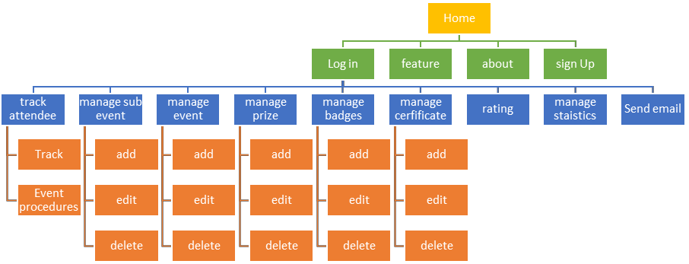

*Figure 54: Website SitMap*

**5.5.2 APPLICATION SITEMAP:**

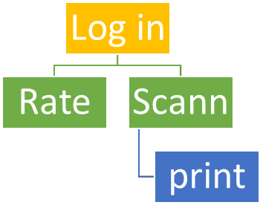

*Figure 55: Application Site Map*

**LOG IN:**

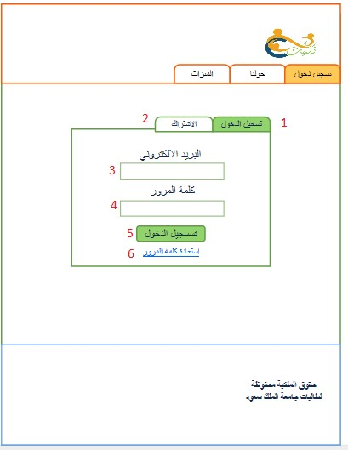

|  |  |
| --- | --- |
| # | Description |
| 1 | Tab that present login interface. |
| 2 | Tab that present sign up interface. |
| 3 | Text field to enter email of organizer’s account. |
| 4 | Text field to enter password of organizer’s account. |
| 5 | A button to login in system. |
| 6 | Link to click if organizer forgot password of account. |

*Table 21: login interface*

**SIGN UP:**

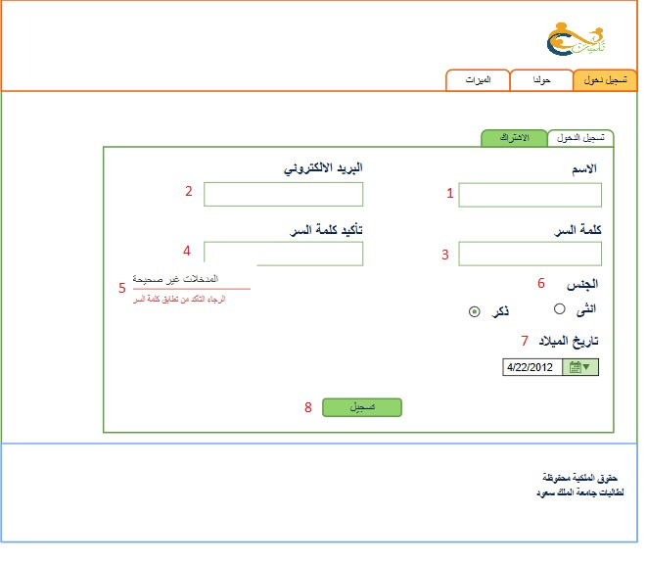

*Table 23: sign up interface*

|  |  |
| --- | --- |
| # | Description |
| 1 | Text field to enter name of organizer. |
| 2 | Text field to enter email of organizer’s account. |
| 3 | Text field to enter password of organizer’s account. |
| 4 | Text field to confirm password. |
| 5 | Error message will appear if organizer’s password didn’t match password in field 3 |
| 6 | Radio button to choose gender of organizer. |
| 7 | Drop list to choose date of birth of organizer. |
| 8 | A button to sign up in system. |

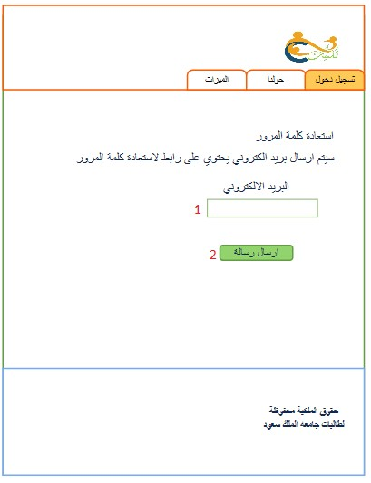

|  |  |
| --- | --- |
| # | Description |
| 1 | Text field to enter email of organizer’s account. |
| 2 | A button to send message with link to recovery password of organizer’s account. |

*Table 22: password interface*

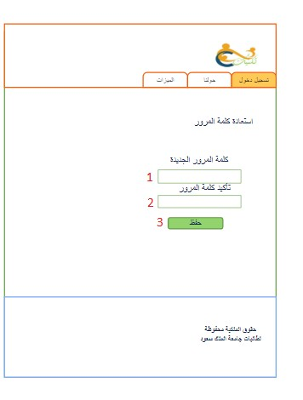

|  |  |
| --- | --- |
| # | Description |
| 1 | Text field to enter new password of organizer’s account. |
| 2 | Text field to confirm new password of organizer’s account. |
| 3 | A button to save new password of organizer’s account. |

*Table 23: reset password interface*

133

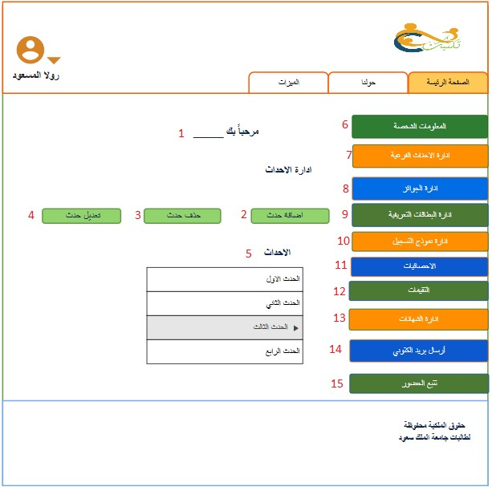

|  |  |
| --- | --- |
| # | Description |
| 1 | Text view to display welcom message with name of organizer |
| 2 | A button click to add event. |
| 3 | A button click to delete event. |
| 4 | A button click to edit event. |
| 5 | Drop down list display list of event. |
| 6 | Tab to display personal information of organizer. |
| 7 | Tab to manage sub events. |

134

|  |  |
| --- | --- |
| 8 | Tab to manage prizes. |
| 9 | Tab to manage badges. |
| 10 | Tab to manage registration form. |
| 11 | Tab to display statistic. |
| 12 | Tab to display rate of event/sub event. |
| 13 | Tab to manage cirtefects. |
| 14 | Tab to send email. |
| 15 | Tab to track attendee. |

*Table 24: manage event interface*

135

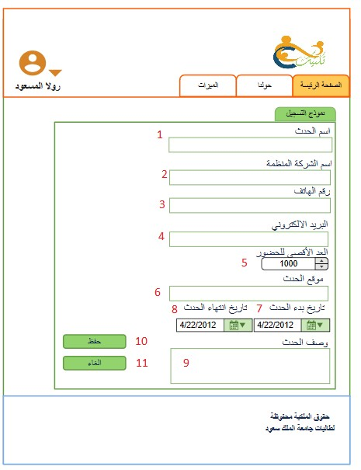

|  |  |
| --- | --- |
| # | Description |
| 1 | Text field to enter name of event. |
| 2 | Text field to enter name of organization. |
| 3 | Text field to enter phone number of responsible person of event. |
| 4 | Text field to enter email of organization. |
| 5 | to enter max number of potential attendee. |
| 6 | Text field to enter location of event. |
| 7 | Drop down list to enter start date of event. |

136

|  |  |
| --- | --- |
| 8 | Drop down list to enter end date of event. |
| 9 | Text field to show brife description of event. |
| 10 | A button to save information of event to be add. |
| 11 | A button to cancel add event proccess. |

*Table 25: add event interface*

**DELETE EVENT:**

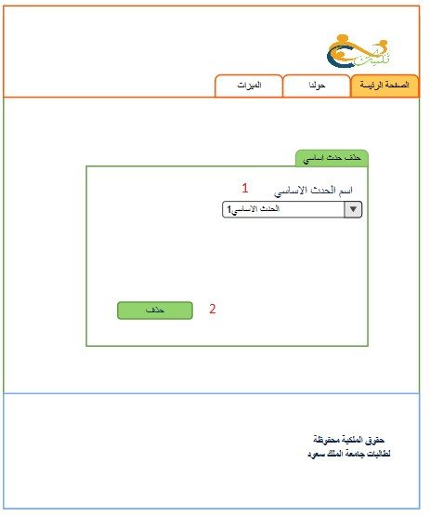

*Table 26: delete event interface*

|  |  |
| --- | --- |
| # | Description |
| 1 | Text field to enter name of event to be delete. |
| 2 | A button to delete an event. |

137

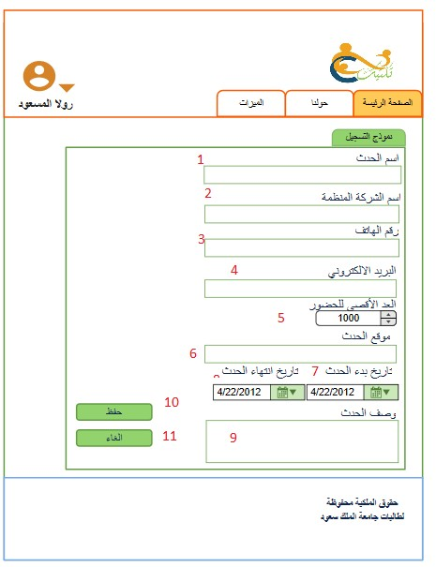**EDIT EVENT:**

138

|  |  |
| --- | --- |
| # | Description |
| 1 | Text field to enter name of event. |
| 2 | Text field to enter name of organization. |
| 3 | Text field to enter phone number of responsible person of event. |
| 4 | Text field to enter email of organization. |
| 5 | to enter max number of potential attendee. |
| 6 | Text field to enter location of event. |

|  |  |
| --- | --- |
| 7 | Drop down list to enter start date of event. |
| 8 | Drop down list to enter end date of event. |
| 9 | Text field to show brife description of event. |
| 10 | A button to save new changes of event. |
| 11 | A button to cancel edit event proccess. |

*Table 27: edit event interface*

139

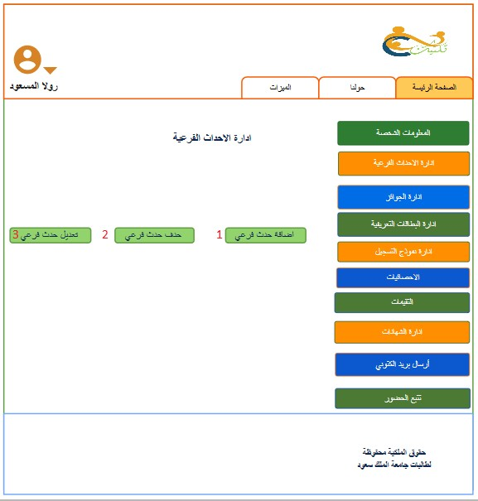

|  |  |
| --- | --- |
| # | Description |
| 1 | A button click to add sub event. |
| 2 | A button click to delete sub event. |
| 3 | A button click to edit sub event. |

*Table 28: manage sub -event interface*

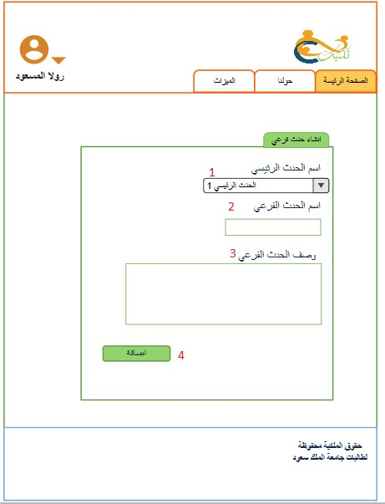

|  |  |
| --- | --- |
| # | Description |
| 1 | Drop down list to display names of events. |
| 2 | Text field to enter name of sub event. |
| 3 | Text field to show brife description of sub event. |
| 4 | A button to add sub event. |

*Table 29: add sub -event interface*

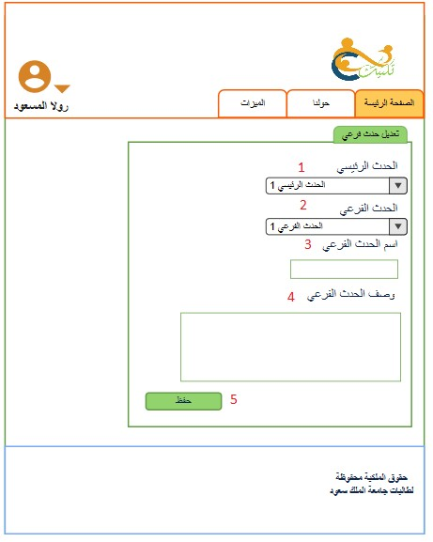

|  |  |
| --- | --- |
| # | Description |
| 1 | Drop down list to display names of events. |
| 2 | Text field to enter name of sub event. |
| 3 | Text field to show brife description of sub event. |
| 4 | A button to save changes of sub event information. |

*Table 30: edit sub -event interface*

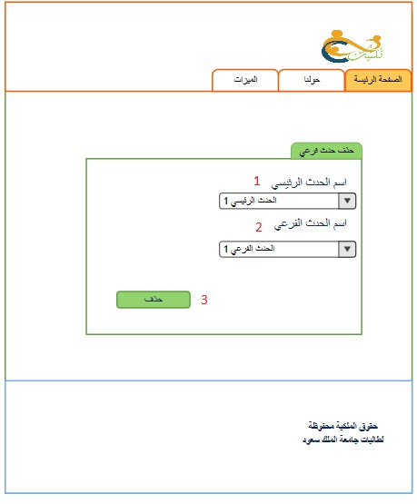

|  |  |
| --- | --- |
| # | Description |
| 1 | Drop down list to display names of events. |
| 2 | Drop down list to display names of sub events. |
| 3 | A button click to delete sub event. |

*Table 31: delete sub -event interface*

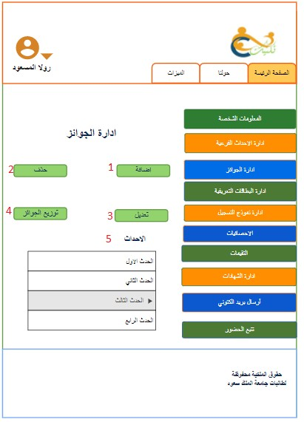

|  |  |
| --- | --- |
| # | Description |
| 1 | A button clicks to add prize. |
| 2 | A button clicks to delete prize. |
| 3 | A button clicks to edit prize. |
| 4 | A button clicks to choose winners of prize. |
| 5 | Drop down list to display names of events. |

*Table 32: manage prize interface*

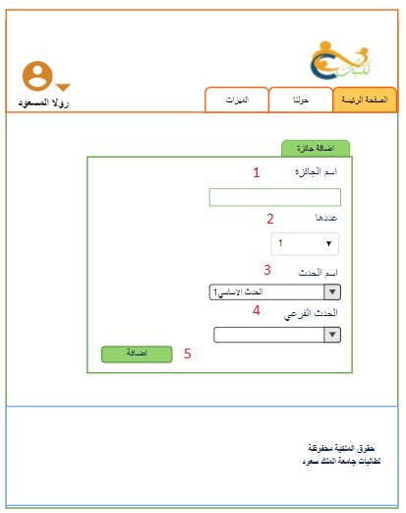

|  |  |
| --- | --- |
| # | Description |
| 1 | Text field to enter name of prize. |
| 2 | Drop down list to choose number of prizes. |
| 3 | Text field to enter name of event. |
| 4 | Drop down list to choose name of sub event. |
| 5 | A button clicks to add prize. |

*Table 33: add prize interface*

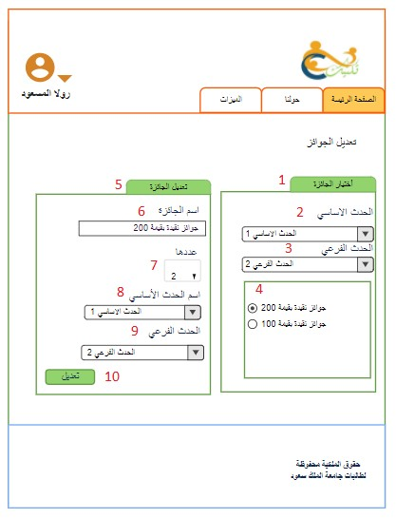

|  |  |
| --- | --- |
| # | Description |
| 1 | Tab to choose prize. |
| 2 | Drop down list to choose name of event. |
| 3 | Drop down list to choose name of sub event. |
| 4 | Radio button to choose name of prizes. |
| 5 | Tab to edit prize. |
| 6 | Text view display name of prize. |
| 7 | Drop down list to choose number of prizes. |
| 8 | Drop down list to choose name of event. |
| 9 | Drop down list to choose name of sub event. |

146

10 A button click to save changes of prize.

*Table 34: edit prize interface*

**DELETE PRIZE:**

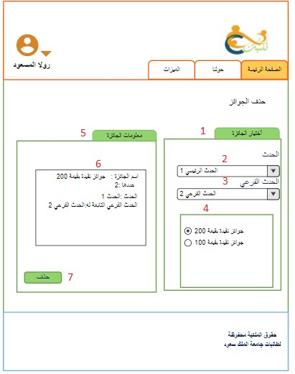

|  |  |
| --- | --- |
| # | Description |
| 1 | Tab to choose prize. |
| 2 | Drop down list to choose name of event. |
| 3 | Drop down list to choose name of sub event. |
| 4 | Radio button to choose name of prizes. |
| 5 | Tab to display information of prize. |
| 6 | Text view display detailed information of prize. |
| 7 | A button click to delete prize. |

*Table 35: delete prize interface*

**CHOOSE WINER:**

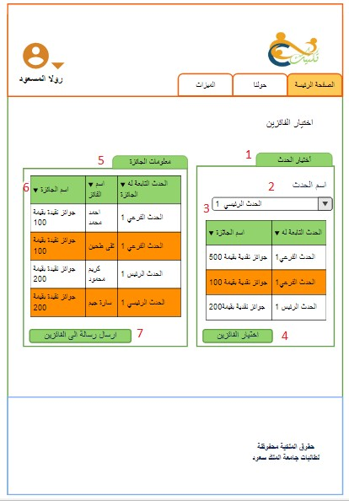

|  |  |
| --- | --- |
| # | Description |
| 1 | Tab to choose event. |
| 2 | Drop down list to choose name of event. |
| 3 | Text view display list of prizes for event and sub event. |
| 4 | A button to choose names of winners. |
| 5 | Tab to display information of prize. |

|  |  |
| --- | --- |
| 6 | Text view display information of winner prize and name of event /sub event related to each prize |
| 7 | A button clicks to send email to winner. |

*Table 36: Choose Winer interface*

**MANAGE BADGES:**

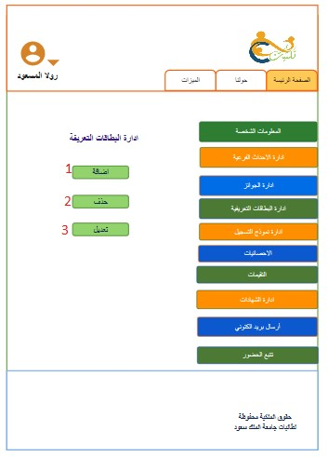

*Table 37: manage badges interface*

|  |  |
| --- | --- |
| # | Description |
| 1 | A button clicks to add badge. |
| 2 | A button clicks to delete badge. |
| 3 | A button clicks to edit badge. |

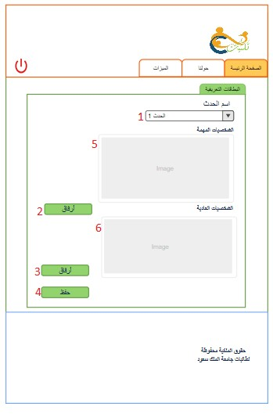

|  |  |
| --- | --- |
| # | Description |
| 1 | Drop down list to choose name of event. |
| 2 | A button clicks to upload badge of VIP attendee. |
| 3 | A button clicks to upload badge of normal attendee. |
| 4 | A button clicks to save uploaded badge. |
| 5 | Image of VIP badge. |
| 6 | Image of normal badge. |

*Table 38: add badges interface*

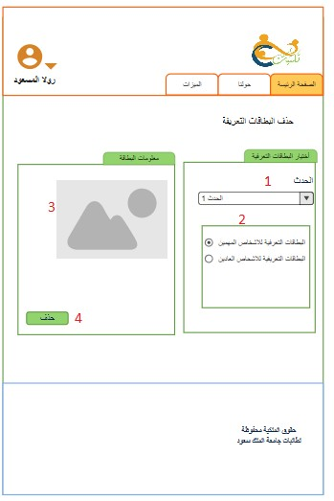

|  |  |
| --- | --- |
| # | Description |
| 1 | Drop down list to display names of events. |
| 2 | Radio button to choose type of badge. |
| 3 | Image of selected type of badge. |
| 4 | A button clicks to delete badge. |

*Table 39: delete badges interface*

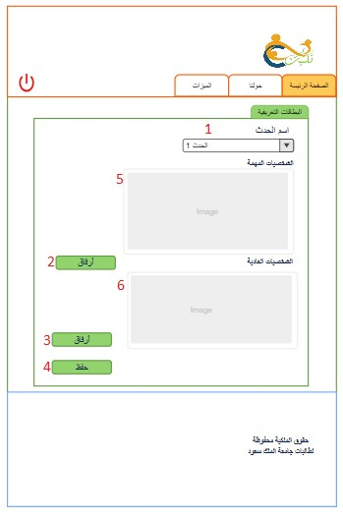

|  |  |
| --- | --- |
| # | Description |
| 1 | Drop down list to choose name of event. |
| 2 | A button clicks to upload badge of VIP attendee. |
| 3 | A button clicks to upload badge of normal attendee. |
| 4 | A button clicks to save changes of uploaded badge. |
| 5 | Image of VIP badge to be add. |
| 6 | Image of normal badge to be add. |

*Table 40: edit badges interface*

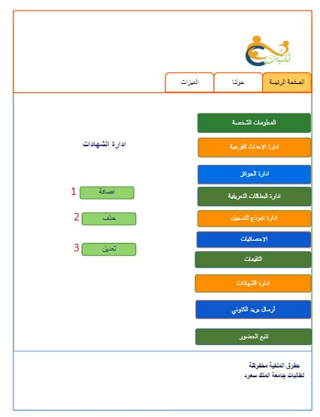

|  |  |
| --- | --- |
| # | Description |
| 1 | A button clicks to add certificate. |
| 2 | A button clicks to delete certificate. |
| 3 | A button clicks to edit certificate. |

*Table 41: Manage Certificate interface*

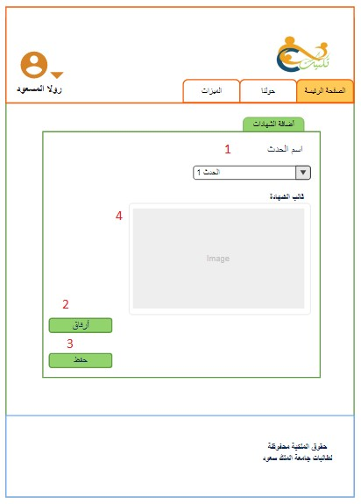

|  |  |
| --- | --- |
| # | Description |
| 1 | Drop down list to choose name of event. |
| 2 | A button clicks to upload certificate. |
| 3 | A button clicks to add certificate. |
| 4 | Image of certificate to be add. |

*Table 42: Add Certificate interface*

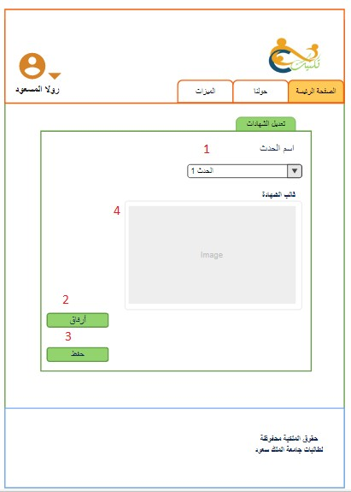

|  |  |
| --- | --- |
| # | Description |
| 1 | Drop down list to choose name of event. |
| 2 | A button clicks to upload certificate. |
| 3 | A button clicks to save changes of uploaded certificate. |
| 4 | Image of new certificate to be add. |

*Table 43: Edit Certificate interface*

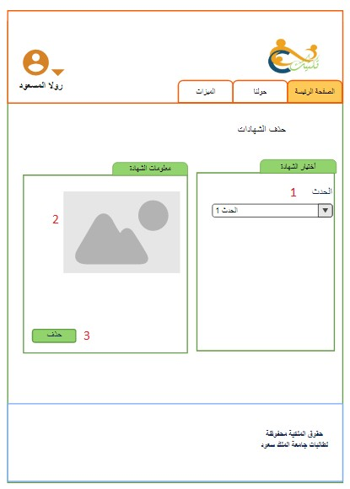

|  |  |
| --- | --- |
| # | Description |
| 1 | Drop down list to choose name of event. |
| 2 | Image of new certificate to be delete. |
| 3 | A button clicks to delete uploaded certificate. |

*Table 44: Delete Certificate interface*

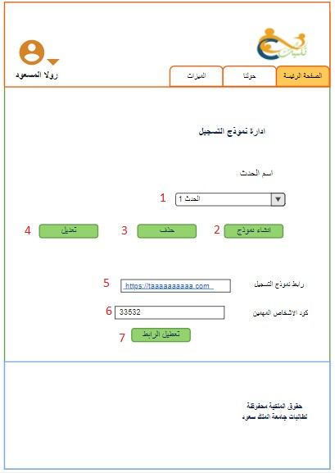

|  |  |
| --- | --- |
| # | Description |
| 1 | Drop down list display names of events. |
| 2 | A button clicks to create registration form. |
| 3 | A button clicks to delete registration form. |
| 4 | A button clicks to edit registration form. |
| 5 | Text field to enter link of event registration form. |
| 6 | Text field to enter code of VIP attendee. |
| 7 | A button clicks to deactivates link of event registration form. |

*Table 45: Manage registration form interface*

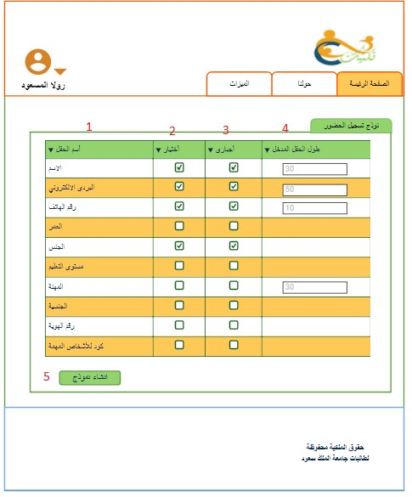

|  |  |
| --- | --- |
| # | Description |
| 1 | Name of the fields. |
| 2 | Check boxes to choose the fields. |
| 3 | Checkboxes to select the required fields. |
| 4 | Input fields to enter the length of the attribute. |
| 5 | Button to create registration form. |

*Table 46: Add form interface*

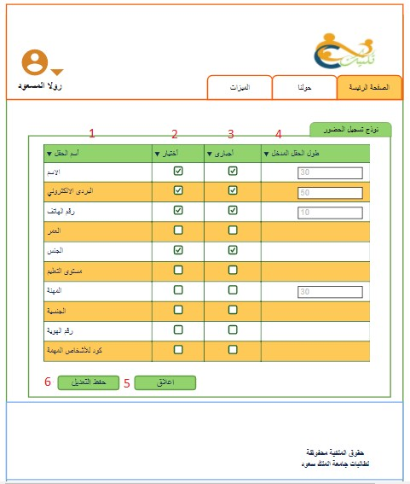

|  |  |
| --- | --- |
| # | Description |
| 1 | Name of the fields. |
| 2 | Check boxes to choose the fields. |
| 3 | Check boxes to select the required fields. |
| 4 | Input fields to enter the length of the attribute. |
| 5 | Button to edit the registration form. |

*Table 47: Edit form interface*

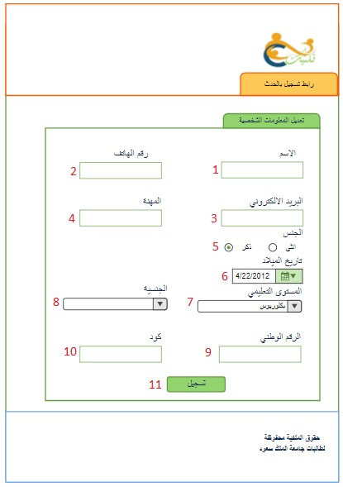

|  |  |
| --- | --- |
| # | Description |
| 1 | Input field to enter the name |
| 2 | Input field to enter the phone |
| 3 | Input field to enter the email |
| 4 | Input field to enter the career |
| 5 | Radio button to enter the |
| 6 | Dropdown list to choose the date |
| 7 | Dropdown list to choose the educational level. |
| 8 | Dropdown list to choose the nationality. |
| 9 | Input field to enter the nationality ID |
| 10 | Input field to enter the VIP code |
| 11 | Button to register. |

Table 48: Registration form interface

**CHOOSE STATISTICAL REPORT:**

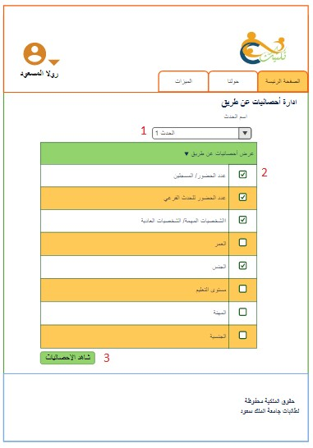

|  |  |
| --- | --- |
| # | Description |
| 1 | Drop down list to choose the event |
| 2 | Checkbox to choose attribute you want to display the statistic based on it. |
| 3 | Button to display the statistic. |

*Table 49: Choose statistical report interface*

161

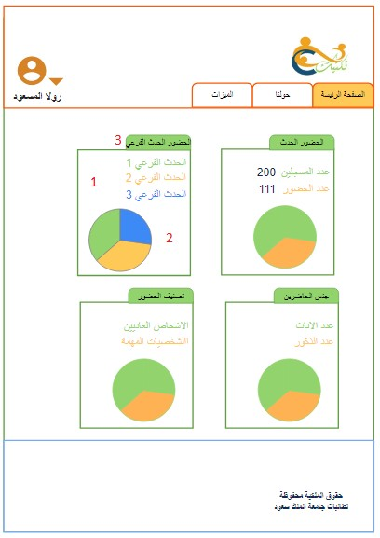

|  |  |
| --- | --- |
| # | Description |
| 1 | Label to show statistic in number. |
| 2 | Graph for to show the statistic. |
| 3 | Statistic in specific attribute. |

*Table 50: Statistical report interface*

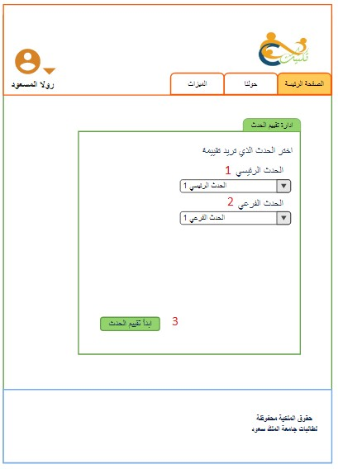

|  |  |
| --- | --- |
| # | Description |
| 1 | Drop down list to choose the event. |
| 2 | Drop down list to choose the sub event. |
| 3 | Button to start rate the event/sub event. |

*Table 51: Manage rating interface*

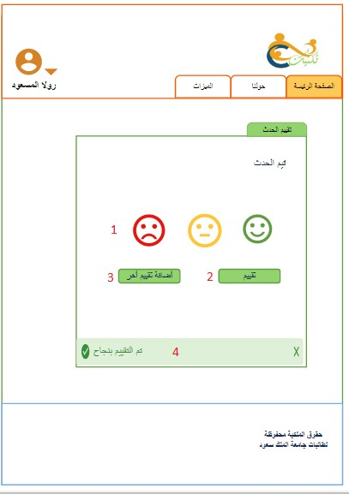

|  |  |
| --- | --- |
| # | Description |
| 1 | Choose smiley face for rate. |
| 2 | Button for save the rate. |
| 3 | Button for new rate |

*Table 52: Rating interface*

**SEND EMAIL**

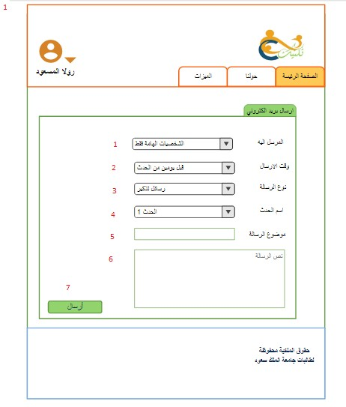

|  |  |
| --- | --- |
| # | Description |
| 1 | Drop down list contain names of VIP/normal/all attendee. |
| 2 | Drop down list to choose date of sending automatic email. |
| 3 | Drop down list to choose type of email. |
| 4 | Drop down list to choose name of event. |
| 5 | Text field to write title of email. |
| 6 | Text area to write body of email. |
| 7 | A button clicks to send an email. |

*Table 53: Send Email interface*

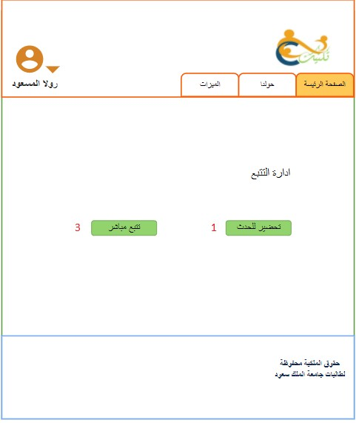

|  |  |
| --- | --- |
| # | Description |
| 1 | Button to arrange the event. |
| 2 | Button to track the event during its time. |

*Table 54: Manage track interface*

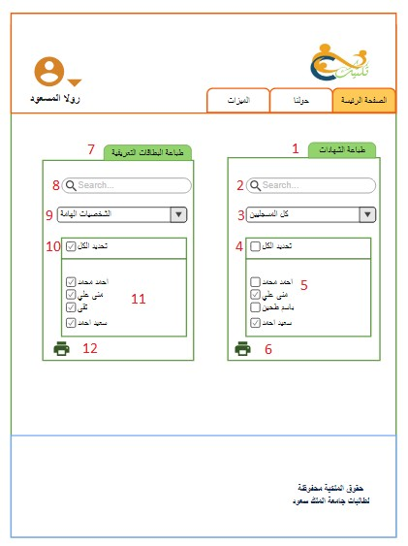

|  |  |
| --- | --- |
| # | Description |
| 1 | Choose to print certificate |
| 2 | Search field for search on specific attendee. |
| 3 | Drop down to choose (all attendee, all registered, VIP registered, formal registered) |
| 4 | Check all the name. |
| 5 | Uncheck name. |
| 6 | Button to print certificate. |
| 7 | Choose to print badges |
| 8 | Search field for search on specific attendee. |
| 9 | Drop down to choose (all registered, VIP registered, formal registered) |
| 10 | Check all the name. |

167

|  |  |
| --- | --- |
| 11 | Uncheck name. |
| 12 | Button to print badges. |

*Table 55: Print badge and certificate interface*

**CHOOSE TO TRACK:**

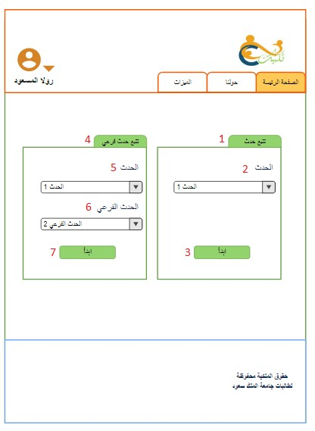

|  |  |
| --- | --- |
| # | Description |
| 1 | Choose to track event. |
| 2 | Dropdown list to Select event |
| 3 | Button to start track for the event. |
| 4 | Choose to track sub event. |
| 5 | Button to start track attendee for the selected event. |
| 6 | Drop down list to choose sub event to track. |
| 7 | Button to start track attendee for the selected sub event. |

*Table 56: Choose to track interface*

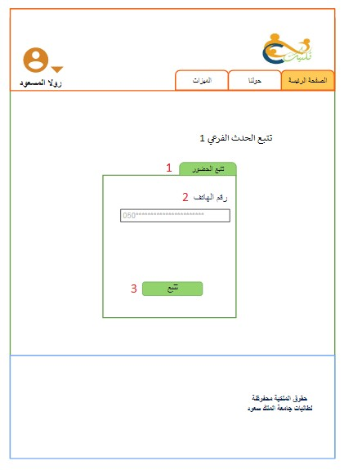

|  |  |
| --- | --- |
| **#** | **Description** |
| 1 | Track attendee in sub event. |
| 2 | Track by phone number |
| 3 | Button for track in sub event |

*Table 57: Track Sub event interface*

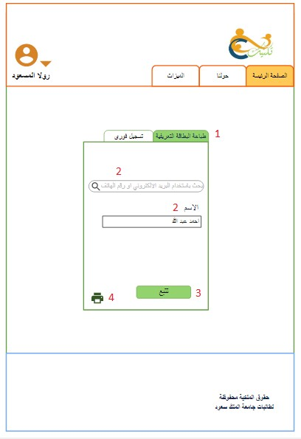

|  |  |
| --- | --- |
| # | Description |
| 1 | Print badge for the attendee at the event. |
| 2 | Search field to search about registered attendee by name and phone |
| 3 | Name of the attendee if found |
| 4 | Button t check in the attendee |
| 5 | Button to print badge |

*Table 58: Track event interface*

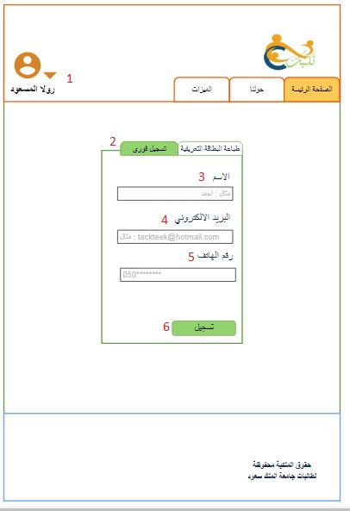

|  |  |
| --- | --- |
| # | Description |
| 1 | Profile of the organizer and can log out |
| 2 | Onsite registration |
| 3 | Input filed for name of the attendee |
| 4 | Input field for email of the attendee |
| 5 | Input field for phone of the attendee |
| 6  *Table 59: Onsit* | Button for onsite register  *e Registration interface* |

171

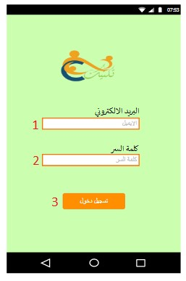

|  |  |
| --- | --- |
| # | Description |
| 1 | Input field for entering organizer email. |
| 2 | Input field for entering organizer password. |
| 3 | Button to log in |

*Table 60: Log in (APP) interface*

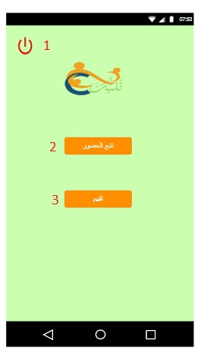

|  |  |
| --- | --- |
| # | Description |
| 1 | Button to log out. |
| 2 | Button for track attendee |
| 3 | Button for rate |

*Table 61: Home page (App) interface*

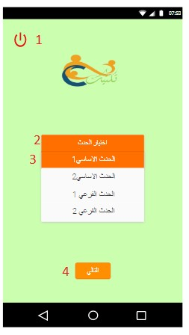

|  |  |
| --- | --- |
| # | Description |
| 1 | Button to log out. |
| 2 | Drop down list to choose the evnt. |
| 3 | Selected event. |
| 4 | Button to move for rating interface. |

*Table 62: Manage rate (App) interface*

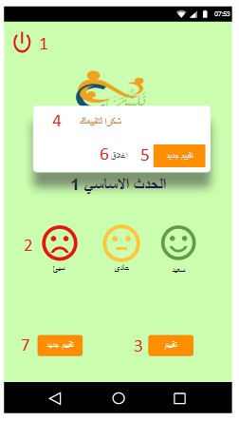

|  |  |
| --- | --- |
| # | Description |
| 1 | A button to log out. |
| 2 | Choose smiley face for rate. |
| 3 | Button for save the rate. |
| 4 | Pop up message after rating |
| 5 | Button for new rate |
| 6 | Close pop up message |
| 7 | Button for new rate. |

*Table 63: Event/subevent Rate (App) interface*

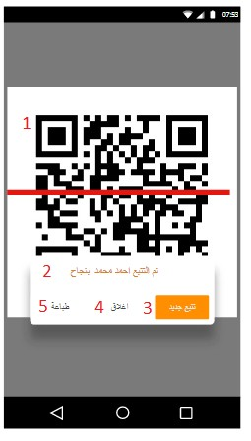

|  |  |
| --- | --- |
| # | Description |
| 1 | Open camera for scan barcode |
| 2 | Pop up message display name of attendee. |
| 3 | Button for new scan |
| 4 | Close pop up message button after track attendee |
| 5 | Print button move to print badge interface |

*Table 64: Track Attendee by scan bar code (App) interface*

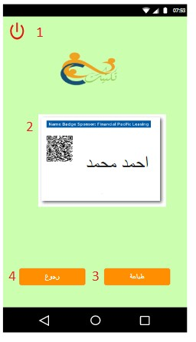

|  |  |
| --- | --- |
| # | Description |
| 1 | A button to log out |
| 2 | Badge of the attendee |
| 3 | A button for print badge |
| 4 | A button back |

*Table 65: Print badge (App) interface*

**5.6 SUMMARY:**

In this chapter, we have covered the system design components of our system in details according to the user requirements, and we have categorized this chapter into many sections particularly.

CHAPTER 6.

SYSTEM IMPLEMENTATION AND INTEGRATION

**6.1 INTRODUCTION:**

This chapter will include the implementation and integration process of the project, the implementation section will talk about the hardware and software that has been used to evolve our application and website. Also, it's included some of problem which faced us during the work, some parts of the project code for the main and major functions will be displayed. The second section will contains the different system component and how its integrated with each other.

**6.2 HARDWARE AND SOFTWARE**

**6.2.1 HARDWARE**

|  |  |  |  |
| --- | --- | --- | --- |
| **No** | **Device** | **Quantity** | **Description** |
| **1** | **Windows laptop** | **5** | **Used for developing the application and website** |
| **2** | **Android mobile** | **1** | **To test the application** |
| **3** | **Printer** | **1** | **To test the system and print the project document** |

Table 6-1: Hardware specification

**6.2.2 SOFTWARE**

|  |  |  |  |
| --- | --- | --- | --- |
| **Software** | **Developer** | **Version** | **Description** |
| **Dropbox** | **Dropbox, Inc** |  | **Used to store our project and project document** |
| **MS Office Word** | **Microsoft** | **2016** | **To write our documentation** |
| **phpMyAdmin** | **ThephpMyAdmin Project** | **5.6.30** | **A tool to manage MySQL database by creating, modifying or deleting tables or row** |
| **Xampp** | **Apache Friends** | **-** | **Used to create a local web server for testing purposes.** |
| **IBM Rational Software Architecture** | **IBM software** | **-** | **To draw the diagrams on the project** |
| **Android studio and android**  **SDK** | **Andrew** | **-** | **To implement the application.** |
| **GitHub** | **GitHub, Inc.** | **-** | **A Git repository hosting server used for source code management and integration.** |

Table 6-2: Software specification

|  |  |  |
| --- | --- | --- |
| MS office | Microsoft | To write the project documentation. |
| XAMPP | XAMPP | To create and use the database. |
| TeamViewer | TeamViewer | To check together. |
| Messenger | Facebook | To make group call. |
| IBM Rational Software  Architecture | IBM | To draw the diagrams on the project |
| Dropbox | Dropbox | To share project's files. |
| Android studio and android  SDK | Android | To implement the application. |

CHAPTER 6.

conclusion

178

**6.1 CONCLUSION:**

This chapter will describe the outcomes document which emphasizes the purpose of this project, we’re going to describe the early stages of our work to complete analysis and design phase.

At the first we describe "تكتيك"application and website in details and discuss the main problems which led us to suggest the idea of this system as a proposed solution. At the second chapter we give a general background and overview description about the project. Then, we followed with the literature review chapter which include similar applications exist in the market been compared with our project. After that, In the system analysis chapter, we covered a detailed description of the analysis and design process and we set the functions that will be implemented in our project starting with system requirements, user characteristics and ending with the system interface.

Furthermore, this application aims to develop a mobile application & website that help event organizers to organize their events by managing it remotely.

the system will encourage volunteers to participate in organizing the events and thus promote the successfulness of the event and satisfy the organizers need.

Also, our system will offer highly valuable information to the event organizer by utilizing the QR use in the registration. In addition, our system will encourage small companies to establish activities that improve their profits and the national economy, and this leads to increase the tourism in the region.

**6.2 LOCAL AND GLOBAL IMPACT:**

**6.2.1 LOCAL IMPACT:**

"تكتيك" provides many services to the organizer that facilitate the management processes and enable the organizer to use a smart events management system that enables him to automate management registration, print the badges for the attendees, keep track on delights attendees in the event, and give the right analytics tools to prove the value of the organizer events.

**6.2.2 Global Impact:**

Our system created to help event organizers around the Arab world to organize their events. Since "تكتيك" will smarty automated the events registration and management tasks, expanding its scope by supporting English language might not be hard to achieve and will make the system beneficial globally.

**6.3 PROBLEMS ENCOUNTERED:**

We did not encounter many problems and difficulties, but one was going on with us which is about the software tool used to design the system interface was not sufficient at all, some programs limits the number of free design pages. So, we had to create more than one account in order to create the full interface of "تكتيك"

**6.4 FUTURE WORK:**

At the next phase of our project we will focus on two more chapters in details, one of them the implementation chapter which is going to focus on building and coding the system functions, the second section of this chapter is the system integration that describes how we integrate the system.

the second chapter will be the testing chapter, it's focus on testing the process of

"تكتيك" the system and finding the errors to achieves the purpose that was developed for.

Moreover, that below are some of the directions for future work desire to achieve

"تكتيك" will be create in Arabic language which will make it distinct from other systems. Also, "تكتيك" use the barcode to make process of printing badges easier and giving the event organizer accessibility to keep tracking attendees of the sub-events:

• Develop a version of “تكتيك” for IOS platforms.

• Releasing the application in English language.

• Integrate our system with (GPS) system.

• Add more features and integrate it with our systems' functionality like location-based advertising for SMS messages.

**6.5 APPENDICES:**

**6.5.1 TIMELINE**

|  |  |  |  |  |
| --- | --- | --- | --- | --- |
|  | **Phases** | **Period** | **Start day** | **Submission day** |
|  | Introduction (Proposal) | 4 days | Wednesday, 7  February | Sunday 11 February |
|  | Background | 7 days | Sunday 11 February | Sunday 18 February |
|  | Literature Review | 11 days | Sunday 18 February | Wednesday 1 March |
|  | System Analysis | 15 days | Wednesday 1 March | Thursday 16 March |
|  | System Design | 22 days | Thursday 16 March | Saturday 7 April |
|  | Conclusion | 15 days | Saturday 7 April | Sunday 22  April |

*Table 66: Timeline.*

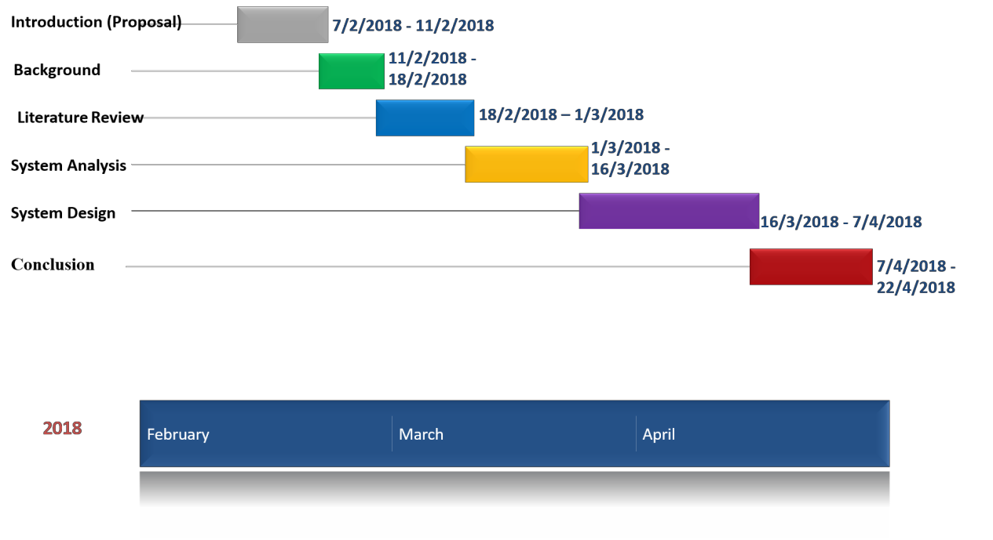

*Table 67: Timeline*

**6.5.2 ROLES AND RESPONSIBILITIES:**

|  |  |  |
| --- | --- | --- |
| **Role** | **Responsibilities** | **Participant(s)** |
| Supervisor | • Review phases.  • Direct the group. | Dr. Bedour Alrayes |
| Leader | • Organize and manage meetings.  • Communicate with supervisor.  • Collect group's work.  • Submit deliverables on time. | Marwa Salahi |
| Academic writer | • Background  • Literature Review | All team's member |
| System Analyst | • Gather requirements.  • Write the SRS document.  • Design the system models. | All team's member |
| System Designer | • Draw the Architecture Design.  • Design the interface.  • Write pseudo code. | All team's member |

*Table 68: Role and responsibilities*

**6.5.3 Hardware and Software Tools: HARDWARE:**

|  |  |  |  |
| --- | --- | --- | --- |
| **Hardware** | **Quantity** | **OS** | **Description** |
| Personal laptops | 5 | Windows  10, 8.1 | Each member laptop |
| Printer | 2 | HP | Each member printer. |

*Table 69: Hardware*

**SOFTWARE:**

**Software type**

**Publisher**

**Description**

|  |  |  |
| --- | --- | --- |
| MS office | Microsoft | To write the project documentation. |
| XAMPP | XAMPP | To create and use the database. |
| TeamViewer | TeamViewer | To check together. |
| Messenger | Facebook | To make group call. |
| IBM Rational Software  Architecture | IBM | To draw the diagrams on the project |
| Dropbox | Dropbox | To share project's files. |
| Android studio and android  SDK | Android | To implement the application. |

*Table 70: Software:*

**6.5.4 COST (IF APPLICABLE)**

Cost = 0

**6.6 REFERENCES:**

[1] HAMEED, N. (2018, January 13). Entertainment authority fires up 45 events for mid- year holiday in Saudi Arabia. Retrieved February 9, 2018, from <http://www.arabnews.com/node/1224641/saudi-arabia>

[2] Retrieved February 9, 2018, from <https://www.eventbrite.co.uk/>

[3] Retrieved February 9, 2018, from <http://lammt.com/>

[4] Unknown, (2017, August 3). SR 11 billion annual economic revenues for tourism events in the KSA Retrieved February 9, 2018, from <https://www.alkhafji.news/2017/08/03/350410.html>

[5] Unknown,” THE STATE OF TICKETED EVENTS IN DUBAI”, DUBAI TOURISM, (JULY 2016),14.

[https://www.visitdubai.com/-/media/pdfs/dtcm-](https://www.visitdubai.com/-/media/pdfs/dtcm-%20the%20state%20of%20ticketed%20events%202016_jul_2016.pdf)

[%20the%20state%20of%20ticketed%20events%202016_jul_2016.pdf](https://www.visitdubai.com/-/media/pdfs/dtcm-%20the%20state%20of%20ticketed%20events%202016_jul_2016.pdf)

[6] Unknown, “e-Permit and e-Ticketing”, DUBAI TOURISM, (August 2015),6*.*

[https://www.google.com.sa/url?sa=t&source=web&rct=j&url=https://www.visitdubai.com/](https://www.google.com.sa/url?sa=t&source=web&rct=j&url=https://www.visitdubai.com/~/media/pdfs/permits-and-licenses/e-permit%2520and%2520e-ticketing%2520faq_2015.ashx&ved=0ahUKEwjoob6U2ZnZAhXD7RQKHQAGCwoQFggbMAA&usg=AOvVaw32kW2B2VHA141zcY9x6lYh)

[~/media/pdfs/permits-and-licenses/e-permit%2520and%2520e-](https://www.google.com.sa/url?sa=t&source=web&rct=j&url=https://www.visitdubai.com/~/media/pdfs/permits-and-licenses/e-permit%2520and%2520e-ticketing%2520faq_2015.ashx&ved=0ahUKEwjoob6U2ZnZAhXD7RQKHQAGCwoQFggbMAA&usg=AOvVaw32kW2B2VHA141zcY9x6lYh) [ticketing%2520faq_2015.ashx&ved=0ahUKEwjoob6U2ZnZAhXD7RQKHQAGCwoQFgg](https://www.google.com.sa/url?sa=t&source=web&rct=j&url=https://www.visitdubai.com/~/media/pdfs/permits-and-licenses/e-permit%2520and%2520e-ticketing%2520faq_2015.ashx&ved=0ahUKEwjoob6U2ZnZAhXD7RQKHQAGCwoQFggbMAA&usg=AOvVaw32kW2B2VHA141zcY9x6lYh) [bMAA&usg=AOvVaw32kW2B2VHA141zcY9x6lYh](https://www.google.com.sa/url?sa=t&source=web&rct=j&url=https://www.visitdubai.com/~/media/pdfs/permits-and-licenses/e-permit%2520and%2520e-ticketing%2520faq_2015.ashx&ved=0ahUKEwjoob6U2ZnZAhXD7RQKHQAGCwoQFggbMAA&usg=AOvVaw32kW2B2VHA141zcY9x6lYh)

[7]” What is an Event?” Retrieved February 9, 2018, from <http://www.eventeducation.com/what-is-event.php>

[8] Visitdubai.com. (2018, 2 19). *Cite a Website - Cite This For Me*. Available at: [https://www.visitdubai.com/~/media/pdfs/permits-and-licenses/e-permit%20and%20e-](https://www.visitdubai.com/~/media/pdfs/permits-and-licenses/e-permit%20and%20e-ticketing%20faq_2015.ashx.%20Â ) [ticketing%20faq_2015.ashx.](https://www.visitdubai.com/~/media/pdfs/permits-and-licenses/e-permit%20and%20e-ticketing%20faq_2015.ashx.%20Â )

[9] event management. (2018, 2 19). Retrieved from webopedia:

[https://www.webopedia.com/TERM/E/event_management.html](https://www.webopedia.com/TERM/E/event_management.htmlÂ )

[10] Android (operating system). (2018, 02 14). Retrieved from Wikimedia:

<https://en.m.wikipedia.org/wiki/Android_(operating_system)>

[11] Mdlinx.com. (2018, 2 14). Medical Conferences CME Conference and Conference

Coverage. Available at:

https:/[/www.mdlinx.com/medical-conference/](http://www.mdlinx.com/medical-conference/)

[12] Eventmanagement.com. (2018, 2 14). Event Management of Conferences. Available

at:

<http://eventmanagement.com/events/conferences/>

[13] Selfgrowth.com. (2018, 2 14). Definition: Seminars and Workshops. Available at:

[http://www.selfgrowth.com/articles/Definition_Seminars_and_Workshops.html](http://www.selfgrowth.com/articles/Definition_Seminars_and_Workshops.htmlÂ )  [14] Types of Meetings and Events. (2018, 2 19). Retrieved from avenues: [http://www.evenues.com/event-planning-guide/types-of-meetings-and-events](http://www.evenues.com/event-planning-guide/types-of-meetings-and-events%20Â )

[15] Sanders, D. (2018, 2 14). Trade Show, Fair or Exhibition? (part 1) - TRADE-SHOW- PR. TRADE-SHOW-PR. Available at:

<http://www.trade-show-pr.com/2013/02/22/trade-show-fair-or-exhibition-part-1/>

[16] Creativecentenaries.org. (2018, 2 14). What is Commemoration? | Creative

Centenaries. Available at:

<http://www.creativecentenaries.org/toolkit/what-commemoration>

[17] wiseGEEK. (2018, 2 14). What are the Different Types of Fundraisers? (with

pictures). Available at:

<http://www.wisegeek.org/what-are-the-different-types-of-fundraisers.htm>

[18] wiseGEEK. (2018, 2 14). What is an Award Ceremony? (with pictures). Available at:

<http://www.wisegeek.com/what-is-an-award-ceremony.htm>

[19] What is a Barcode. (2018, 02 14). Retrieved from Barcodesinc:

https:/[/www.barcodesinc.com/articles/what-is-a-barcode.htm](http://www.barcodesinc.com/articles/what-is-a-barcode.htm)

[20] Why Have a Website. (2018, 2 14). Retrieved from cbscreative:

<http://www.cbscreative.com/webreasons.htm>

[21] UKEssays. (2018, 2 14). *Smartphone Essay - Importance of Smart Phones*. Available at:

[https://www.ukessays.com/essays/information-technology/importance-of-smart-phones-in-daily-](https://www.ukessays.com/essays/information-technology/importance-of-smart-phones-in-daily-life-information-technology-essay.php) [life-information-technology-essay.php.](https://www.ukessays.com/essays/information-technology/importance-of-smart-phones-in-daily-life-information-technology-essay.php)

[22] eVenues. (2018, 2 14). Types of Meetings and Events - eVenues.com. Available at:

<http://www.evenues.com/event-planning-guide/types-of-meetings-and-events>

Anon, (2018, 2 14). Available at: https://support.idautomation.com/Barcode-Learning/_412

[23] Scandit. (2018, 2 14). Types of Barcodes: Choosing the Right Barcode. Available at:

<https://www.scandit.com/types-barcodes-choosing-right-barcode/>

[24] Tutorial, M. (2018, 2 14). MaxiCode 2D Barcode Tutorial | IDAutomation.

Idautomation.com. Available at:

https:/[/www.idautomation.com/barcode-faq/2d/maxicode/](http://www.idautomation.com/barcode-faq/2d/maxicode/)

[25] Mobile-qr-codes.org. (2018, 2 14). How Are QR Codes Better Than Barcodes – QR Code Advantages, Quick Response Code, QR Codes Compared To Barcodes, Quick Response Codes, QR Code, QR Codes, QR Codes Images. Available at: <http://www.mobile-qr-codes.org/qr-codes-vs-barcodes.html>

**[26]** Explain that Stuff. (2018, 2 14). *How QR codes (and other 2D barcodes) work*. Available at: [http://www.explainthatstuff.com/how-data-matrix-codes-work.html.](http://www.explainthatstuff.com/how-data-matrix-codes-work.html)

[27] Retrieved February 9, 2018, from <http://lammt.com/>

[28] Retrieved February 9, 2018, from <http://stytickets.com/>

[29] Retrieved February 9, 2018, from <https://www.eventbrite.co.uk/>

[30] Retrieved February 9, 2018, from <https://www.jollytech.com/eventleaf/> [31] Retrieved March 18, 2018, from <http://lammt.com/page/about>

[32] Retrieved March 18, 2018, from

<http://stytickets.com/wp-content/uploads/2017/02/Profile.pdf>

[33] Retrieved March 18, 2018, from

<https://itunes.apple.com/sa/app/halayalla-sports-entertainment/id1097399425?mt=8>

[34] Retrieved March 18, 2018, from <https://jobs.lever.co/eventbrite/1a4522ef-929f-4dce-95ce-0db7eebb9db3>

[35] Retrieved March 18, 2018, from <https://www.youtube.com/watch?v=A0pXgmIJUGI>

187